Section-21- Databases in AWS

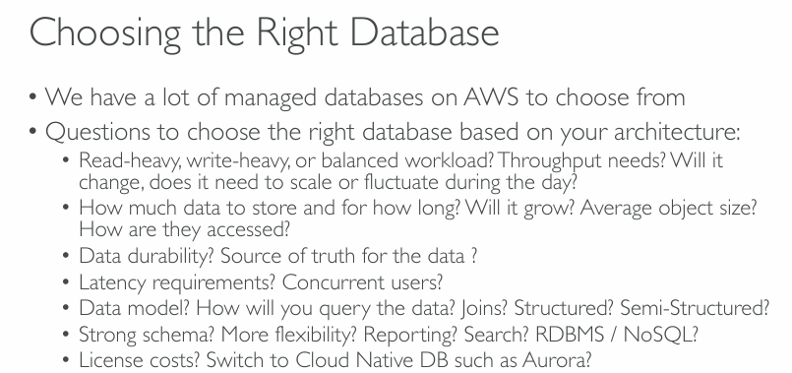  
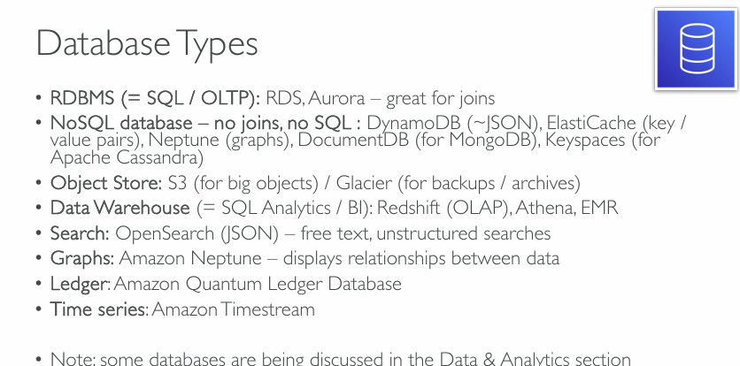  
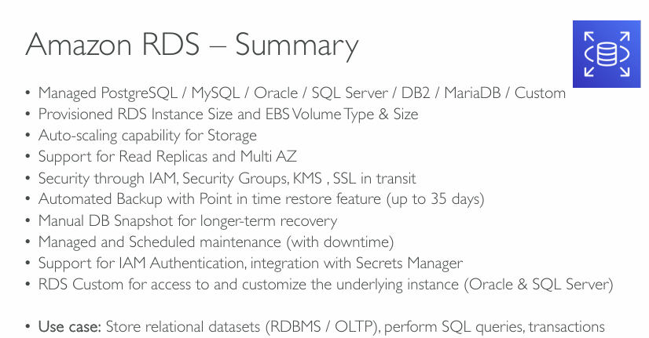  
**Key Features Explained**

**✅ Supported Database Engines**

* **Amazon RDS supports multiple engines**, giving architects flexibility to choose the best-fit technology:
  + **PostgreSQL / MySQL / MariaDB**: Popular open-source engines.
  + **Oracle / SQL Server / DB2**: Commercial engines often used in enterprise environments.
  + **Custom**: RDS Custom allows greater control for advanced configurations (especially for Oracle and SQL Server), enabling support for specific application requirements.

**✅ Provisioned Instance & Storage**

* Architects can **provision compute (instance type/size)** and **EBS storage (type/size)** independently based on workload needs.
* This provides predictable performance for **transactional workloads (OLTP)** or **read-heavy** applications.

**✅ Auto-Scaling for Storage**

* RDS can **automatically increase storage size** when you’re running out of space, minimizing downtime and manual intervention.
* Important for workloads with **unpredictable growth patterns**.

**✅ Read Replicas and Multi-AZ Deployment**

* **Read Replicas**: Improve read scalability and performance by offloading read traffic.
* **Multi-AZ**: Provides **high availability (HA)** and **disaster recovery (DR)** by maintaining a synchronous standby replica in a different availability zone (AZ).

**✅ Security**

* RDS integrates with:
  + **IAM** for authentication and access control.
  + **Security Groups** for network-level protection.
  + **KMS (Key Management Service)** for encryption at rest.
  + **SSL/TLS** for encryption in transit.
* Ensures **data protection** and **compliance** (e.g., HIPAA, GDPR, SOC 2).

**✅ Backups and Snapshots**

* **Automated backups**:
  + Point-in-time recovery within a **35-day window**.
  + Ensures **business continuity** and **data durability**.
* **Manual snapshots**:
  + Useful for **long-term retention**, such as quarterly backups or pre-upgrade saves.

**✅ Managed Maintenance**

* AWS handles **patching, updates, and OS maintenance**.
* Scheduling is available, but it may involve **planned downtime**—critical for designing **maintenance windows** in production.

**✅ IAM & Secrets Manager Integration**

* **IAM Authentication** simplifies password management and improves security posture.
* **Secrets Manager integration** automates credential rotation and reduces hardcoding credentials in code.

**✅ RDS Custom**

* Offers deeper customization for applications that:
  + Require **specific OS-level configurations**.
  + Depend on **3rd-party software agents** or advanced **Oracle/SQL Server features**.
* Ideal for migrating **legacy, on-prem workloads** without rearchitecting.

**💼 Use Case (As Highlighted)**

* Best suited for **OLTP (Online Transaction Processing)** systems needing:
  + **ACID-compliant transactional support**
  + **Relational data models**
  + **Complex SQL queries, joins, and stored procedures**

Examples:

* E-commerce apps
* Banking & financial systems
* CRM/ERP tools
* Inventory & order management

**🧠 Architectural Considerations**

When choosing RDS in a solution architecture:

| **Decision Point** | **Consideration** |
| --- | --- |
| Engine Selection | Compatibility with application, licensing costs, performance needs |
| Availability | Use Multi-AZ for critical systems |
| Scalability | Enable storage auto-scaling and read replicas as required |
| Cost Optimization | Choose instance types wisely; utilize Reserved Instances for cost savings |
| Security | Enforce encryption, IAM roles, VPC peering, Secrets Manager |
| Backup Strategy | Use automated backups + manual snapshots for compliance |
| Maintenance Strategy | Define maintenance windows for updates |

**✅ Summary:**

As a Solution Architect, Amazon RDS abstracts the operational overhead of managing relational databases while still offering fine-grained control over **performance**, **availability**, **security**, and **scalability**. It aligns well with cloud-native design principles like **automation, elasticity, and managed infrastructure**, enabling faster time-to-market and improved system reliability.

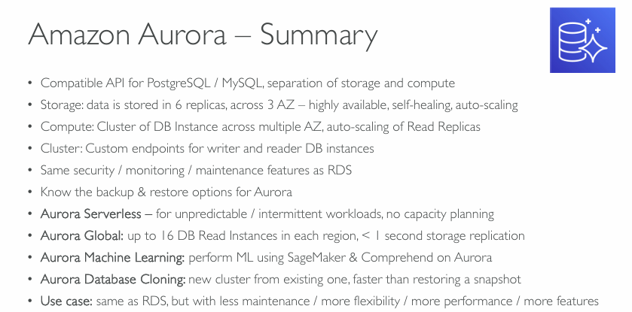  
**Amazon Aurora – Key Technical Highlights**

**✅ 1. PostgreSQL/MySQL Compatibility & Architecture**

* **Aurora is compatible with MySQL and PostgreSQL**, making it easy to migrate existing applications without code changes.
* Supports **separation of storage and compute**, which allows **independent scaling** and better cost/resource optimization.

**✅ 2. High Durability & Availability (Storage Layer)**

* Data is stored as **6 copies across 3 Availability Zones (AZs)**.
* **Self-healing**: Aurora continuously monitors and repairs disk failures.
* **Auto-scaling**: The storage layer can automatically grow up to 128 TB per database.

🔧 **Architect’s insight**: No need for provisioning disk size up front; Aurora handles scaling and replication internally, reducing operational complexity.

**✅ 3. Compute Layer & Clustering**

* Supports a **clustered architecture**:
  + One **writer node** and multiple **reader nodes** (Aurora Replicas).
  + Each node can be deployed in different AZs for **HA and disaster tolerance**.
  + **Custom endpoints**: Application can connect to different endpoints for reads and writes.

📌 Enables **read scaling**, **zero-downtime failovers**, and **load balancing** with built-in endpoint logic.

**✅ 4. Security, Monitoring & Maintenance**

* Inherits the **same security and compliance features** as RDS:
  + IAM, VPC, KMS, SSL/TLS
  + CloudWatch, CloudTrail, Enhanced Monitoring
* **Managed patching and upgrades** to ensure database health and performance.

**✅ 5. Backup & Restore**

* Aurora continuously backs up data to Amazon S3 with **no performance impact**.
* **Point-in-time recovery** available.
* Backup is automatic and supports **manual snapshots** too.

**🆕 Advanced Aurora Features**

**⚡ Aurora Serverless**

* Ideal for **intermittent, unpredictable workloads**.
* No instance provisioning — Aurora auto-starts/stops based on traffic.
* **Pay-per-second** pricing.

🎯 Great fit for dev/test environments, or variable-load applications like ticketing or e-commerce flash sales.

**🌍 Aurora Global Databases**

* Enables **cross-region disaster recovery and low-latency global reads**.
* Supports up to **16 read replicas per region** with **<1 second replication lag**.

🌐 Suitable for globally distributed applications that require data locality or DR.

**🧠 Aurora Machine Learning**

* Integrates with **Amazon SageMaker** and **Amazon Comprehend**.
* Enables **in-database machine learning inference**, like sentiment analysis or fraud detection without data movement.

⚙️ Reduces latency and increases security by keeping sensitive data in the DB layer.

**📀 Aurora Database Cloning**

* Enables **instantaneous, cost-effective copies** of databases without the need to restore from snapshots.
* Useful for:
  + Dev/test environments
  + QA testing with production data
  + Schema upgrade testing

**📌 Use Case**

*Same as RDS, but with*:

* **Lower administrative overhead**
* **Better performance (up to 5x MySQL, 3x PostgreSQL)**
* **Higher availability**
* **More advanced features** (Serverless, ML, Global DB)

**Typical Use Cases**:

* Enterprise applications
* SaaS platforms
* Gaming backends
* Analytics workloads
* E-commerce and financial systems requiring high throughput

**🔍 Solution Architect Summary**

| **Feature** | **RDS** | **Aurora** |
| --- | --- | --- |
| Compatibility | Multiple engines | MySQL & PostgreSQL only |
| Performance | Baseline | Up to 5x MySQL / 3x PostgreSQL |
| High Availability | Multi-AZ | Multi-AZ + 6-way storage replication |
| Read Scaling | Read replicas (limited) | Up to 15 Aurora Replicas |
| Serverless | Limited (Serverless v2 in preview) | Aurora Serverless (v1 & v2) |
| Global Reach | Cross-region read replicas (manual setup) | Aurora Global DBs with <1s lag |
| Cost | Depends on engine | Slightly higher but optimized for performance |

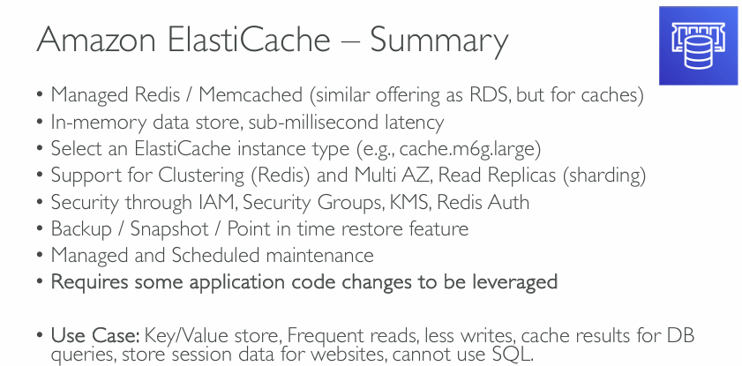  
**Amazon ElastiCache – In-Depth Explanation**

**✅ 1. Managed Redis / Memcached**

* AWS provides a fully managed environment for both:
  + **Redis**: More feature-rich (supports persistence, pub/sub, clustering).
  + **Memcached**: Simpler, multi-threaded, no persistence, ideal for caching.
* Similar to **Amazon RDS** in terms of provisioning and management, but designed specifically for **low-latency in-memory storage**.

🔧 Choose based on workload: Redis (more advanced features), Memcached (simpler, ephemeral caching needs).

**✅ 2. Performance – Sub-millisecond Latency**

* In-memory data storage provides **ultra-fast access** to frequently used data.
* Ideal for performance-critical applications (gaming, financial systems, real-time analytics).

🎯 Architectural benefit: Offloads read-heavy workloads from primary databases, improving application scalability and responsiveness.

**✅ 3. Instance Type Selection**

* Example: cache.m6g.large – optimized for memory-intensive workloads.
* Choose based on **memory size, network performance, and throughput needs**.

📌 **Right-sizing** ElastiCache nodes is important for cost and performance optimization.

**✅ 4. Clustering, Multi-AZ, and Read Replicas**

* **Redis Clustering**:
  + Horizontally scales cache data by sharding.
  + Ensures high availability and better throughput.
* **Multi-AZ with Auto-Failover** (Redis only):
  + Provides fault tolerance by replicating primary node to standby across AZs.
* **Read Replicas**:
  + Offload reads to replicas, improving read scalability.

🔁 Helps in designing highly available, scalable caching layers for production workloads.

**✅ 5. Security & Compliance**

* **IAM**, **Security Groups**, **KMS Encryption**, and **Redis AUTH** are supported.
* Also supports **TLS in-transit** and **encryption at-rest** for secure communication.

🔐 Ensures compliance with enterprise security standards (HIPAA, GDPR, etc.).

**✅ 6. Backup, Snapshot, Restore**

* **Redis** supports **automatic backups**, **manual snapshots**, and **point-in-time restore**.
* Useful for disaster recovery and data protection.

💡 Memcached does **not support persistence or backup**.

**✅ 7. Maintenance & Updates**

* AWS handles **patching, failover management, and minor version upgrades**.
* You can schedule maintenance windows for **non-disruptive updates**.

**⚠️ 8. Application Code Changes**

* ElastiCache cannot be used as a **drop-in replacement** for traditional databases.
* It requires the **application to integrate with Redis/Memcached client libraries**.
* Application logic must implement **cache retrieval/fallback strategy** (cache-aside or write-through).

💬 “**Cache logic must be explicit** in your codebase” – this is a design consideration.

**🗂️ Use Cases – Solution Architect View**

| **Use Case** | **Description** |
| --- | --- |
| **Key/Value Store** | Store simple objects or serialized values for fast retrieval |
| **Frequent Reads / Less Writes** | Cache frequently accessed data (e.g., product catalogs, pricing, etc.) |
| **DB Query Results Caching** | Avoid expensive joins or aggregations on the RDS/Aurora layer |
| **Session Storage** | Store web session tokens, JWTs, shopping carts, etc. |
| **Gaming Leaderboards / Real-Time Analytics** | Maintain counters, scoreboards, or low-latency dashboards |
| **Pub/Sub Messaging (Redis only)** | Redis can act as a lightweight message broker for real-time communication |

🚫 **SQL is not supported**: Data must be managed using native Redis/Memcached commands.

**🧩 Solution Architecture Perspective**

Integrating ElastiCache improves:

* **Response time** for APIs
* **Database offloading**
* **System scalability** and **resilience**
* **User experience** via reduced latency

Typical integration pattern:

1. Check cache →
2. If miss, query DB →
3. Store result in cache for future use

**🧪 Bonus: Cache Strategy Options**

* **Write-through**: Write to cache and DB simultaneously.
* **Cache-aside (Lazy loading)**: Application fetches from DB if not in cache.
* **Write-behind**: Write to cache first, then asynchronously persist to DB.

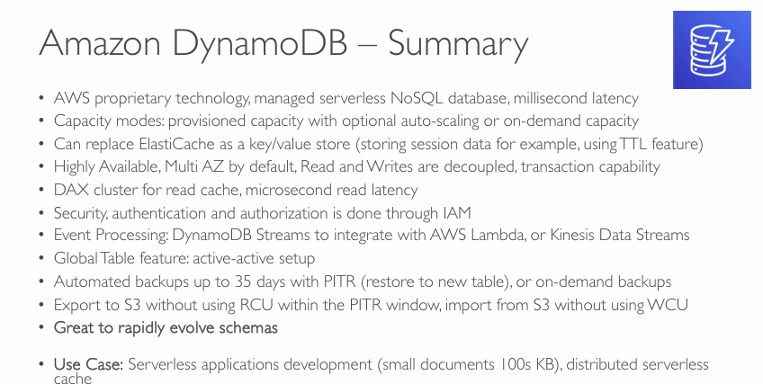

So DynamoDB, from an exam perspective anytime we see that we need to rapidly evolve schema which have a flexible type of database schema is going to be a great choice.

**Amazon DynamoDB – Deep Dive for Solution Architects**

**✅ 1. Serverless NoSQL Database (AWS Proprietary)**

* **Managed, serverless** — no infrastructure provisioning or management.
* Built by AWS from the ground up (not based on open-source NoSQL engines like MongoDB or Cassandra).
* Delivers **single-digit millisecond latency** consistently at any scale.

🧠 Ideal for applications needing fast access to **key-value** or **document-based** data without worrying about provisioning or scaling infrastructure.

**✅ 2. Capacity Modes**

* **Provisioned**: Specify Read and Write Capacity Units (RCUs/WCUs); better control over throughput and cost.
* **On-demand**: Pay-per-request model; suitable for unpredictable workloads.
* **Auto-scaling**: Dynamically adjusts provisioned throughput based on traffic.

⚙️ Choose based on workload predictability and cost management needs.

**✅ 3. ElastiCache Alternative**

* DynamoDB can act as a **key/value store**, similar to ElastiCache, using its **Time-To-Live (TTL)** feature to expire session data.
* However, it trades **slightly higher latency** (ms vs sub-ms) for **durability, availability**, and **zero cache invalidation issues**.

**✅ 4. Availability and Architecture**

* **Highly available**, Multi-AZ by default.
* **Separation of reads/writes** helps scale operations independently.
* Supports **transactions** (ACID compliance) for mission-critical operations.

**✅ 5. DAX (DynamoDB Accelerator)**

* **In-memory cache** for DynamoDB queries with **microsecond latency**.
* Fully managed, sits in front of DynamoDB.
* Ideal for **read-heavy** applications (e.g., product catalogs, real-time dashboards).

🚀 Improves performance by up to 10x, reduces latency, and reduces DynamoDB read costs.

**✅ 6. Security**

* Uses **IAM** for authentication/authorization.
* Supports encryption at rest using AWS KMS.
* VPC endpoints for private access (via DynamoDB Gateway).

**✅ 7. Event Processing**

* **DynamoDB Streams** capture change logs (insert, update, delete).
* Can trigger:
  + **AWS Lambda** functions (e.g., for serverless event-driven pipelines),
  + **Kinesis Data Streams** for near real-time analytics.

🛠️ This enables **serverless, reactive architectures** with DynamoDB as the core.

**✅ 8. Global Tables (Multi-Region, Active-Active)**

* **Active-active replication** across multiple AWS regions.
* Enables low-latency, multi-region read/write access with built-in conflict resolution.

🌍 Great for global applications requiring **local low-latency access**.

**✅ 9. Backup & Restore**

* **Point-in-time recovery (PITR)**: Restore to any second in the past 35 days.
* **On-demand backups** are available as well.
* Restores are done to a **new table**, maintaining isolation from live workloads.

**✅ 10. Data Export/Import**

* Export data to **Amazon S3** without consuming **Read Capacity Units** during PITR window.
* Supports data **import back from S3** without consuming Write Capacity.

🧬 Useful for long-term archiving, analytics integration (e.g., with Athena, Redshift), or cross-account migration.

**✅ 11. Schema Evolution**

* **No fixed schema**: Flexible data model for storing evolving JSON documents.
* Allows teams to adapt and iterate quickly as application requirements change.

🛠️ Reduces friction in agile development environments.

**🗂️ Use Cases for DynamoDB**

| **Use Case** | **Description** |
| --- | --- |
| **Serverless Applications** | Core component in AWS Lambda architectures, often alongside API Gateway |
| **Session Stores** | Using TTL and rapid read/write capabilities |
| **Gaming Leaderboards** | High-velocity updates and quick reads |
| **IoT Device Data** | Scalable ingestion and storage of time-series or event data |
| **E-commerce Carts & Catalogs** | High-speed, low-latency product retrieval and cart updates |
| **Real-Time Data Processing** | When paired with Streams and Lambda for event-based workflows |

**🧩 Solution Architect Recommendations**

* Use **on-demand mode** for new, unpredictable workloads; switch to **provisioned with auto-scaling** once patterns stabilize.
* Implement **DAX** if read latency is critical and caching consistency is manageable.
* Use **Streams + Lambda** for serverless event-driven designs.
* For global apps, design with **Global Tables** for **geo-distributed access** and **disaster resilience**.

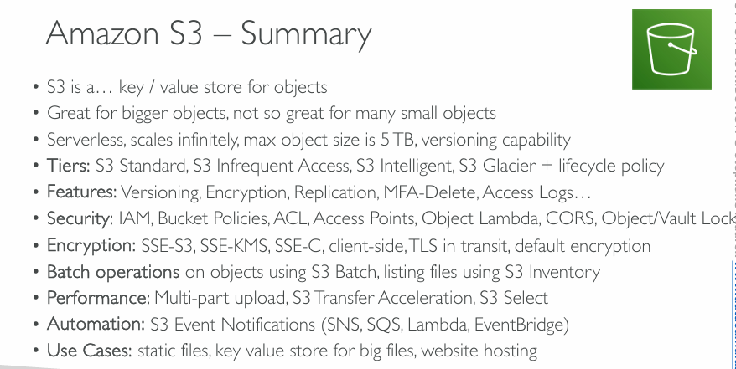  
**Amazon S3 – Solution Architecture Deep Dive**

**✅ 1. Object Storage (Key/Value)**

* S3 is a **key/value store** for **unstructured object data**.
* Objects can be documents, images, videos, backups, or any binary blobs.
* Each object is stored with a unique key inside a bucket.

🧠 Designed for **durability (11 9’s)** and **availability**, making it ideal for mission-critical backups and static content.

**✅ 2. Scalability & Performance**

* **Serverless & virtually unlimited scale**.
* **Max object size**: 5 TB.
* Supports **multi-part uploads** for large files (uploads in parallel).
* **Transfer Acceleration** speeds up upload/download via edge locations.
* Use **S3 Select** to retrieve a subset of object data (e.g., querying specific rows in a CSV).

**✅ 3. Storage Classes (Tiers)**

Choose based on **access frequency and cost**:

| **Tier** | **Use Case** |
| --- | --- |
| **S3 Standard** | Frequent access |
| **S3 IA (Infrequent Access)** | Less frequent, cost-saving |
| **S3 Intelligent-Tiering** | Auto-switches between tiers based on usage |
| **S3 Glacier / Deep Archive** | Archival storage, low cost, high latency |
| **Lifecycle Policies** | Automate movement between tiers |

💸 Optimizes **storage costs** without manual intervention.

**✅ 4. Advanced Features**

* **Versioning**: Keep multiple versions of an object.
* **Encryption**: SSE-S3, SSE-KMS, SSE-C, or client-side.
* **Replication**: Cross-region or same-region replication for HA/DR.
* **MFA-Delete**: Adds extra security for object deletion.
* **Access Logs**: Track object access for security/audit.

**✅ 5. Security**

* Enforced using:
  + **IAM policies**
  + **Bucket policies**
  + **ACLs (Legacy)**
  + **Access Points**: Granular access control for shared buckets
  + **Object Lambda**: Run custom code when data is retrieved (e.g., filter/transform)
  + **Object Lock / Vault Lock**: Prevents deletions (WORM compliance)

🔐 Highly customizable for **fine-grained access control** and compliance.

**✅ 6. Encryption**

* **Server-side**: SSE-S3, SSE-KMS (AWS Key Management), SSE-C (customer-managed).
* **Client-side**: Encrypt before upload.
* **In-transit**: TLS.
* **Default encryption** can be enforced at the bucket level.

**✅ 7. Automation & Events**

* **S3 Event Notifications** trigger workflows:
  + **SNS**: Notify systems.
  + **SQS**: Queue-based processing.
  + **Lambda**: Serverless compute trigger.
  + **EventBridge**: Event-driven integrations across services.

🔁 Enables powerful **data pipelines**, real-time processing, and automation.

**✅ 8. Batch Operations**

* **S3 Batch** allows operations like tagging, copying, restoring, etc., across **millions of objects**.
* Combine with **S3 Inventory** (CSV listing of bucket contents) to define targets.

**✅ 9. Use Cases**

| **Use Case** | **Description** |
| --- | --- |
| **Static Website Hosting** | Host HTML/CSS/JS directly with S3 + Route53 |
| **Backup and Archival** | Long-term storage with Glacier |
| **Big Data Analytics** | Store data lakes (Athena, EMR, Redshift Spectrum) |
| **Media Storage/Delivery** | Scalable content storage for streaming |
| **Application Assets** | Store application logs, models, data files |
| **Software Distribution** | Host large binaries or datasets |

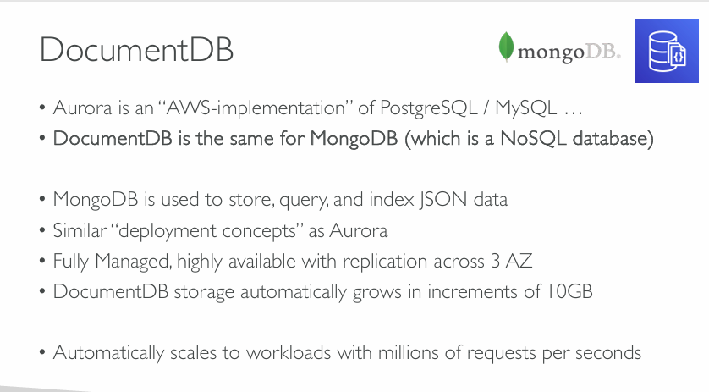  
So at the exam, if you see anything related to MongoDB, think DynamoDB, or if you see anything related to no SQL databases, think DocumentDB and also DynamoDB.

**Amazon DocumentDB – Architecture Summary**

**✅ 1. What is DocumentDB?**

* **AWS’s managed implementation of MongoDB**, much like how **Aurora** is for MySQL/PostgreSQL.
* Offers **MongoDB API compatibility**, making it easier to migrate MongoDB workloads with minimal application code changes.

📌 **Note:** While compatible with MongoDB APIs, it is not a native MongoDB engine—it uses its own underlying architecture.

**✅ 2. JSON-centric NoSQL Database**

* DocumentDB stores **semi-structured data** in **JSON-like documents**.
* Supports **indexing, querying, and aggregation** of document data.

Use cases include **content management**, **catalogs**, **user profiles**, and **mobile app data stores**.

**✅ 3. Deployment & Architecture**

* **Fully managed service** (provisioned clusters).
* Uses similar deployment strategies as **Amazon Aurora**:
  + **Separation of compute and storage**.
  + **Automatic replication across 3 Availability Zones** (multi-AZ HA setup).
  + **No need to manage replicas manually**.

🛡️ High availability and fault tolerance built-in.

**✅ 4. Storage & Scaling**

* **Storage auto-scales** in **10 GB increments**, up to **64 TB per cluster**.
* No need to pre-provision or resize storage manually.
* **Throughput and IOPS scale with storage**.

🔄 **Storage layer is decoupled** from compute, enabling higher performance and better resilience.

**✅ 5. Performance & Workload Handling**

* Designed to handle **millions of read/write requests per second**.
* Supports **horizontal read scaling** with multiple read replicas.
* Built-in **backup and restore**, **automated snapshots**, and **point-in-time recovery**.

**✅ 6. Security & Compliance**

* Integrates with:
  + **IAM** for access control.
  + **VPC** for network isolation.
  + **KMS** for encryption at rest.
  + **TLS** for encryption in transit.

**🔄 Comparison With MongoDB Atlas (if needed):**

| **Feature** | **DocumentDB** | **MongoDB Atlas** |
| --- | --- | --- |
| Provider | AWS Native | MongoDB Inc. |
| API Compatibility | Partial (MongoDB 3.6, 4.0, 5.0) | Full |
| Deployment Flexibility | AWS only | Multi-cloud |
| Advanced MongoDB features | Limited | Full (e.g., Change Streams, Transactions) |

**💼 Common Use Cases**

* Content Management Systems (CMS)
* IoT event storage
* Product catalogs
* User/session/profile data
* Semi-structured logs or analytics

**📌 Architect's Tips**

* **Use DocumentDB for MongoDB-compatible applications** that benefit from AWS-native integration and managed scaling.
* **Ensure compatibility**—some advanced MongoDB features may not be fully supported.
* Monitor costs—DocumentDB charges for **instances**, **storage**, **I/O**, and **backups**.
* **Consider alternatives** like DynamoDB for key-value or single-table designs, especially for serverless workloads.  
  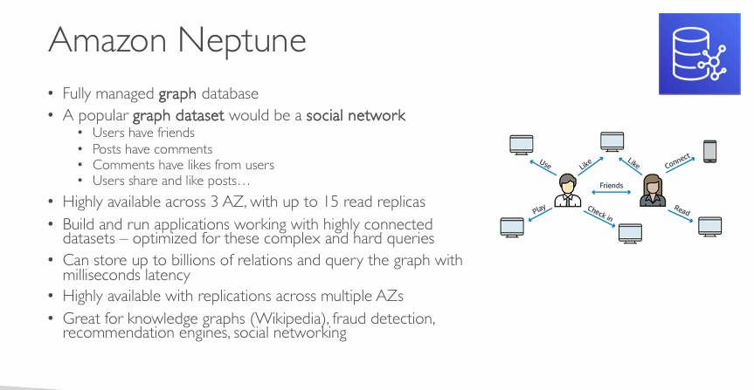  
  In exam perspective, any time if you see anything related to graph databases, think no more than Neptune.

**Amazon Neptune – Architecture Summary**

* **✅ 1. What is Amazon Neptune?**
* A **fully managed graph database** service on AWS.
* Designed to efficiently store and navigate **highly connected datasets**.
* **✅ 2. Graph Data Modeling**
* Graphs consist of **nodes** (entities) and **edges** (relationships).
* A typical example is a **social network**:
* Users → Friends
* Posts → Comments → Likes
* Users → Share or Like Posts
* 🧠 Ideal for use cases where relationships matter more than individual records.
* **✅ 3. Supported Graph Models**
* **Property Graph** using **TinkerPop Gremlin**
* **RDF** (Resource Description Framework) using **SPARQL**
* This dual support makes Neptune suitable for both transactional (OLTP) and semantic (linked data) graph workloads.
* **✅ 4. Performance & Scalability**
* Stores **billions of relationships**.
* Designed for **sub-millisecond latency queries**.
* Up to **15 read replicas** supported for horizontal read scaling.
* **Highly available** with replication across **3 Availability Zones (AZs)**.
* 🧩 Optimized for **complex, relationship-heavy queries**.
* **✅ 5. Availability & Reliability**
* Multi-AZ **replication for fault tolerance**.
* Continuous **backup to Amazon S3**, with point-in-time restore capability.
* **✅ 6. Security**
* Integration with:
* **IAM** for access control
* **VPC** for network isolation
* **KMS** for encryption at rest
* **TLS** for encryption in transit
* **✅ 7. Use Cases**
* **Knowledge graphs** (e.g., Wikipedia)
* **Fraud detection** (detect suspicious patterns)
* **Recommendation engines** (product/user similarity)
* **Social networking** (user relations and interactions)
* **Network/IT Ops** (dependency mapping)
* **✅ 8. Architect's Best Practices**
* Use **Neptune for graph traversal queries** that would be expensive in RDBMS or NoSQL systems.
* Choose between **Gremlin** and **SPARQL** depending on the graph type and use case.
* **Do not use Neptune** as a general-purpose database; it's purpose-built for relationship-heavy queries.
* **Monitor query performance** using CloudWatch metrics and Neptune Workbench.

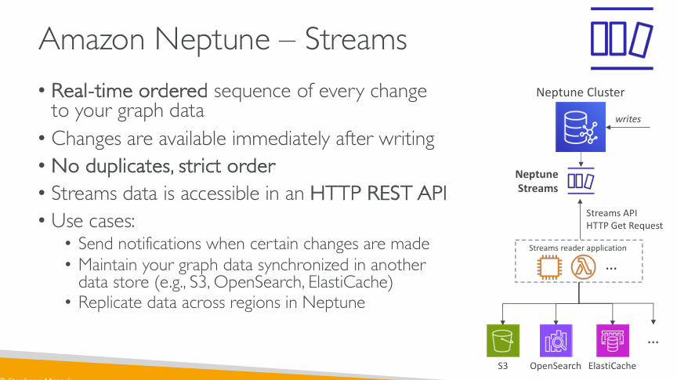  
  
**Amazon Neptune – Streams (Change Data Capture)**

**✅ 1. What Is Neptune Streams?**

* **Streams** capture a **real-time, ordered log** of every change made to graph data in a Neptune cluster.
* Think of it as **Change Data Capture (CDC)** specifically for **graph databases**.

**✅ 2. Key Characteristics**

* 🔄 **Real-time & Ordered**: Delivers changes **immediately** after they are written.
* 🚫 **No duplicates**: Guarantees **strict ordering** and **exactly-once semantics**.
* 🌐 Accessible via **HTTP REST API** – allows easy polling or integration with other services.

**✅ 3. Architecture Flow**

1. Writes are made to Neptune.
2. Neptune Streams logs these changes.
3. A **Streams Reader Application** (e.g., Lambda) **polls** the Streams REST API.
4. Changes can be processed and stored in other systems like:
   * **Amazon S3**
   * **Amazon OpenSearch**
   * **Amazon ElastiCache**

**✅ 4. Use Cases**

* 🔔 **Trigger notifications** on graph updates (e.g., friend request, new relationship).
* 🔄 **Sync graph changes to other stores** for analytics, caching, or search:
  + Example: Send graph updates to **S3** for storage or **OpenSearch** for full-text search.
* 🌍 **Cross-region replication**: Mirror changes from one Neptune region to another.

**✅ 5. When to Use Neptune Streams**

* When you need **real-time reactivity** to graph changes.
* For **ETL pipelines** where graph changes must sync to data lakes or search indexes.
* To build **event-driven architectures** on top of graph data.

**✅ 6. Best Practices**

* Implement **idempotent readers** to ensure consistent downstream states.
* Use **Lambda with retries and dead-letter queues (DLQs)** for fault tolerance.
* **Filter unnecessary changes** to reduce read load and optimize costs.

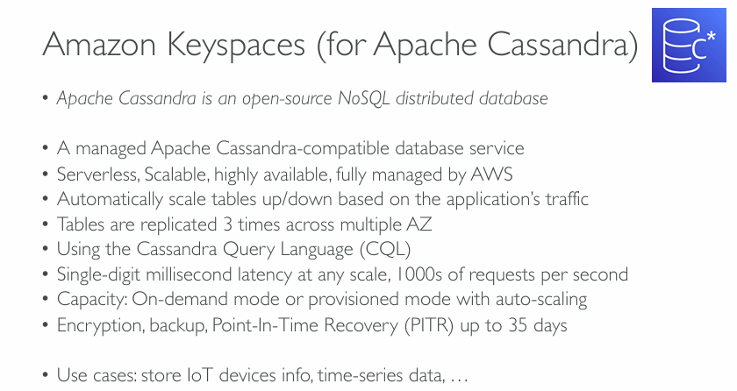  
In exam perspective, any time if you see Apache Cassandra, you just think about Amzon Keyspaces.

**What is Amazon Keyspaces?**

Amazon Keyspaces is a **fully managed** and **Cassandra-compatible** database service that enables developers to run Cassandra workloads on AWS **without needing to manage infrastructure** (e.g., nodes, clusters, tuning, patching).

It is part of AWS’s **serverless database portfolio**, along with DynamoDB and Aurora Serverless.

**🔍 Key Features and Deep Dive**

**🔧 Cassandra Compatibility**

* Supports the **Cassandra Query Language (CQL)**.
* Enables customers to **lift-and-shift** existing Cassandra workloads to AWS with **minimal changes** to code.
* Ideal for organizations looking to **modernize legacy Cassandra clusters** without rewriting applications.

**☁️ Serverless, Fully Managed**

* No need to manage cluster nodes, replication, backups, scaling, patching, or security.
* AWS handles:
  + Software versioning
  + Monitoring and availability
  + Patching and upgrades
  + Capacity provisioning
* **You only pay for what you use** (similar to DynamoDB On-Demand mode).

**📈 Scalability and Availability**

* **Elastic scaling**: Read/write capacity scales up/down automatically based on demand.
* **Tables are automatically partitioned** and replicated across **three Availability Zones (AZs)** in a Region.
* This meets AWS’s **high availability and fault-tolerant design standards**.

**🚀 Performance**

* Delivers **single-digit millisecond latency** even at scale.
* Can handle **thousands of requests per second**.
* Backed by **SSD-based storage**, with predictable performance characteristics similar to DynamoDB.

**⚙️ Capacity Modes**

Amazon Keyspaces supports two capacity modes:

1. **On-Demand Mode** (default):
   * Ideal for unpredictable workloads.
   * Automatically adjusts to application traffic.
   * Billed based on read/write request units.
2. **Provisioned Mode**:
   * Allows developers to define specific read/write throughput (RU/s).
   * Use **auto-scaling** to adjust provisioned capacity based on utilization.

**🔒 Security and Data Protection**

* **Encryption at rest and in transit** using AWS KMS.
* **VPC Endpoints** (via AWS PrivateLink) available for private connectivity.
* **Point-In-Time Recovery (PITR)**:
  + Restores table to any point in the past 35 days.
  + Ideal for accidental deletes/overwrites or data corruption.

**📅 Backup and PITR**

* Automatic daily backups are provided.
* PITR provides **granular data restore capabilities** similar to those offered in DynamoDB.
* Meets compliance and data durability requirements.

**🔗 Use Cases**

Best suited for:

* **IoT telemetry data** ingestion (e.g., millions of device data points/minute)
* **Time-series data** (e.g., logs, metrics)
* **High-write, low-latency read scenarios**
* Real-time analytics
* Applications requiring **eventual consistency** and **horizontal scalability**

**🆚 Cassandra on EC2 vs Amazon Keyspaces**

| **Feature** | **Cassandra on EC2** | **Amazon Keyspaces** |
| --- | --- | --- |
| Setup & Management | Self-managed (manual) | Fully managed |
| Scalability | Manual (add nodes) | Serverless & auto-scaling |
| High Availability | Must be manually architected | Built-in, across 3 AZs |
| Backups / PITR | Manual scripting | Automatic, PITR up to 35 days |
| Security | Manual IAM/VPC/KMS integration | Native integration with AWS IAM/KMS |
| Cost Efficiency | Pay for EC2 and storage always | Pay-per-request model (on-demand) |
| Maintenance Burden | High (patches, node failures, etc.) | None (managed by AWS) |

**🧠 Solution Architect Insights:**

As a Solutions Architect, consider Amazon Keyspaces when:

* You need a **serverless wide-column NoSQL database** with **Cassandra compatibility**.
* You're replacing legacy Cassandra workloads that are **complex to manage** on-premises or in EC2.
* You're building a new IoT, telemetry, or time-series system that must **scale automatically**.
* You need to **offload operational overhead** while maintaining Cassandra syntax.

⚠️ **Note**: Amazon Keyspaces does not currently support all Cassandra features (e.g., secondary indexes, batch operations with unlogged batches are limited). Evaluate for compatibility during migration.

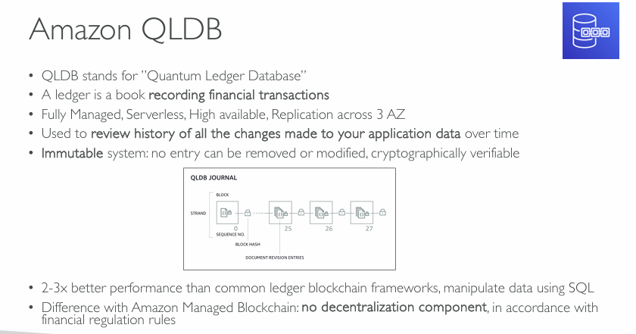  
Any time if you see financial transactions and ledger, think QLDB.  
  
  
  
  
**What is Amazon QLDB?**

Amazon QLDB is a **purpose-built ledger database** designed to provide a **transparent, immutable, and cryptographically verifiable transaction log**. It tracks **every change to application data** and maintains a **complete and verifiable history** over time.

It's ideal for systems where **auditability, traceability, and data integrity** are paramount — such as financial, regulatory, and operational systems.

**🧠 Deep Dive on Key Features**

**📘 "Ledger" – Financial Transactions Analogy**

* A **ledger** is a **chronological record of transactions**, historically used in finance.
* QLDB brings that **ledger-like functionality to modern applications**, but **without the complexity of blockchain networks**.

**☁️ Fully Managed and Serverless**

* No need to manage infrastructure (nodes, replication, scaling, etc.).
* Serverless: You don’t provision instances or clusters.
* Automatically scales to meet demand.
* Replicates data **across 3 Availability Zones (AZs)** to ensure **high availability and durability**.

**📜 Immutable and Cryptographically Verifiable**

* QLDB **uses a journal-first architecture**:
  + Every change (revision) is recorded in an **append-only journal**.
  + Data cannot be **deleted or altered**, ensuring **immutability**.
* Each block is **hashed and linked** (like blockchain), forming a cryptographically verifiable chain of revisions.
* Supports **SHA-256 hashing**, enabling **integrity verification of the entire data history**.
* This design makes QLDB ideal for:
  + **Audit logs**
  + **Banking records**
  + **Regulatory compliance systems**

**🕵️ Auditability: Full Change History**

* You can **review the entire lineage** of data changes, making QLDB excellent for:
  + Audits
  + Fraud detection
  + Change reconciliation
* Provides an **immutable history** of all document revisions — a critical requirement in regulated environments.

**💻 SQL-Compatible Query Interface**

* Unlike traditional blockchain frameworks that require custom SDKs or query languages, QLDB supports:
  + **PartiQL** — a SQL-compatible query language for document data.
  + Enables familiar syntax for developers and DBAs.

**⚙️ Performance**

* QLDB offers **2–3× better performance** than traditional blockchain ledger frameworks due to:
  + **Centralized trust model** (no consensus mechanism)
  + **Optimized architecture** for speed and throughput
* Suitable for **high-throughput applications** that still require **immutability and verification**.

**🔗 Amazon QLDB vs Amazon Managed Blockchain**

| **Feature** | **Amazon QLDB** | **Amazon Managed Blockchain (AMB)** |
| --- | --- | --- |
| Trust Model | **Centralized** (AWS is the trust anchor) | **Decentralized** (multiple participants) |
| Use Case | Internal audit, compliance, tracking | Multi-party transactions, consortiums |
| Data Immutability | Built-in (journal + cryptographic hashing) | Achieved via consensus across nodes |
| Performance | High (2–3× better than blockchain) | Medium (due to consensus overhead) |
| Query Language | PartiQL (SQL-like) | Depends on blockchain framework (e.g., Ethereum/Solidity, Hyperledger) |
| Node Management | Serverless, fully managed by AWS | Nodes are provisioned and managed by users |
| Regulatory Fit | **Great for finance/regulatory apps** | Not ideal where decentralization is unnecessary |

**💼 Use Cases for QLDB**

* Financial ledgers (accounts, transactions, settlements)
* Insurance claims and policies
* Supply chain traceability
* Document versioning and tracking
* HR and payroll audit logs
* Healthcare records (with strict traceability)

**📌 Final Thoughts for Architects**

As a Solutions Architect, choose Amazon QLDB when:

* You need **immutability** and **verifiable audit trails**.
* You **do not need decentralization** (i.e., you trust AWS as the sole authority).
* You want **simpler integration** using SQL-based access.
* You are **replacing or modernizing legacy ledgers or audit systems**.

⚠️ **Don’t use QLDB** for decentralized trust use cases or when parties don’t fully trust each other — in that case, go with Amazon Managed Blockchain.

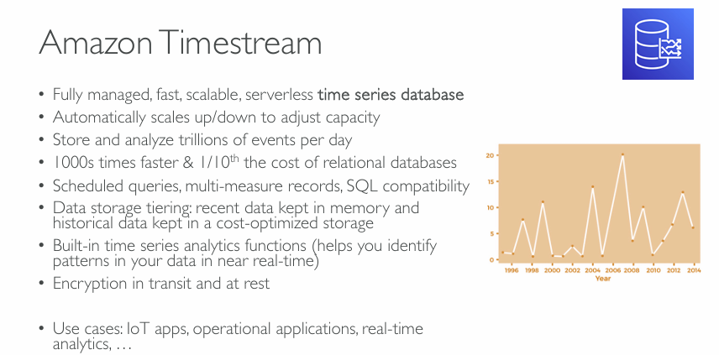  
**What is Amazon Timestream?**

**Amazon Timestream** is designed to **store, analyze, and query time series data** generated by IoT devices, applications, and infrastructure monitoring systems. Time series data is timestamped and often arrives in high volumes, with frequent writes and occasional reads for analytics.

**🔍 Deep Dive into Key Features**

**⚙️ Fully Managed & Serverless**

* No provisioning or managing servers.
* Automatically handles:
  + **Scaling** (up/down based on ingestion volume),
  + **Replication**,
  + **Availability** across AZs.

**📈 Optimized for Time Series Data**

* **Trillions of events per day** supported.
* Suitable for:
  + Sensor/IoT data,
  + Application telemetry,
  + Metrics from monitoring systems (e.g., Prometheus, Telegraf).

**💨 Performance & Cost Efficiency**

* Claimed to be **1000× faster** and **1/10th the cost** of traditional relational databases for time-series workloads.
* Achieved by:
  + Purpose-built storage engine optimized for append-only workloads.
  + Compression and tiered storage strategies.

**🧠 Built-in Time Series Functions**

* Native support for **analytic functions**:
  + Moving averages
  + Smoothing
  + Interpolation
  + Trend analysis
* Enables **real-time dashboards**, anomaly detection, and predictive maintenance.

**📊 SQL-Compatible**

* Uses **SQL-like query language**, which:
  + Supports scheduled queries
  + Allows **multi-measure records** (e.g., multiple metrics per timestamp)
  + Easily integrates with BI tools and JDBC clients

**💾 Data Tiering**

* **Memory tier** for recent “hot” data → fast access
* **Magnetic tier** for older “cold” data → cost savings
* Automatic tiering policy reduces operational overhead and cost.

**🔐 Security**

* **Encryption in transit** (TLS) and **at rest** (KMS integration).
* Fine-grained IAM policies for access control.
* CloudTrail logging for audit.

**🧰 Use Cases**

* IoT telemetry (temperature, pressure, GPS, etc.)
* DevOps and application performance monitoring
* Smart city or industrial analytics
* Real-time metrics from containerized apps or microservices

**🏗️ Amazon Timestream – Architecture Breakdown**

This architecture diagram shows how Timestream fits into a **real-time data processing pipeline**:

**Ingestion Sources:**

* **AWS IoT Core**: Sensor/device data sent via MQTT/HTTP to AWS cloud.
* **Kinesis Data Streams**: Real-time streaming data (e.g., app logs, metrics).
* **Amazon MSK (Kafka)**: Custom streaming pipelines.
* **Prometheus / Telegraf**: Used for monitoring infrastructure and sending metrics.

**Preprocessing:**

* **AWS Lambda**: Lightweight serverless compute layer for transformation/filtering before inserting into Timestream.
* **Kinesis Data Analytics (Apache Flink)**: Real-time stream processing (e.g., enrichment, aggregation).

**Storage:**

* **Amazon Timestream**: Central time series storage for analytics and querying.

**Analytics / Visualization:**

* **Amazon QuickSight**: Business intelligence dashboards and visualizations.
* **Amazon SageMaker**: ML model training or forecasting (e.g., time series prediction).
* **Grafana**: Real-time operational dashboards.
* **Any JDBC Tool**: Custom BI or SQL clients for ad-hoc analysis.

**📌 Strategic Architectural Notes**

1. **Lambda vs. Flink**:
   * Use Lambda for lightweight ETL, format translation.
   * Use Flink when real-time **aggregation, windowing, pattern detection**, or complex event processing is needed.
2. **Security**:
   * Integrate with **IAM for fine-grained access**, **KMS for encryption**, **CloudTrail for audit**.
   * VPC support to isolate Timestream traffic from public networks.
3. **High Availability**:
   * Multi-AZ replication is built-in.
   * No single point of failure in ingestion (Kinesis and MSK support fault tolerance).
4. **Cost Optimization**:
   * Timestream reduces cost by automatically tiering data.
   * You avoid running EC2/RDS or maintaining your own time series DB (e.g., InfluxDB, Prometheus TSDB).

**🧪 When to Use Amazon Timestream**

* You need **real-time analytics** on high-volume time series data.
* Your data follows a **high-write / low-read pattern**.
* You want **serverless scale** with low operational overhead.
* You're integrating with AWS-native analytics and monitoring tools.

🛑 **Avoid Timestream** for:

* General-purpose relational data
* Complex transactional workloads
* Applications needing strong referential integrity or joins across large datasets

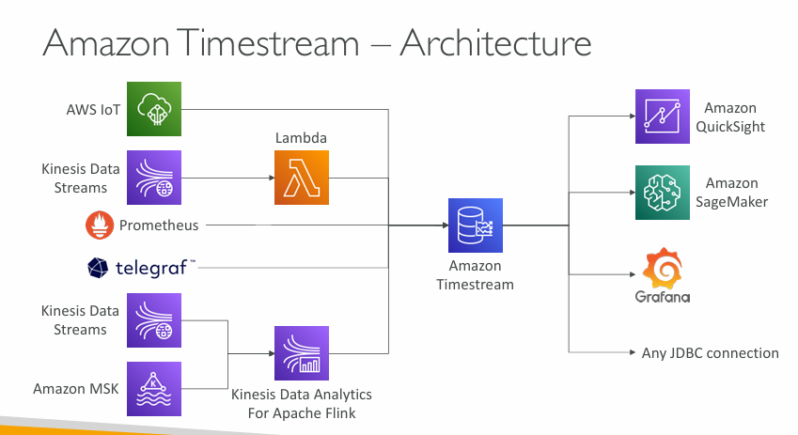

Section-22 – Data & Analytics:

**What is Amazon Athena?**

**Amazon Athena** is a **serverless query service** provided by AWS that allows you to **analyze data directly in Amazon S3 using SQL**.

**🧠 Simple Explanation:**

Think of Athena as a **magic SQL engine**:

* You store raw data (CSV, JSON, Parquet, logs, etc.) in S3.
* You write SQL queries to explore or analyze that data.
* Athena gives you instant answers — **no need to set up servers or databases**.

**⚙️ How it works:**

1. 🗂️ You put your data files into **Amazon S3**.
2. 📊 You define a **table schema** using SQL (like a virtual database).
3. ✍️ You run standard **SQL queries**.
4. 📈 Athena processes your query and returns results.
5. 💰 You only pay **per query, based on the amount of data scanned**.

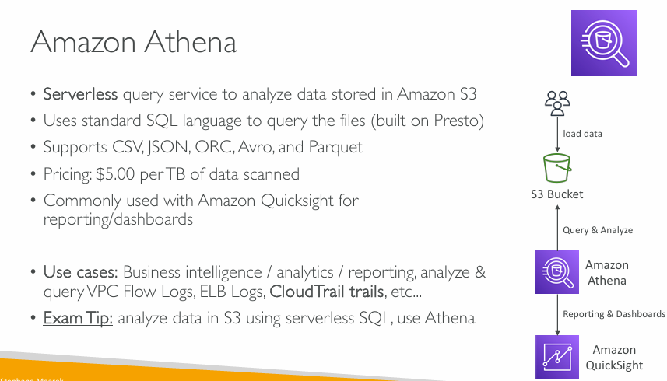  
Exam Tip: anytime you need to analyze data in Amazon S3 using a serverless SQL engine, you can think about, Athena.

**What is Amazon Athena?**

* **Serverless**: No infrastructure to manage; you just write and run SQL queries.
* **Built on Presto**: Uses the Presto distributed SQL engine under the hood.
* **Query data directly in S3**: No need to move or transform your data beforehand.

**📂 Supported File Formats**

* **CSV**
* **JSON**
* **ORC**
* **Avro**
* **Parquet** (highly recommended for performance and cost-efficiency)

**💵 Pricing**

* **$5.00 per TB of data scanned**
  + You can reduce cost by compressing, partitioning, and converting data to columnar formats like **Parquet**.

**📊 Common Use Case**

* Often paired with **Amazon QuickSight** for **visual reporting and dashboards**.

**🧠 Use Cases**

* Business intelligence and analytics
* Querying:
  + **VPC Flow Logs**
  + **ELB Logs**
  + **CloudTrail trails**
  + Other structured or semi-structured log data in S3

**📝 Exam Tip**

If a question asks how to **analyze data stored in S3 using SQL**, **Athena** is the answer.

**🧭 Athena Workflow (from diagram)**

1. **Data is loaded** into an **S3 bucket**.
2. **Amazon Athena** queries the data using SQL.
3. Data can be sent to **Amazon QuickSight** for dashboards and reports.

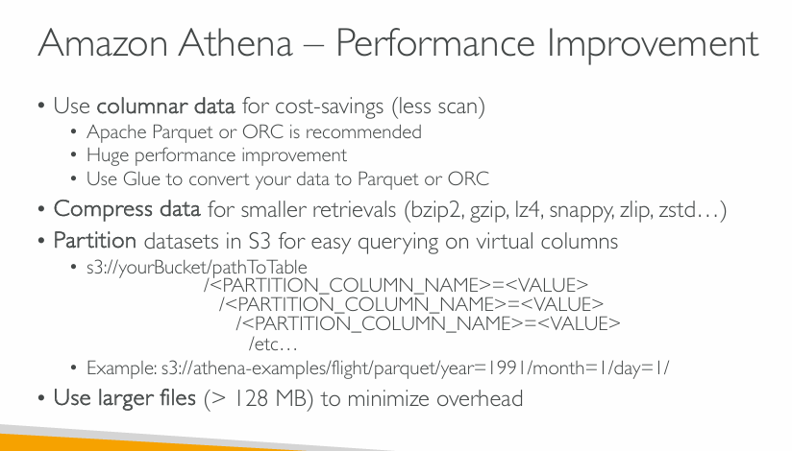  
**Amazon Athena – Performance Tips**

**🧱 1. Use Columnar Data (Parquet or ORC)**

* Reduces the amount of data scanned → **lower costs**
* Offers a **significant performance boost**
* Use **AWS Glue** to convert raw data formats (e.g., CSV/JSON) into **Parquet or ORC**

**Difference from CSV or JSON:**

* **CSV/JSON** are **row-based** formats: all the data for a row is stored together.
* **Parquet/ORC** are **column-based** formats: all values of one column are stored together.

**📦 2. Compress Data**

* Reduces the size of data being scanned
* Supported compression formats:
  + bzip2, gzip, lz4, snappy, zlib, zstd

**🗂️ 3. Partition Datasets in S3**

* Organize data by virtual columns to **speed up queries**
* Example S3 key structure:

sql

CopyEdit

s3://yourBucket/pathToTable/

year=1991/

month=1/

day=1/

* Queries on year, month, or day scan only matching partitions

**📁 4. Use Larger Files**

* Files **larger than 128 MB** reduce overhead
* Fewer metadata reads → better performance

**✅ Summary**

| **Optimization** | **Benefit** |
| --- | --- |
| Parquet/ORC format | Less data scanned |
| Compression | Smaller retrievals |
| Partitioning | Fast filtering with S3 keys |
| Large files (>128MB) | Lower latency & overhead |

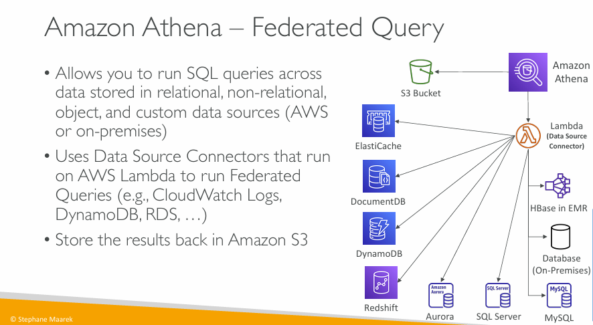

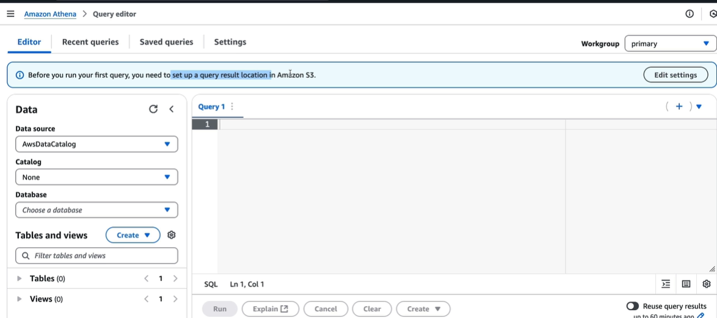  
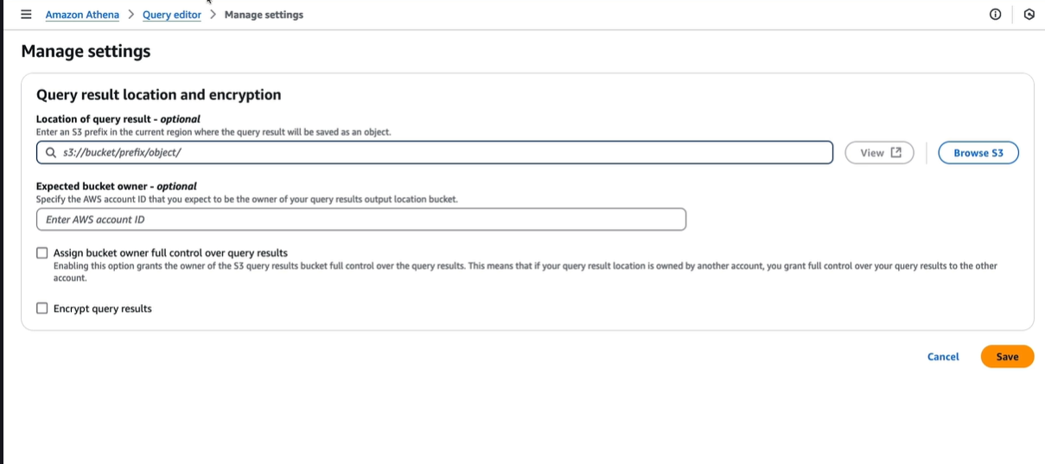

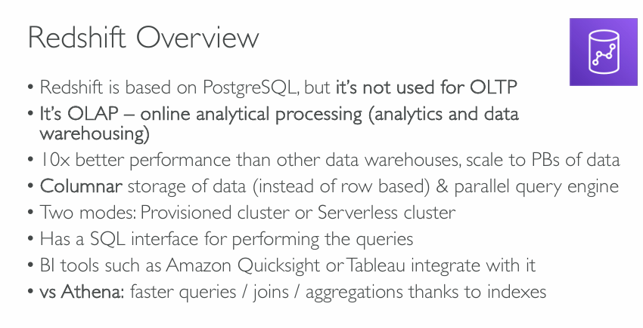  
**What is Amazon Redshift?**

Amazon Redshift is a **cloud-based data warehouse** service offered by AWS. It’s designed for **analyzing large amounts of data quickly and efficiently**.

**🧬 “Redshift is based on PostgreSQL, but it’s not used for OLTP”**

* **PostgreSQL** is a popular open-source database, and Redshift is built on top of it.
* But Redshift is **not** made for **OLTP** (Online Transaction Processing), which is what normal applications (e.g., banking, shopping) use.
* Instead, Redshift is optimized for **OLAP** (Online Analytical Processing), which is used for **analytics and reporting**, not for inserting/updating data often.

**📊 “It’s OLAP – online analytical processing (analytics and data warehousing)”**

* **OLAP** means it’s designed for **analyzing huge volumes of data**, like:
  + Finding trends
  + Running reports
  + Generating dashboards
* Used by data analysts, data engineers, and BI (Business Intelligence) tools.

**⚡ “10x better performance than other data warehouses, scale to PBs of data”**

* It can process **petabytes (PB)** of data — that’s millions of gigabytes!
* It’s also very fast — **up to 10 times faster** than many traditional systems, because of smart architecture and parallel processing.

**🧱 “Columnar storage of data (instead of row based) & parallel query engine”**

* Redshift stores data in **columns**, not rows.
  + Imagine a spreadsheet: instead of reading row by row, it reads column by column.
  + This is **much faster** for analytics (e.g., summing a column of sales).
* It uses a **parallel query engine**, which means it **splits big queries into smaller pieces** and runs them in parallel, speeding things up.

**🛠️ “Two modes: Provisioned cluster or Serverless cluster”**

* **Provisioned**: You manually choose how much capacity (CPU, memory) you want.
* **Serverless**: Redshift automatically figures out how much power is needed and scales for you.
  + Easier for beginners or unpredictable workloads.

**💬 “Has a SQL interface for performing the queries”**

* You can use **SQL** (Structured Query Language), just like in MySQL or PostgreSQL.
* No need to learn a new language — you write queries in SQL to explore and analyze data.

**📈 “BI tools such as Amazon QuickSight or Tableau integrate with it”**

* Redshift works well with **business intelligence tools**:
  + **Amazon QuickSight** (AWS BI tool)
  + **Tableau**, **Power BI**, etc.
* These tools can **visualize the data** and **create dashboards** directly from Redshift.

**🆚 “vs Athena: faster queries / joins / aggregations thanks to indexes”**

* **Athena** is another AWS service for querying data stored in S3 using SQL.
* **Redshift is faster** than Athena when it comes to:
  + Complex **joins** (combining tables)
  + **Aggregations** (sum, average, count)
* Why? Because Redshift uses **indexes** and optimized storage, while Athena reads raw files from S3.

**🧠 Summary**

Amazon Redshift is a **high-performance analytics tool** built for running complex SQL queries on massive datasets — ideal for data warehousing and business intelligence.

Let me know if you want a comparison table with **Athena, RDS, and Redshift** or a **real-world use case** (e.g., sales analytics)!

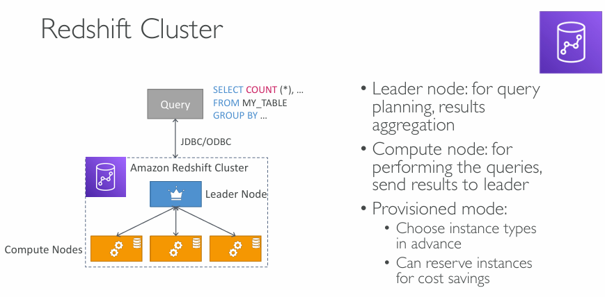  
**What is a Redshift Cluster?**

A **Redshift cluster** is a group of computing resources (nodes) that work together to run your SQL queries efficiently. It includes two main types of nodes:

**🧠 1. Leader Node (the “brain” of the cluster)**

* Handles **query planning and coordination**.
* When you send a SQL query (like SELECT COUNT(*) FROM my_table GROUP BY ...), it **parses and optimizes** the query.
* It **sends instructions** to compute nodes and **collects results** from them.
* Think of it as the **project manager**.

**🧮 2. Compute Nodes (the “workers” of the cluster)**

* These are the **machines that actually perform the heavy lifting**:
  + They **scan the data**, run filters, joins, and aggregations.
  + They send **intermediate results** back to the leader node.
* The more compute nodes you have, the more **parallelism** and the **faster** your query can be executed.

**🔌 JDBC/ODBC Interfaces**

* Applications (like BI tools or custom apps) **connect to Redshift via JDBC/ODBC drivers**.
* These drivers allow your application to talk to Redshift using standard SQL.

**🛠️ Provisioned Mode (Manual Setup Mode)**

* You **manually choose** the size and number of nodes.
* You can select:
  + Instance types (CPU, RAM, disk size)
  + Number of nodes
* You can also **reserve instances** (for 1 or 3 years) to **save money** compared to pay-as-you-go pricing.

**🧩 Summary**

| **Component** | **Role** |
| --- | --- |
| Leader Node | Plans the query, gathers results |
| Compute Nodes | Do the actual data processing |
| Provisioned Mode | Manual control over resources |

**🔄 Workflow:**

1. You send a SQL query.
2. Leader node plans the execution.
3. Compute nodes execute the steps.
4. Results are sent back to the leader, then to you.

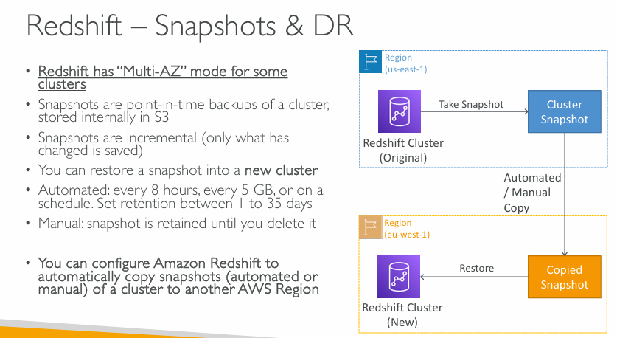

**What’s this slide about?**

This slide explains **how Redshift protects your data** using **snapshots** and how it supports **disaster recovery (DR)** by allowing you to **restore or copy** these snapshots across AWS regions.

**🧷 Key Concepts Explained:**

**🔄 Snapshots**

* **What are they?**  
  Snapshots are like **backups** — they capture the state of your Redshift cluster at a specific point in time.
* **Stored in:**  
  **Amazon S3** (internally managed by AWS).
* **Incremental:**  
  Only changes since the last snapshot are saved, which **reduces storage and costs**.
* **Types of snapshots:**
  + **Automated:** Taken on a schedule (e.g., every 8 hours, every 5 GB of changes).
  + **Manual:** You create them yourself, and they stay forever unless deleted.

**🚀 Restoring from a Snapshot**

* You can take a snapshot and use it to **create a new Redshift cluster** — for example, if your original cluster is lost or corrupted.

**📍 Cross-Region Copy for Disaster Recovery**

* You can **automatically or manually copy snapshots** to a **different AWS region**.
* This helps with **Disaster Recovery (DR)** — if a whole region goes down, your data is safe elsewhere.
* Example:
  + You take a snapshot in **us-east-1**
  + Copy it to **eu-west-1**
  + You can **restore it into a new cluster** in **eu-west-1**

**🗃️ Multi-AZ Mode**

* Some Redshift clusters support **Multi-AZ** (availability zones), improving **fault tolerance and availability**.

**🔁 Snapshot Retention**

* **Automated snapshots**:
  + You can set how long to keep them (1 to 35 days).
* **Manual snapshots**:
  + Stay until **you delete them**.

**🧩 Visual Breakdown of the Diagram:**

| **Element** | **Description** |
| --- | --- |
| **Redshift Cluster (Original)** | The active data warehouse you're running. |
| **Cluster Snapshot** | A point-in-time backup taken from the original cluster. |
| **Copied Snapshot** | A copy of the snapshot, stored in a different region for DR. |
| **Redshift Cluster (New)** | A new cluster that can be **restored** from the copied snapshot in case of disaster. |

**✅ Why it matters:**

* Helps **protect your data**
* Ensures **business continuity** if something goes wrong
* Meets **compliance** and **backup** policies
* Supports **geographic redundancy**

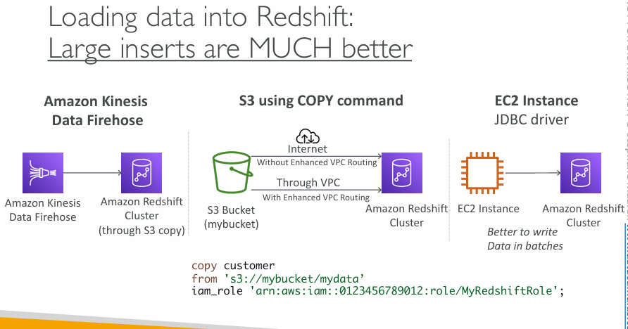

**“Loading Data into Redshift: Large Inserts are MUCH better”**

This slide is about the **different ways to load data** into an Amazon Redshift cluster and emphasizes that **loading large batches of data at once is more efficient** than sending many small inserts.

**🚪 1. Amazon Kinesis Data Firehose → Redshift**

* **Kinesis Data Firehose** is a fully managed service that **automatically delivers streaming data** to destinations like Redshift.
* It **buffers the data**, then **loads it in larger chunks**, which is faster and more efficient.
* Under the hood, it uses the **S3 + COPY command** method (explained below).
* Good for **real-time analytics** on streaming data (like logs, metrics, events).

**📥 2. S3 using COPY command (RECOMMENDED)**

* **Best practice** for bulk loading.
* Steps:
  1. Store data files (CSV, Parquet, JSON, etc.) in an **Amazon S3 bucket**.
  2. Use Redshift’s COPY command to load that data into tables.
* It’s **highly optimized for performance**: uses parallel processing and is much faster than inserting row-by-row.
* Example:

sql

CopyEdit

copy customer

from 's3://mybucket/mydata'

iam_role 'arn:aws:iam::0123456789012:role/MyRedshiftRole';

* Two ways data can travel from S3 to Redshift:
  1. **Over the internet** (less secure, unless encrypted)
  2. **Through VPC (Virtual Private Cloud)** using Enhanced VPC Routing (more secure and private)

**🖥️ 3. EC2 Instance using JDBC Driver**

* You can run a script or application on an EC2 instance that uses **JDBC/ODBC** to insert data into Redshift.
* This is **okay for small updates**, but it’s **slow for large data loads**.
* Why? Because each SQL INSERT statement processes just one or a few rows — this creates **too many round-trips**, slowing things down.
* ✅ **Tip:** Always try to batch multiple rows together when using this approach.

**✳️ Summary (When to use what):**

| **Method** | **Best For** | **Performance** | **Notes** |
| --- | --- | --- | --- |
| **Kinesis Firehose** | Real-time streaming | Fast & automated | Uses S3 and COPY under the hood |
| **S3 + COPY** | Bulk/batch loads | **Very fast** ✅ | Recommended for loading large data |
| **JDBC from EC2** | Small/manual loads | Slow ❌ | Only insert in **batches**, not one-by-one |

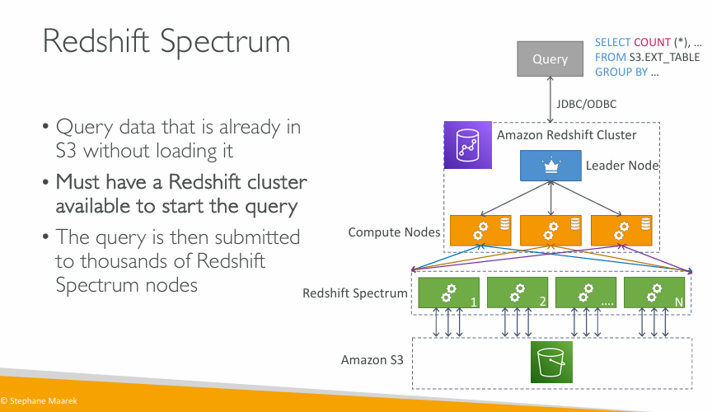

**What is Redshift Spectrum?**

**Redshift Spectrum** is a feature that allows you to:

* **Query data directly from S3** without having to load it into Redshift.
* This is useful when dealing with **huge volumes of raw or archived data** stored in S3, like logs or external data lakes.

**🔄 How does it work (Step-by-step)?**

1. ✅ **You must have an active Redshift cluster** — the query starts from the Redshift cluster.
2. 🟦 The **Leader Node** receives the SQL query via JDBC/ODBC.
3. 🟧 The Leader Node sends the query to Redshift’s **Compute Nodes**.
4. 🟩 These nodes **delegate the query to Redshift Spectrum nodes**, which are a separate fleet of thousands of servers managed by AWS.
5. 📦 Redshift Spectrum nodes read the data **directly from S3** in parallel.
6. 🔁 Results are sent back up: from Spectrum → Compute Nodes → Leader Node → Your client.

**🧠 Key Concepts in Simple Terms**

| **Concept** | **Explanation** |
| --- | --- |
| **No Data Loading** | You don’t need to COPY data into Redshift. It queries it **in-place** from S3. |
| **Redshift Cluster Required** | You still need a Redshift cluster running — the Spectrum nodes only help execute part of the query. |
| **Highly Scalable** | Spectrum can use **thousands of nodes**, so it's fast even for massive data. |
| **Example Query** | SELECT COUNT(*) FROM S3.EXT_TABLE GROUP BY ... – the table here is external (stored in S3). |

**🔍 When to Use Redshift Spectrum?**

Use Spectrum when:

* You have **cold data** in S3 that you don’t want to load into Redshift yet.
* You want to **join Redshift tables with S3 data**.
* You’re building a **data lake architecture** with Athena, Glue, and Redshift.

**⚠️ Important Notes**

* Spectrum queries can be **slower than querying internal Redshift tables**, especially for small data sets.
* You should use **partitioning and columnar formats** (like Parquet) for best performance on S3.
* You are **charged based on the amount of S3 data scanned**, so filter early in queries (e.g., with WHERE clauses).

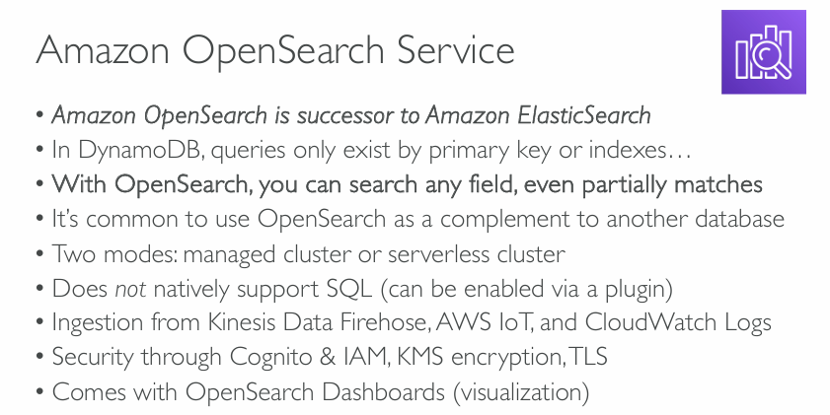

**What is Amazon OpenSearch?**

* **Amazon OpenSearch** is the **new version (successor)** of what used to be **Amazon Elasticsearch**.
* It is a **search and analytics engine** — great for fast full-text search, log analysis, monitoring, and more.

**🔍 Why use OpenSearch?**

Unlike **DynamoDB** (which only allows fast lookups using primary keys or indexes), OpenSearch allows you to:

* 🔎 **Search any field**, even if the match is **partial**.
  + For example, searching "user" will match "username", "user_id", etc.
  + Very useful when you don’t know the exact data or want to run keyword searches like in Google.

**🧩 Typical Use Case**

* OpenSearch is often used **alongside another database**.
  + E.g., store your structured data in DynamoDB or RDS.
  + Send logs, errors, and analytics to OpenSearch for **powerful search and visualization**.

**⚙️ Modes of Operation**

* 🔹 **Managed Cluster**: You manage the size, instance types, scaling, etc.
* 🟣 **Serverless Cluster**: No need to manage infrastructure — AWS handles scaling and resource allocation.

**🧑‍💻 Querying**

* OpenSearch **doesn’t use SQL** by default.
  + It uses its own query language (DSL - Domain Specific Language).
  + But you **can enable SQL support** using a plugin if you’re more comfortable with SQL.

**📥 Data Ingestion**

* OpenSearch can receive data from various AWS services:
  + **Kinesis Data Firehose** (for streaming data)
  + **AWS IoT** (for sensor/device data)
  + **CloudWatch Logs** (for system logs)

**🔐 Security**

OpenSearch supports **strong security options**, such as:

* **Cognito + IAM** for user access and identity control
* **KMS encryption** to secure data at rest
* **TLS encryption** to secure data in transit

**📊 Visualization**

* OpenSearch comes with built-in **Dashboards** (similar to Kibana).
  + You can create real-time graphs, filters, and log search panels — great for monitoring systems and business intelligence.

**✅ Summary**

| **Feature** | **Explanation** |
| --- | --- |
| **Search Power** | Search any field, not just keys |
| **SQL?** | Not native, but possible with plugin |
| **Security** | Cognito, IAM, KMS, TLS |
| **Ingest Sources** | Firehose, IoT, CloudWatch |
| **Modes** | Managed or serverless |
| **Visualization** | Built-in dashboards |

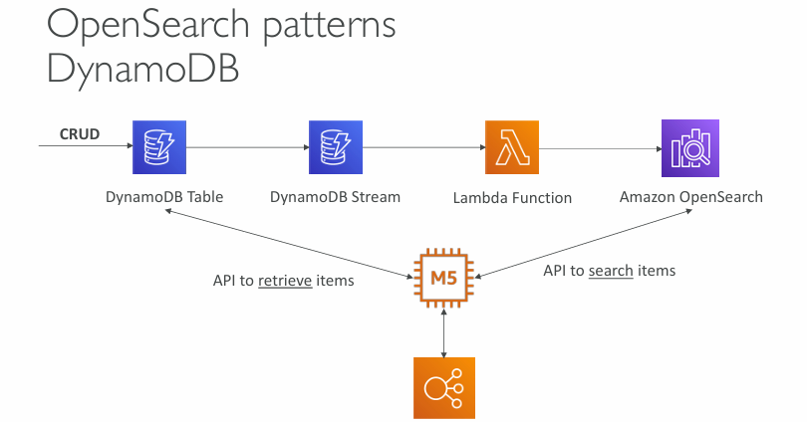

**What’s Happening Here?**

This architecture shows a **common pattern** for combining **DynamoDB** (fast NoSQL database) with **Amazon OpenSearch** (search engine).

Why?  
Because DynamoDB is great for fast lookups by key, but **not** good for flexible search (e.g., full-text, partial matches, filtering on multiple fields). That’s where OpenSearch helps!

**🔁 Step-by-Step Workflow**

**1. CRUD Operations on DynamoDB Table**

* You perform regular operations (Create, Read, Update, Delete) on a **DynamoDB table**.

**2. DynamoDB Streams Trigger Lambda**

* DynamoDB **Streams** capture changes (insert/update/delete) in real-time.
* These changes are **automatically sent to an AWS Lambda function**.

**3. Lambda Function Updates OpenSearch**

* The **Lambda function** takes the changed data and **indexes it into Amazon OpenSearch**.
  + This ensures OpenSearch is always synced with the DynamoDB table.

**4. User/Service Uses Two APIs**

An app (shown as "M5" here) interacts with both services:

* 🔍 **Search API → OpenSearch**
  + Used when the user wants to search across multiple fields or use full-text search.
* 📥 **Retrieve API → DynamoDB**
  + Once the desired item's ID is found via OpenSearch, the app retrieves **full details from DynamoDB**, which is optimized for fast lookups.

**✅ Why This Pattern Is Powerful**

| **Need** | **Solution** |
| --- | --- |
| Fast primary key access | DynamoDB |
| Flexible search (e.g. partial match, filter, sort) | OpenSearch |
| Real-time sync between the two | DynamoDB Stream + Lambda |

**🔐 Security & Scalability**

* This pattern **scales automatically** using serverless components like Lambda.
* IAM roles ensure each component only accesses what it should.

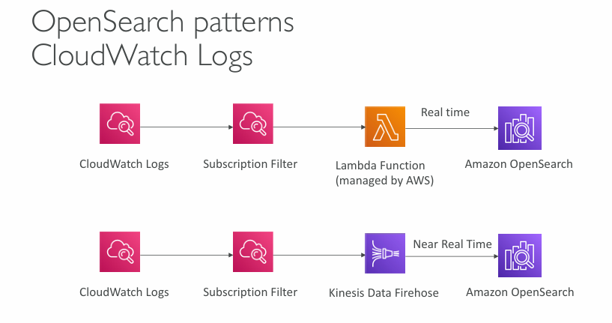

**Goal:**

To **search, analyze, and visualize** your application logs (stored in **CloudWatch Logs**) using **Amazon OpenSearch**.

**🔄 Two Common Patterns for Ingesting Logs**

**☁️ 1. Real-Time Ingestion via Lambda**

**Flow:**

pgsql

CopyEdit

CloudWatch Logs → Subscription Filter → Lambda → OpenSearch

* **CloudWatch Logs**: Stores logs from EC2, Lambda, ECS, etc.
* **Subscription Filter**: A rule that lets you send selected logs somewhere else.
* **Lambda (Managed by AWS)**: Processes the logs (e.g., transforms them) and **pushes to OpenSearch** immediately.
* **Amazon OpenSearch**: Now you can search and visualize the logs in real-time.

🔸 **Use case**: When you need **low-latency log ingestion** (e.g., for alerting, troubleshooting).

**🔁 2. Near Real-Time Ingestion via Kinesis Data Firehose**

**Flow:**

pgsql

CopyEdit

CloudWatch Logs → Subscription Filter → Kinesis Firehose → OpenSearch

* **Kinesis Data Firehose**: A managed service that buffers, transforms, and streams data to OpenSearch.
* **Near Real-Time**: Firehose delivers data with slight delay (typically seconds to minutes).
* It's more **scalable** and **cost-efficient** than Lambda for high-volume logs.

🔸 **Use case**: Ideal for **large-scale log ingestion** where near real-time is acceptable.

**🛠️ Summary Table**

| **Feature** | **Lambda (Real-Time)** | **Firehose (Near Real-Time)** |
| --- | --- | --- |
| Latency | Very low (ms) | Slight delay (seconds) |
| Scalability | Limited (per Lambda limits) | High |
| Managed by AWS | Yes | Yes |
| Data transformation | Yes (in Lambda) | Yes (via Firehose processors) |
| Cost | Can get expensive | More cost-effective for volume |

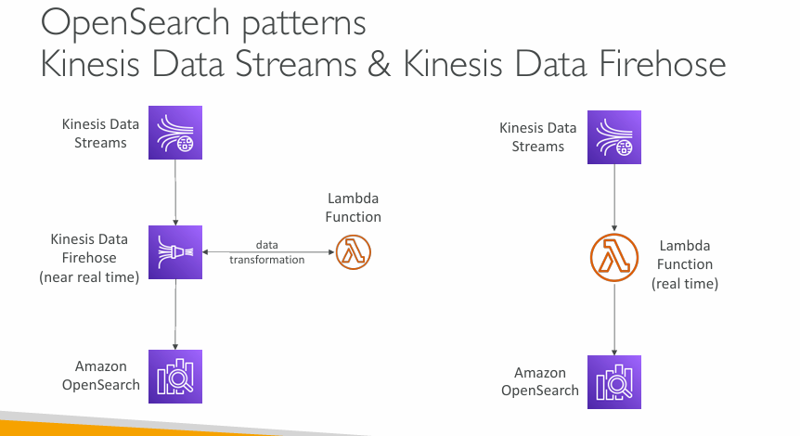

**Purpose:**

To **ingest streaming data into Amazon OpenSearch**, so you can **search and analyze** it in near real-time or real-time.

**🔁 Two Common Patterns**

**🔸 1. Kinesis Data Streams → Firehose → OpenSearch (Left Side)**

**Flow:**

cpp

CopyEdit

Kinesis Data Streams → Kinesis Firehose → OpenSearch

↑

(optional)

Lambda for transformation

* **Kinesis Data Streams**: Collects real-time event data (e.g., logs, clickstreams, metrics).
* **Kinesis Data Firehose**: A **fully managed** service that:
  + Buffers and batches data.
  + Optionally transforms data using a **Lambda function**.
  + Delivers it **near real-time** to OpenSearch.
* **Amazon OpenSearch**: Stores and indexes the data so it can be searched and visualized.

✅ **Pros**:

* Simple setup.
* Scalable.
* Lower cost for large volumes.

⏱️ **Latency**: *Near real-time* (few seconds delay due to buffering).

**🔸 2. Kinesis Data Streams → Lambda → OpenSearch (Right Side)**

**Flow:**

Kinesis Data Streams → Lambda → OpenSearch

* Lambda consumes events from the stream **immediately**.
* You control how data is transformed and sent to OpenSearch.
* Suitable when **real-time** processing is critical.

✅ **Pros**:

* Full control over transformation.
* **Real-time** data ingestion.

⚠️ **Cons**:

* More complex logic needed in Lambda.
* You manage failure retries, batching, etc.

**🛠️ When to Use Which?**

| **Use Case** | **Use Firehose Pattern** | **Use Lambda Pattern** |
| --- | --- | --- |
| Large-scale ingestion, simple flow | ✅ Yes | ❌ Not ideal |
| Need real-time ingestion | ⚠️ Slight delay (buffering) | ✅ Best suited |
| Custom processing or transformation | ✅ via Firehose Lambda (optional) | ✅ Full control in Lambda |
| Cost-efficient, hands-off processing | ✅ Yes | ❌ Slightly higher cost |

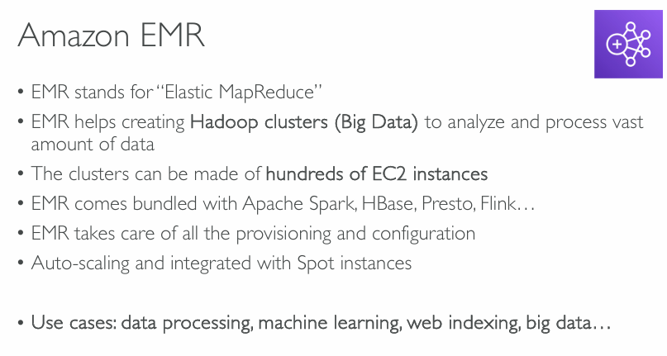

**What is Amazon EMR?**

**Amazon EMR (Elastic MapReduce)** is a **managed cluster platform** that simplifies running **big data frameworks** like Apache Hadoop and Apache Spark on AWS to process and analyze vast amounts of data.

**🏗️ Key Features**

**✅ Hadoop Clusters (Big Data)**

* EMR is primarily used to build Hadoop-based clusters.
* Ideal for large-scale data processing tasks.

**✅ Scalable EC2-based Clusters**

* You can run EMR clusters on **hundreds (or thousands)** of EC2 instances.
* Supports both on-demand and **Spot Instances** for cost efficiency.

**✅ Pre-installed Big Data Frameworks**

* EMR comes with:
  + **Apache Spark** (for fast in-memory data processing)
  + **Apache HBase** (NoSQL database)
  + **Presto** (distributed SQL query engine)
  + **Apache Flink** (streaming data processing)

**✅ Managed Provisioning**

* AWS handles:
  + EC2 provisioning
  + Networking setup
  + Software installation
  + Cluster configuration

**✅ Auto-scaling**

* EMR can automatically scale the number of nodes based on workload.
* Easily integrates with **Spot Instances** to reduce cost.

**🎯 Use Cases**

* **Data Processing**: Batch processing of logs, files, and datasets.
* **Machine Learning**: Training ML models on large datasets with Spark MLlib.
* **Web Indexing**: Crawling and indexing web content (e.g., like a search engine).
* **Big Data Analytics**: ETL pipelines, data lake analysis, business intelligence.

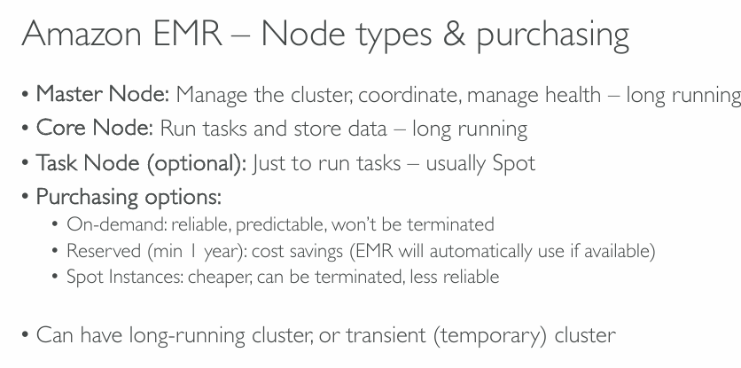

**What is Amazon EMR?**

Amazon EMR is a service used to process **big data** using frameworks like Apache Spark, Hadoop, etc. It runs on a **cluster** of EC2 instances (virtual machines), which are grouped into **node types**.

**🖥️ Node Types in Amazon EMR**

**1. Master Node**

* Acts as the **brain of the cluster**.
* **Controls and coordinates** everything: schedules jobs, monitors health, and tracks progress.
* Only **one Master Node** per cluster.
* **Runs for the entire lifespan** of the cluster (long-running).

**2. Core Node**

* These nodes **perform tasks** (like processing data).
* Also responsible for **storing data** using HDFS (Hadoop Distributed File System).
* There can be **multiple core nodes**.
* They are **always running** until the cluster is terminated.

**3. Task Node (Optional)**

* These nodes are **only for extra computing power** (they do not store data).
* They can **help process jobs faster** by taking on additional tasks.
* These are **not required**, but useful when you want to scale processing temporarily.
* Usually **Spot Instances** (more about this below).

**💰 Purchasing Options for Nodes**

There are three ways you can pay for the EC2 instances in an EMR cluster:

**a. On-Demand Instances**

* **Pay by the hour/second**.
* **Reliable and stable** – won't be stopped by AWS.
* Good for **critical workloads**.

**b. Reserved Instances**

* You **reserve capacity** for at least **1 year**.
* **Cheaper** than On-Demand (cost-effective).
* EMR **automatically uses them** if available.

**c. Spot Instances**

* **Very cheap**, often 70–90% less than On-Demand.
* But they are **not guaranteed** – AWS can **terminate them anytime**.
* Great for **non-critical tasks** (like Task Nodes).

**🕒 Cluster Duration Types**

You can run EMR clusters in two ways:

* **Long-running cluster**: Stays up continuously for ongoing jobs or frequent processing.
* **Transient cluster**: Starts up, runs a job, and then shuts down (temporary use).

**📌 Summary:**

| **Node Type** | **Role** | **Runs Tasks** | **Stores Data** | **Common Purchase Type** |
| --- | --- | --- | --- | --- |
| Master Node | Manages cluster & jobs | No | No | On-Demand/Reserved |
| Core Node | Runs & stores data | Yes | Yes | On-Demand/Reserved |
| Task Node | Extra task processing | Yes | No | Spot |

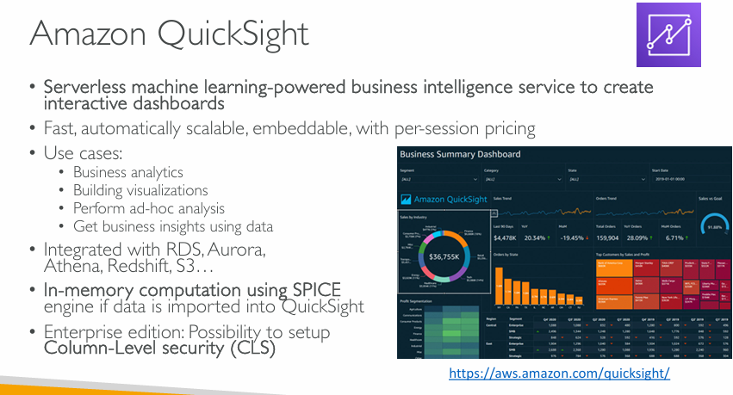

**What is Amazon QuickSight?**

* **Serverless**: You don't need to manage any servers or infrastructure.
* **Machine learning-powered**: It can automatically find patterns in your data and provide insights.
* **Business Intelligence (BI)** tool: Used to create **interactive dashboards**, **graphs**, and **reports** to help understand your data.

**🚀 Key Features**

**1. Scalable and Fast**

* Automatically scales depending on the number of users and data size.
* Fast data rendering with **per-session pricing** (you only pay when someone accesses the dashboard).

**2. Use Cases**

* **Business analytics**: Helps companies analyze their performance and KPIs.
* **Visualizations**: Charts, graphs, maps, etc., are created easily.
* **Ad-hoc analysis**: You can explore data on the fly without predefined queries.
* **Business insights**: Discover trends, forecasts, and key metrics.

**🔗 Data Integration**

QuickSight can pull data from:

* **Amazon RDS**
* **Aurora**
* **Athena**
* **Redshift**
* **S3 (Simple Storage Service)**

It can also connect to on-premises databases, Excel files, and more.

**⚡ SPICE Engine**

* SPICE = **Super-fast, Parallel, In-memory Calculation Engine**
* If you import data into QuickSight, it uses SPICE for:
  + Faster performance
  + In-memory processing
  + High scalability
* Think of SPICE like a turbocharged RAM engine that helps analyze data very quickly without querying the original data source every time.

**🔐 Security**

* In **Enterprise Edition**, you can apply **Column-Level Security (CLS)**:
  + Restrict which users can view specific columns.
  + Useful for sensitive data like salary, PII, etc.

**📊 Dashboard Example (Image on Slide)**

* Shows various data visuals like:
  + KPIs (e.g., total revenue, growth)
  + Sales by industry
  + Orders by category
  + Regional performance
* This kind of dashboard can help decision-makers quickly understand their business metrics.

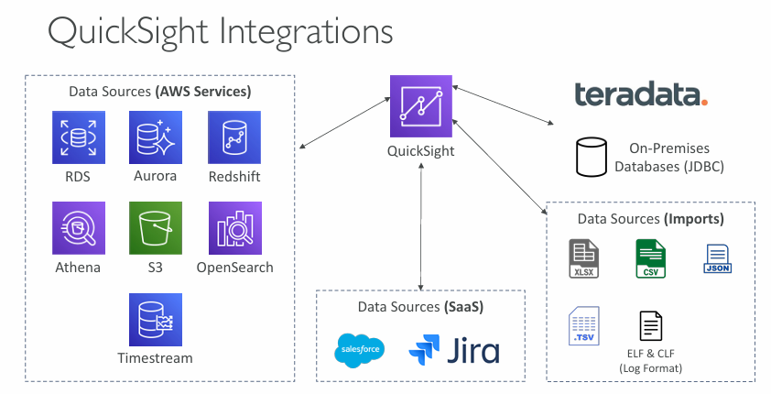

**What is Being Shown?**

QuickSight connects to **a wide range of data sources**, which are categorized into:

**1. AWS Services (Native Integrations)**

These are services inside AWS that QuickSight connects to **directly**:

* **RDS**: Relational Database Service (e.g., MySQL, PostgreSQL, SQL Server).
* **Aurora**: High-performance version of RDS.
* **Redshift**: Data warehouse for large-scale analytics.
* **Athena**: Query data directly in S3 using SQL.
* **S3**: Amazon’s object storage system (e.g., CSV/JSON files).
* **OpenSearch**: Used for full-text search and analytics.
* **Timestream**: Purpose-built time series database (good for IoT or logs).

**2. SaaS Applications**

QuickSight can also pull data from **Software as a Service (SaaS)** platforms:

* **Salesforce**: CRM data like leads, contacts, sales.
* **Jira**: Project management and issue tracking data.

**3. On-Premises Databases (via JDBC)**

* QuickSight supports JDBC connections to databases that are **not in the cloud**, such as:
  + **Teradata** or any local enterprise databases.
* Useful when a business hasn’t moved all its data to the cloud yet.

**4. File-Based Imports**

You can **upload data files** to QuickSight directly:

* **Excel (XLSX)**
* **CSV**
* **JSON**
* **TSV**
* **ELF/CLF log formats** (used in server logs)

This is helpful for **ad hoc analysis** or **proof of concept** dashboards.

**🧠 Why This Matters**

QuickSight is **very flexible** with data sources:

* You can combine **cloud**, **local**, and **third-party** data in one place.
* Great for companies that have **hybrid** (cloud + on-prem) data environments.
* This versatility allows QuickSight to act as a **central analytics hub**.

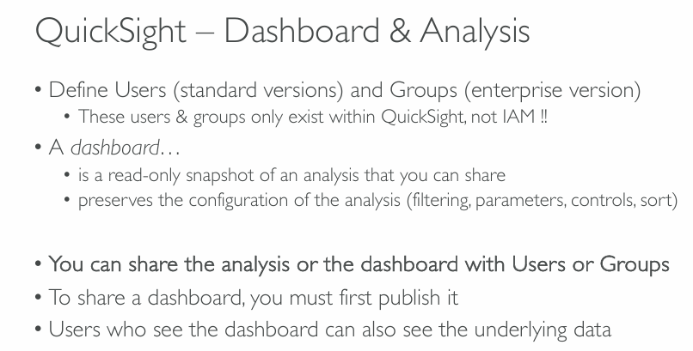

**Users and Groups in QuickSight**

* In **QuickSight**, you create **Users** and **Groups**:
  + **Users**: People who can access QuickSight.
  + **Groups**: Collections of users for easier access control.
* These are **not the same as AWS IAM users** – they only exist **inside QuickSight**.
* Groups are available only in the **Enterprise Edition** of QuickSight.

**📊 What is a Dashboard?**

* A **dashboard** is a **read-only version** of a report (called an **analysis**).
* It’s meant for **sharing insights** without letting others modify anything.
* A dashboard **preserves filters, parameters, sorting, and other settings** you’ve applied during your analysis.

**🔁 Analysis vs. Dashboard**

* An **analysis** is editable. You build and explore data here.
* A **dashboard** is a published, fixed version that others can view but not change.

**👥 Sharing**

* You can **share** either the **analysis** (editable) or the **dashboard** (read-only) with others.
* You must **publish the dashboard** before you can share it.
* When users see a dashboard, they can also access the **underlying data** it is connected to.

**📌 Summary**

| **Term** | **Purpose** | **Editable?** | **Requires Publishing?** |
| --- | --- | --- | --- |
| Analysis | Explore and build visual reports | Yes | No |
| Dashboard | Share snapshot of the analysis | No | Yes |

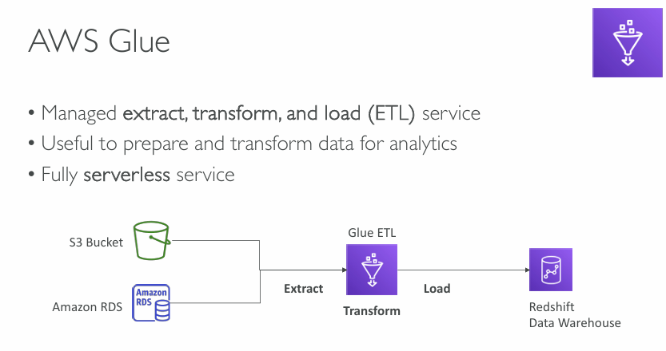

**Users and Groups in QuickSight**

* In **QuickSight**, you create **Users** and **Groups**:
  + **Users**: People who can access QuickSight.
  + **Groups**: Collections of users for easier access control.
* These are **not the same as AWS IAM users** – they only exist **inside QuickSight**.
* Groups are available only in the **Enterprise Edition** of QuickSight.

**📊 What is a Dashboard?**

* A **dashboard** is a **read-only version** of a report (called an **analysis**).
* It’s meant for **sharing insights** without letting others modify anything.
* A dashboard **preserves filters, parameters, sorting, and other settings** you’ve applied during your analysis.

**🔁 Analysis vs. Dashboard**

* An **analysis** is editable. You build and explore data here.
* A **dashboard** is a published, fixed version that others can view but not change.

**👥 Sharing**

* You can **share** either the **analysis** (editable) or the **dashboard** (read-only) with others.
* You must **publish the dashboard** before you can share it.
* When users see a dashboard, they can also access the **underlying data** it is connected to.

**📌 Summary**

| **Term** | **Purpose** | **Editable?** | **Requires Publishing?** |
| --- | --- | --- | --- |
| Analysis | Explore and build visual reports | Yes | No |
| Dashboard | Share snapshot of the analysis | No | Yes |

Would you like to see an example flow of creating and sharing a dashboard in QuickSight?

**You said:**

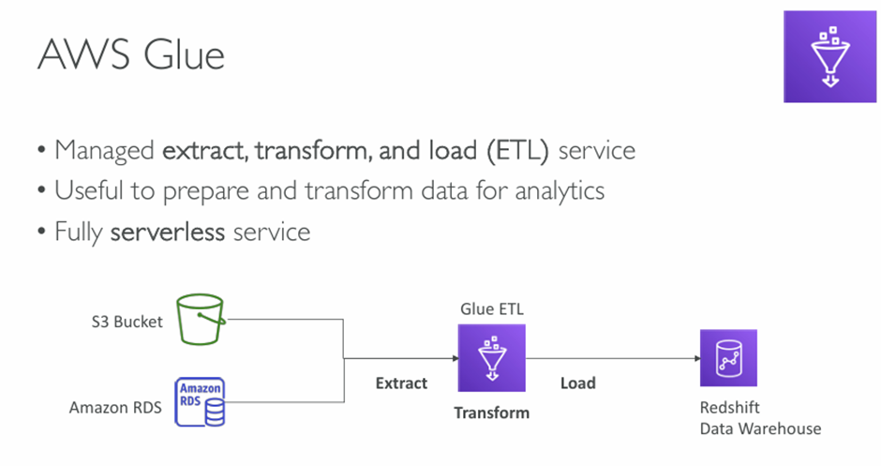

**ChatGPT said:**

This slide explains **AWS Glue** in a simple and visual way. Let me break it down for you in clear and easy-to-understand terms:

**💡 What is AWS Glue?**

**AWS Glue** is a fully **managed ETL service**, which means it helps you do:

* **E**xtract – pull data from different sources like S3 or RDS.
* **T**ransform – clean, filter, reformat, or enrich the data.
* **L**oad – put the processed data into another place like Redshift for analysis.

**⚙️ Key Features**

* **Managed**: You don’t have to set up or manage servers.
* **Serverless**: AWS handles all the infrastructure for you.
* **Analytics-ready**: Helps you prepare your data so that it can be easily used in tools like Amazon QuickSight, Redshift, or Athena.

**🔁 Visual Workflow Explanation**

1. **Data Sources**:
   * Data is stored in **Amazon S3** (object storage) or **Amazon RDS** (relational database).
2. **Glue ETL Job**:
   * It **extracts** the raw data from S3 or RDS.
   * It **transforms** the data—like removing errors, converting formats, or combining tables.
   * It **loads** the final, clean data into **Amazon Redshift**, a data warehouse used for analytics.

**📌 Why Use AWS Glue?**

* Ideal for **data engineers** and **analysts** who want to automate data preparation.
* **No server setup**, so it’s easy to scale.
* Works well with other AWS services like S3, RDS, Redshift, Athena, etc.

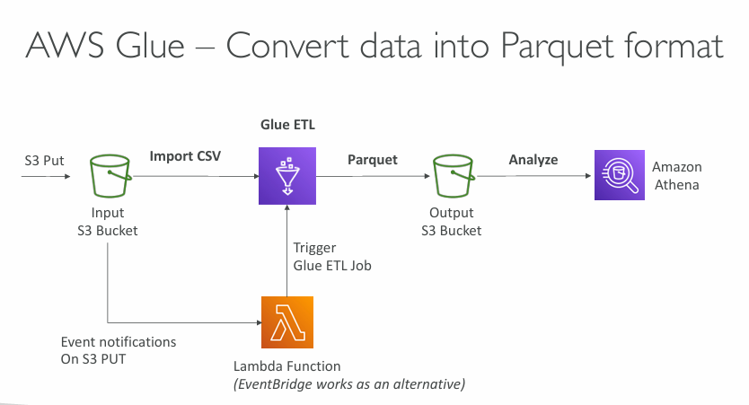

**AWS Glue Workflow – CSV to Parquet Conversion**

1. **📤 S3 Put (CSV Upload)**  
   A CSV file is uploaded to an **S3 input bucket**.
2. **🔔 Event Notification Trigger**
   * S3 triggers a **Lambda function** when a new file is uploaded.
   * Alternatively, you can use **Amazon EventBridge** for triggering.
3. **🚀 Lambda Function**
   * The Lambda function triggers a **Glue ETL job**.
   * The job will **import the CSV file**, process it, and convert it into Parquet format.
4. **🔄 Glue ETL Job**
   * **Import CSV**: Reads the raw CSV file.
   * **Transform to Parquet**: Converts it into the more efficient **Parquet** format (columnar storage, optimized for performance and cost).
   * **Write to Output Bucket**: Saves the transformed Parquet file into an **output S3 bucket**.
5. **🔍 Analyze with Athena**
   * **Amazon Athena** queries the Parquet data directly from the output S3 bucket using SQL-like syntax.
   * Fast, serverless, and cost-effective.

**📝 Why Use Parquet Format?**

* **Highly compressed** and **columnar**, which means:
  + Faster queries
  + Lower storage costs
  + Optimized for analytics

**✅ Summary**

| **Step** | **Component** | **Purpose** |
| --- | --- | --- |
| 1 | S3 (CSV Upload) | Raw data input |
| 2 | Lambda / EventBridge | Trigger Glue job |
| 3 | AWS Glue | Convert CSV → Parquet |
| 4 | Output S3 | Stores optimized data |
| 5 | Athena | Query and analyze data |

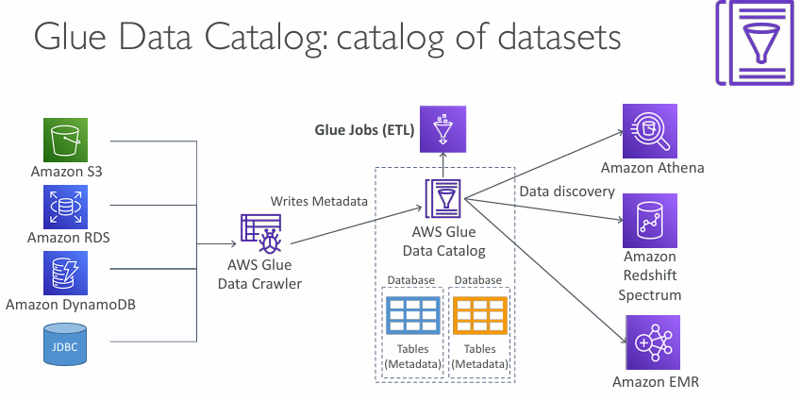

**What is AWS Glue Data Catalog?**

A **centralized metadata catalog** that stores structural and operational metadata for your data assets across various AWS services.

**🔄 Workflow Overview**

1. **📥 Data Sources**
   * Includes **Amazon S3**, **Amazon RDS**, **Amazon DynamoDB**, and **JDBC**-compatible databases.
2. **🧭 AWS Glue Data Crawler**
   * Automatically connects to the data sources.
   * Scans and identifies schema and metadata.
   * **Writes metadata** (tables, schema, formats, partitions) to the **AWS Glue Data Catalog**.
3. **📂 AWS Glue Data Catalog**
   * Stores the metadata in **Databases** and **Tables** (not actual data).
   * Used for **data discovery** and schema tracking.
4. **🔧 AWS Glue Jobs (ETL)**
   * Uses the metadata from the catalog to extract, transform, and load data.
   * Enhances automation and transformation workflows.
5. **🔍 Integration with Analytics Services**
   * **Amazon Athena**: Run SQL queries on data in S3 using cataloged metadata.
   * **Amazon Redshift Spectrum**: Extends Redshift to query data directly from S3.
   * **Amazon EMR**: Use with Hadoop/Spark to read metadata for processing.

**✅ Benefits**

| **Feature** | **Benefit** |
| --- | --- |
| Automated Crawling | No manual schema creation |
| Central Metadata Store | Easier data governance |
| Integration | Works seamlessly with Athena, EMR, Redshift |
| Cost-Efficient | Serverless, no infrastructure to manage |

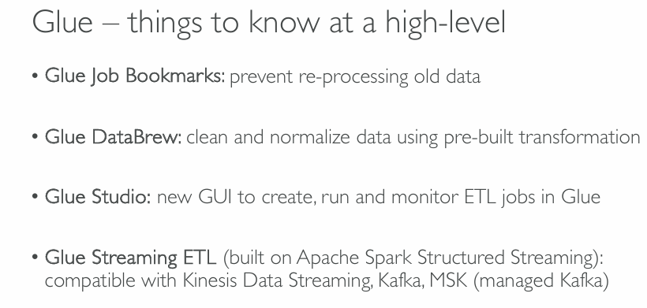

**Glue – Key Things to Know**

1. **🧷 Glue Job Bookmarks**
   * **Purpose**: Prevents reprocessing of previously processed data.
   * **Use Case**: Ideal for incremental ETL jobs where you only want to process new data.
2. **🧪 Glue DataBrew**
   * **Purpose**: Cleans and normalizes data using **pre-built transformations**.
   * **GUI-based tool**: No coding required.
   * **Use Case**: Data analysts preparing data for ML or reporting.
3. **🖥️ Glue Studio**
   * **Purpose**: Provides a visual interface (GUI) to create, run, and monitor Glue ETL jobs.
   * **Use Case**: Developers and data engineers can build pipelines without deep Spark knowledge.
4. **🌊 Glue Streaming ETL**
   * **Built on**: **Apache Spark Structured Streaming**.
   * **Purpose**: Process real-time streaming data.
   * **Compatible with**:
     + Amazon Kinesis Data Streams
     + Apache Kafka
     + Amazon MSK (Managed Streaming for Kafka)
   * **Use Case**: Real-time log ingestion, event processing, fraud detection.

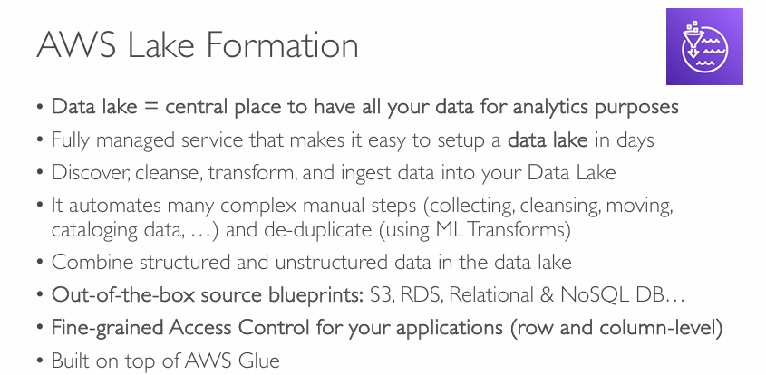

**AWS Lake Formation – Key Concepts**

1. **📍 Data Lake = Central Data Hub**
   * Acts as a **single repository** for all your data used for analytics.
2. **🔧 Fully Managed Service**
   * Quickly sets up a secure data lake in **days** instead of weeks/months.
3. **🔍 Data Discovery & Transformation**
   * Capabilities to **discover, cleanse, transform, and ingest** data.
   * Great for preparing data for **ML, BI, and analytics** tools.
4. **⚙️ Automates Complex Steps**
   * Handles:
     + Collection
     + Cleansing
     + Movement
     + Cataloging
     + De-duplication (with ML Transforms)
5. **🧩 Supports Mixed Data Types**
   * Works with both **structured** and **unstructured** data.
6. **📦 Built-in Source Blueprints**
   * Predefined connectors for:
     + S3
     + RDS
     + Relational Databases
     + NoSQL Databases
7. **🔐 Fine-Grained Access Control**
   * Enforces **row-level and column-level** security.
   * Ensures sensitive data is only accessed by authorized users/apps.
8. **🧱 Built on AWS Glue**
   * Extends Glue's capabilities with **data lake-specific features**.

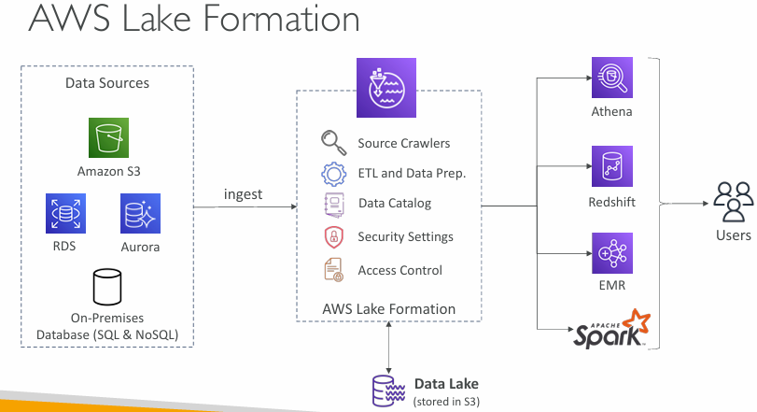  
**What is a Data Lake?**

A **data lake** is a centralized repository where you store **structured**, **semi-structured**, and **unstructured** data **at any scale** (like logs, images, audio, relational data, etc.), often in raw format.

**🔶 What is AWS Lake Formation?**

AWS Lake Formation is a **managed service** to:

* **Ingest** data from various sources,
* **Organize** it,
* **Secure** it,
* And make it **available for analytics**.

**🔹 Step-by-step Flow from the Diagram**

**1. Data Sources**

Lake Formation pulls data from multiple sources:

* ✅ **Amazon S3** (files, logs, objects)
* ✅ **Amazon RDS / Aurora** (relational databases)
* ✅ **On-premises databases** (SQL or NoSQL)

👉 This data is **ingested** (moved/imported) into Lake Formation.

**2. AWS Lake Formation (Middle Box)**

Once data is ingested, Lake Formation handles the following:

**🔍 Source Crawlers**

* Automatically scan your data
* Identify structure (columns, types)
* Create metadata

**⚙️ ETL and Data Prep**

* Clean, filter, and transform raw data using services like **Glue**
* Convert to optimized formats (like Parquet)

**🗃️ Data Catalog**

* Central registry of your datasets (like a table of contents)
* Describes what data is available and where

**🔐 Security Settings & Access Control**

* Fine-grained access to data (who can access what and how)
* Integrates with **IAM** and **Lake Formation permissions**

**3. Data Lake (Storage)**

* Final, processed data is stored in **Amazon S3**
* This is your **data lake**

**4. Analytics & Access by Users**

Now the processed, secured, and cataloged data can be used by services:

**📊 Amazon Athena**

* Serverless SQL queries on S3 data

**🧠 Amazon Redshift**

* For powerful data warehousing and complex analytics

**⚡ Amazon EMR (Apache Spark, Hadoop)**

* For big data processing, ML pipelines, etc.

All of these services fetch the data from the **catalogued Data Lake** and make it accessible to **users or analysts**.

**✅ Why Use AWS Lake Formation?**

* 📉 Reduces time to set up a data lake from months to days
* 🔐 Helps enforce consistent data security
* 🧩 Seamless integration with other AWS services
* 🚀 Supports massive scale data analytics and machine learning

**📌 Summary**

| **Component** | **Role in Lake Formation** |
| --- | --- |
| Data Sources | Where the raw data comes from |
| Lake Formation | Central manager for cataloging, ETL, security |
| Data Lake (S3) | Where the clean/organized data is stored |
| Athena/Redshift/EMR | How users analyze or process that data |

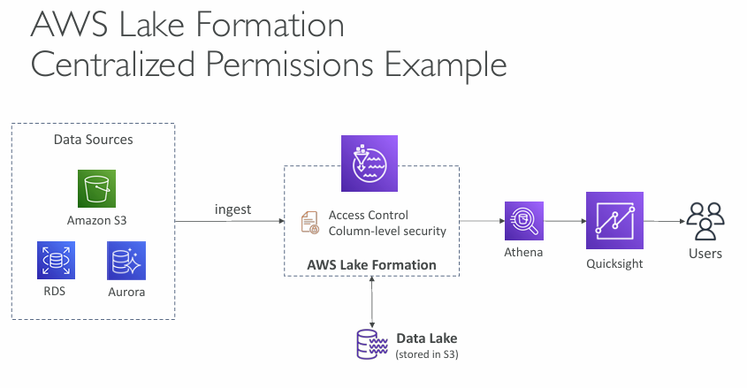  
**What’s the Goal of This Architecture?**

To ingest data from multiple sources into a **centralized data lake**, enforce **strict access permissions**, and allow **secure analytics and visualization** for users using services like **Athena** and **QuickSight**.

**🔄 Step-by-Step Explanation**

**1. Data Sources**

Your raw data can come from:

* 🪣 **Amazon S3** – Object storage (e.g., CSV, JSON, logs)
* 🧩 **RDS & Aurora** – Relational databases

👉 This data is **ingested** into the Lake Formation pipeline.

**2. AWS Lake Formation – Central Engine**

After ingesting data, Lake Formation handles:

**🔐 Access Control**

* Who can access which data?
* Works at **database, table, row, and column** level.
* Example: Finance team may see "salary" column, HR may not.

**📏 Column-level Security**

* You can **mask or restrict certain columns** in a table.
* Very useful for **compliance and data governance** (like GDPR, HIPAA).

**🗃️ Data Lake (in S3)**

* The transformed and secured data is stored in S3 as the **centralized data lake**.

**3. Analytics & Visualization**

**🔍 Amazon Athena**

* Run SQL queries on the S3 data using the catalog and security rules defined by Lake Formation.

**📊 Amazon QuickSight**

* AWS's BI (Business Intelligence) tool for creating **dashboards, graphs, and reports**.
* It connects to Athena and respects the same access policies from Lake Formation.

**4. Users**

* Business analysts, data scientists, or any internal users
* Get **secured and filtered data access**, based on their permissions
* No need to manually manage S3 access for each user or group

**🔐 Why Centralized Permissions Matter?**

Imagine:

* You have 100 datasets, used by 10 departments
* You want to restrict access by **team, department, or role**
* Doing this manually per S3 bucket, per user is messy

✅ **Lake Formation centralizes and simplifies this** — one place to set and manage rules.

**📌 Summary Table**

| **Component** | **Role** |
| --- | --- |
| S3, RDS, Aurora | Raw data sources |
| Lake Formation | Ingests data, manages centralized permissions, secures columns |
| S3 Data Lake | Stores cleaned and secured data |
| Athena | Runs queries on data lake |
| QuickSight | Builds dashboards & visual reports |
| Users | Access data securely, only what they're allowed to see |

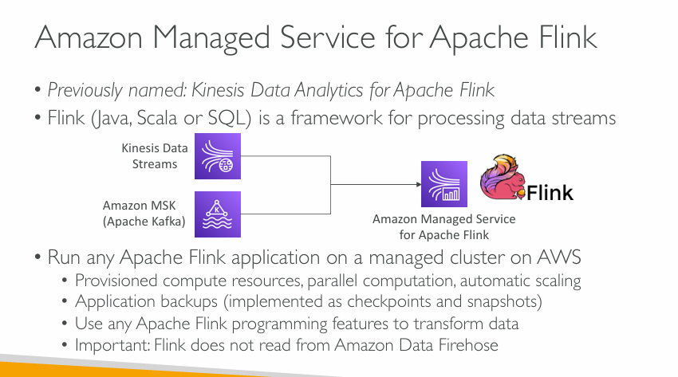

**What is Apache Flink?**

Apache Flink is an **open-source framework** for **processing data streams in real-time**.

* Think of it like a machine that continuously **reads incoming data**, **processes it immediately**, and **outputs results** — all within milliseconds.
* It supports writing programs in **Java, Scala, or SQL**.

**🔁 Real-time Data Sources**

You can feed live data into Flink from:

* 🔹 **Kinesis Data Streams** – AWS service to capture real-time data (like logs, events, clicks).
* 🔹 **Amazon MSK (Managed Streaming for Kafka)** – AWS-managed version of Apache Kafka, a widely used data streaming platform.

**⚙️ Amazon Managed Service for Apache Flink**

Instead of you setting up and managing Flink clusters (which is hard), AWS does it for you:

* ✅ **Provisioned compute**: AWS automatically provides computing power.
* ✅ **Parallel computation**: Processes data across multiple nodes in parallel — faster and scalable.
* ✅ **Automatic scaling**: Handles spikes in traffic by adding/removing resources.
* ✅ **Backups**: Uses **checkpoints** and **snapshots** to resume processing if something fails.

You can use **any standard Flink code** (no need to change your programs) on this managed service.

**🚫 Important Note**

**Flink does *not* read data from Amazon Kinesis Data Firehose.**

So if you're using Firehose (which buffers and sends data to destinations like S3), Flink can't process that directly — it works with **raw streams**, not delivery services.

**🧑‍💻 Use Cases**

Some real-world applications:

* Fraud detection in bank transactions.
* Real-time analytics dashboards.
* Clickstream analytics on websites.
* IoT sensor data processing.

**🔄 Simple Flow:**

pgsql

CopyEdit

1. Data is streamed in → (from Kinesis or Kafka)

2. Apache Flink processes it in real-time → (on AWS-managed infrastructure)

3. Results are produced → (and stored or sent somewhere)

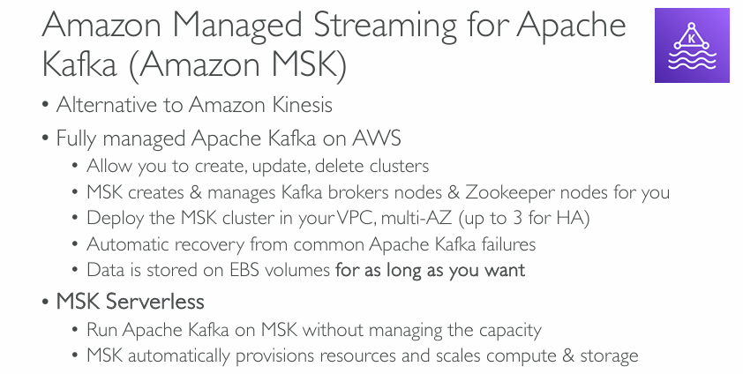

**What is Apache Kafka?**

Apache Kafka is an **open-source distributed platform** used for **building real-time data pipelines and streaming apps**. It allows you to **publish, store, and process** data streams at high throughput.

**✅ What is Amazon MSK?**

Amazon MSK is a **fully managed version of Kafka on AWS**, designed to make running Kafka easier.

**🌟 Key Features:**

* **Alternative to Amazon Kinesis**: If you're used to Kafka or need Kafka-specific features, this is a direct alternative to Kinesis.
* You can **create, update, and delete Kafka clusters** using AWS tools like the console or CLI.
* AWS **automatically sets up and manages**:
  + **Kafka broker nodes** (which process the data),
  + and **Zookeeper nodes** (which coordinate the cluster).
* You can **deploy MSK across multiple Availability Zones (up to 3)** for high availability (HA).
* **Automatic recovery** from common Kafka failures — reduces manual effort.
* **Data is stored on EBS (Elastic Block Store)** — persistent storage — and you can keep it **as long as you want**.

**🌀 MSK Serverless (Newer Feature)**

* With **MSK Serverless**, you don’t have to:
  + Choose instance types,
  + Set up capacity,
  + Scale storage.
* AWS **automatically handles everything**: compute, memory, and scaling.

👉 Just start producing or consuming data, and AWS scales the Kafka infrastructure behind the scenes.

**📊 Use Case Scenarios:**

* Log and event ingestion
* Real-time analytics
* Stream processing pipelines
* Connecting IoT devices

**📝 Summary:**

| **Feature** | **Traditional Kafka** | **Amazon MSK** |
| --- | --- | --- |
| Setup complexity | High | Low (AWS manages it) |
| Scaling | Manual | Auto (especially with serverless) |
| Zookeeper management | Manual | Done by AWS |
| High availability | Needs effort | Built-in across multiple AZs |
| Storage duration | Needs monitoring | As long as you want (EBS) |

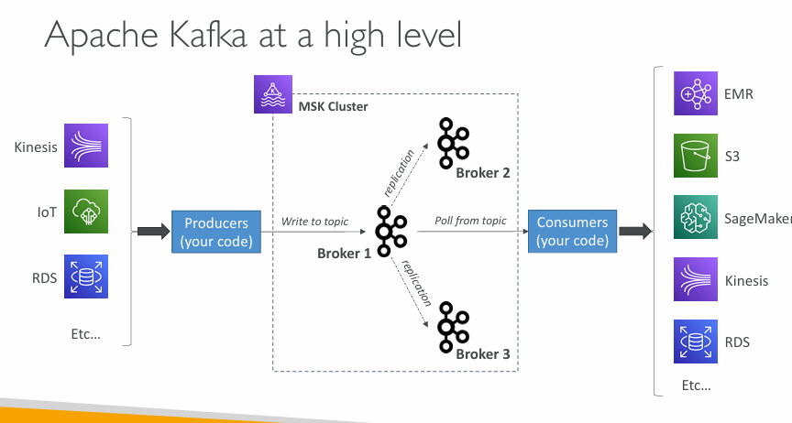

**Kafka in One Sentence:**

**Apache Kafka is like a messaging system that lets you stream data from producers to consumers in real time.**

**🧱 Key Components in the Diagram:**

**1. Producers (your code)**

* These are **your applications or services** that **send (write) data** into Kafka.
* Example: IoT sensors, logs from applications, or data from a database (like RDS or Kinesis).

**2. MSK Cluster (Kafka on AWS)**

* This is the **core Kafka system** running in the cloud using **Amazon MSK**.
* It contains **multiple "brokers"** (Broker 1, Broker 2, Broker 3).
  + Think of brokers as **servers that handle Kafka topics** (like post boxes for messages).
* Data is written to **topics** (a named stream of messages).
* **Replication**: Kafka copies data across brokers for **reliability**. If one broker fails, others still have the data.

**3. Consumers (your code)**

* These are your apps or services that **read (pull) data** from Kafka topics.
* You can **analyze**, **store**, or **further process** the data.

**🔄 Flow of Data:**

1. **Producers** send data → to **topics** in **Broker 1**.
2. Kafka automatically **replicates** that data to Broker 2 and Broker 3 (backup copies).
3. **Consumers** read data from the topic (e.g., a real-time dashboard or ML model).
4. Data can go into tools like:
   * **Amazon EMR** (big data processing),
   * **S3** (for storage),
   * **SageMaker** (for machine learning),
   * or **Kinesis**, **RDS**, etc.

**📊 Real-World Example:**

Imagine you have IoT devices in smart homes:

* Devices send temperature readings every second (producer).
* Kafka stores this data in real time.
* A machine learning model in SageMaker (consumer) uses that data to detect anomalies.
* The data is also saved to S3 for long-term storage.

**📝 Summary Table:**

| **Component** | **Role** |
| --- | --- |
| Producers | Write data to Kafka topics |
| Brokers | Store and replicate data in Kafka cluster |
| Topics | Logical groupings of related data/messages |
| Consumers | Read and process data from Kafka topics |

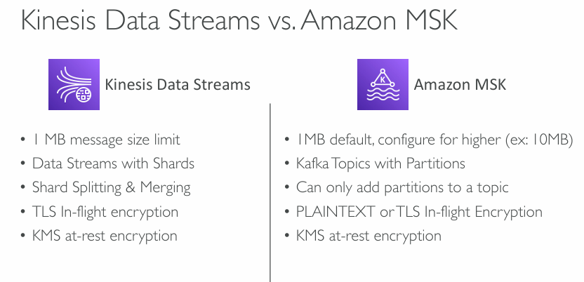

**Kinesis Data Streams (AWS-native solution)**

| **Feature** | **Explanation** |
| --- | --- |
| **1 MB message size limit** | Maximum size for each message is 1 MB. |
| **Streams use Shards** | Data is split into “shards,” which control parallelism and throughput. |
| **Shard Splitting & Merging** | You can scale by splitting/merging shards dynamically. |
| **TLS in-flight encryption** | Data is encrypted while being transmitted (TLS = Transport Layer Security). |
| **KMS at-rest encryption** | Data is encrypted while stored using AWS Key Management Service. |

**🧩 Amazon MSK (Managed Apache Kafka)**

| **Feature** | **Explanation** |
| --- | --- |
| **1 MB default, configurable** | Default is 1 MB, but you can increase (e.g., 10 MB). |
| **Topics with Partitions** | Kafka splits data by topics, each having partitions (like shards). |
| **Partitions only grow** | You can **add** partitions, but **not remove or merge** them easily. |
| **PLAINTEXT or TLS in-flight** | You can choose encrypted (TLS) or unencrypted (PLAINTEXT) transmission. |
| **KMS at-rest encryption** | Uses AWS KMS for encrypting stored data (like Kinesis). |

**🧠 Key Differences at a Glance:**

| **Capability** | **Kinesis Data Streams** | **Amazon MSK (Kafka)** |
| --- | --- | --- |
| Data Unit | Shards | Partitions |
| Message Size | 1 MB max | 1 MB default, can increase (e.g. 10 MB) |
| Scaling Flexibility | Shards can be split/merged | Partitions can only be added |
| Transport Encryption | TLS only | TLS or PLAINTEXT |
| Storage Encryption | KMS | KMS |

**✅ When to Use:**

* **Use Kinesis Data Streams** if you want a fully AWS-native, simple, auto-scalable stream ingestion service.
* **Use Amazon MSK** if you need Kafka's advanced features, ecosystem compatibility, and larger message size support.

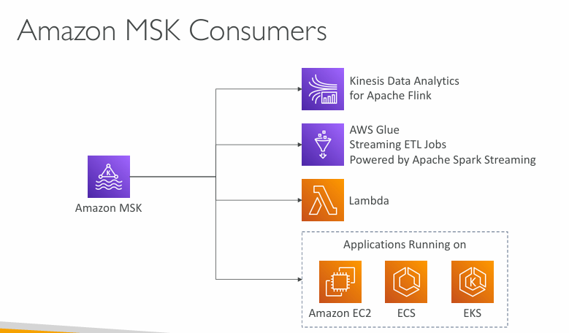

**Amazon MSK Consumers**

**🔗 1. Kinesis Data Analytics for Apache Flink**

* Runs **Apache Flink applications** on managed infrastructure.
* Ideal for **real-time stream processing**, transformations, aggregations, and complex event processing.

**🔗 2. AWS Glue (Streaming ETL)**

* Allows **ETL (Extract, Transform, Load)** jobs to process streaming data.
* Uses **Apache Spark Streaming** under the hood.
* Great for real-time **data enrichment and cleaning**.

**🔗 3. AWS Lambda**

* Can **trigger functions** directly from MSK topics (via Event Source Mapping).
* Best for **lightweight processing, alerts, or routing logic**.
* Serverless: scales automatically, no infrastructure to manage.

**🔗 4. Custom Applications running on:**

* **Amazon EC2** – Traditional VM-style deployments.
* **Amazon ECS (Elastic Container Service)** – Containerized apps (Docker) without needing to manage Kubernetes.
* **Amazon EKS (Elastic Kubernetes Service)** – Kubernetes-based deployment of Kafka consumers.

These apps can use **Kafka client libraries** to consume messages from MSK and do anything from analytics to ML model inference to real-time dashboards.

**✅ Summary:**

Amazon MSK is **highly flexible**, supporting a wide range of consumers:

| **Use Case** | **Consumer Service** |
| --- | --- |
| Real-time Analytics | Flink |
| ETL Pipelines | AWS Glue |
| Lightweight Functions | Lambda |
| Custom Code | EC2 / ECS / EKS |

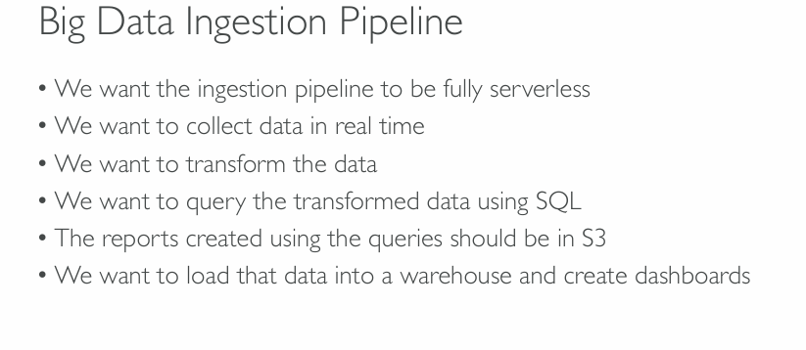

**Goal Breakdown and Matching AWS Services:**

| **Requirement** | **AWS Service** | **Description** |
| --- | --- | --- |
| **Fully serverless ingestion** | **Amazon Kinesis Data Streams** or **Amazon MSK Serverless** | Ingest real-time data without managing infrastructure. |
| **Collect data in real time** | Same as above (Kinesis/MSK) | Real-time streaming data collection. |
| **Transform the data** | **AWS Glue Streaming ETL** or **Kinesis Data Analytics (Apache Flink)** | Stream processing and transformation. Flink supports SQL, Java, Scala. |
| **Query transformed data using SQL** | **Amazon Athena** | Serverless querying directly on S3 data using SQL. |
| **Reports in S3** | **Athena + S3 Output location** | Query results automatically saved to S3. |
| **Load data into warehouse and dashboarding** | **Amazon Redshift Serverless** + **Amazon QuickSight** | Redshift for warehousing, QuickSight for visualization. |

**🛠️ Recommended Pipeline Architecture:**

1. **Data Ingestion**  
   → Use **Amazon Kinesis Data Streams** or **Amazon MSK Serverless** to ingest real-time data.
2. **Streaming Data Transformation**  
   → Use **AWS Glue Streaming ETL** or **Kinesis Data Analytics for Apache Flink** to clean, filter, or enrich the data.
3. **Data Storage**  
   → Transformed data is stored in **Amazon S3** as a Data Lake.
4. **Querying and Reporting**  
   → Use **Amazon Athena** to run SQL queries on S3 data.  
   → Query outputs (reports) are automatically stored in **S3**.
5. **Warehouse and Dashboard**  
   → Load structured data into **Amazon Redshift Serverless**.  
   → Visualize with **Amazon QuickSight** (fully serverless BI tool).

**🧩 Final Architecture (Summary):**

CopyEdit

[ Kinesis/MSK ]

↓

[ Glue Streaming ETL or Flink ]

↓

[ Transformed Data in S3 ] ←→ [ Athena for SQL Queries ]

↓

[ Redshift Serverless ] ←→ [ QuickSight Dashboards ]

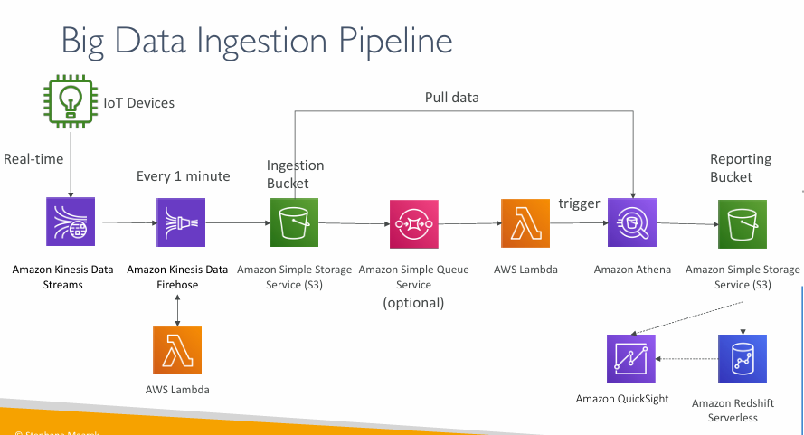

**1. IoT Devices (Real-time Data Generation)**

* These devices continuously generate data (e.g., temperature sensors, GPS trackers).
* Data needs to be collected, stored, processed, and visualized.

**🚀 2. Amazon Kinesis Data Streams**

* **Streams** receive data **in real-time** from IoT devices.
* Think of this as a **high-speed conveyor belt** where data flows continuously.

**⏱️ 3. Amazon Kinesis Data Firehose**

* **Batches and delivers data** every 1 minute (or configurable interval).
* It **buffers, transforms (if needed), and stores** the data in a destination — here it is **Amazon S3**.

**🪣 4. Amazon S3 (Ingestion Bucket)**

* This is the **temporary storage location** for incoming data.
* Acts as a landing zone where raw data is stored before processing.

**📥 5. Amazon SQS (Optional Step)**

* SQS (Simple Queue Service) is used to **decouple** processing logic.
* Instead of processing data immediately, it gets put into a **queue** and handled when ready.

**🧠 6. AWS Lambda (Trigger Function)**

* Once new data is in S3 (or SQS), Lambda is **automatically triggered**.
* It runs a small piece of code to **clean**, **filter**, or **trigger downstream services**.

**🔍 7. Amazon Athena**

* Athena is a **serverless query engine** that lets you **analyze data directly from S3 using SQL**.
* Lambda can trigger Athena to run queries on the newly added data.

**📦 8. Amazon S3 (Reporting Bucket)**

* Results from Athena queries (like summaries or reports) can be stored in a different S3 bucket.
* This makes it easy to share or archive processed data.

**📊 9. Amazon QuickSight**

* AWS business intelligence tool used to **visualize data** from Athena or Redshift.
* Helps teams create dashboards and gain insights.

**🗄️ 10. Amazon Redshift Serverless**

* Redshift is a **data warehouse** for running complex queries across large datasets.
* Serverless version auto-scales and doesn't need manual provisioning.
* Useful for deep analysis, BI tools, or machine learning.

**💡 Summary: End-to-End Flow**

plaintext

CopyEdit

IoT Device ➝ Kinesis Streams ➝ Firehose ➝ S3 (Ingestion)

⤷ Optional: Lambda or SQS ➝ Lambda ➝ Athena ➝ S3 (Reporting)

⤷ QuickSight / Redshift

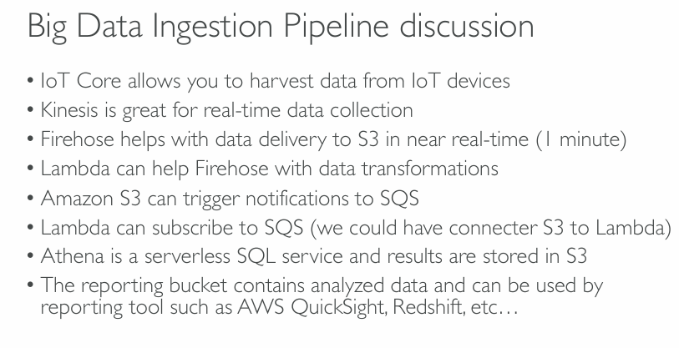

**Component-wise Explanation:**

**1. IoT Core**

* **Purpose:** Collect data from smart devices (sensors, meters, trackers).
* It’s the **entry point** for the pipeline, where data originates.

**2. Kinesis Data Streams**

* **Use:** Handles **real-time data ingestion** (data flows in continuously).
* Like a live data feed that keeps receiving data without stopping.

**3. Kinesis Data Firehose**

* **Use:** Takes the streaming data and **delivers it to S3 every minute**.
* It acts like a **batch delivery truck**: it waits briefly, then ships data to storage.

**4. Lambda with Firehose**

* Firehose can trigger a **Lambda function** to **transform data** (e.g., filter, enrich) before saving it to S3.

**5. Amazon S3 & Notifications**

* Once data is in S3, it can **trigger events** (like notifying a queue system).
* Think of S3 as a **smart bucket** that can react when it receives new files.

**6. Amazon SQS (Optional)**

* **Use:** Acts like a buffer or waiting area for messages.
* S3 sends notifications here, and **Lambda can then process those messages**.

**7. Lambda (Triggering from SQS or S3)**

* Lambda can either:
  + Be triggered **directly by S3**
  + Or **subscribe to SQS**, pull messages, and run the logic

**8. Amazon Athena**

* **Use:** Run SQL queries on data stored in S3 (serverless).
* You don’t need a database. Just write SQL directly on your files (CSV, JSON, Parquet, etc.).

**9. Reporting Bucket**

* Stores the **results of Athena queries**.
* These are clean, structured results — ready for visualization.

**10. Reporting Tools (QuickSight, Redshift, etc.)**

* Read from the **Reporting Bucket**.
* Tools like:
  + **QuickSight:** Create dashboards, charts
  + **Redshift:** Run deeper analytics across huge datasets

**💬 Summary:**

This discussion helps you understand the **why and how** behind each service:

* **IoT → Kinesis → Firehose → S3 → (Optional: SQS) → Lambda → Athena → S3 (Reporting) → QuickSight/Redshift**

Each piece is **modular**, **serverless**, and **scalable** — ideal for a big data pipeline using AWS.

Section-23-Machine Learning

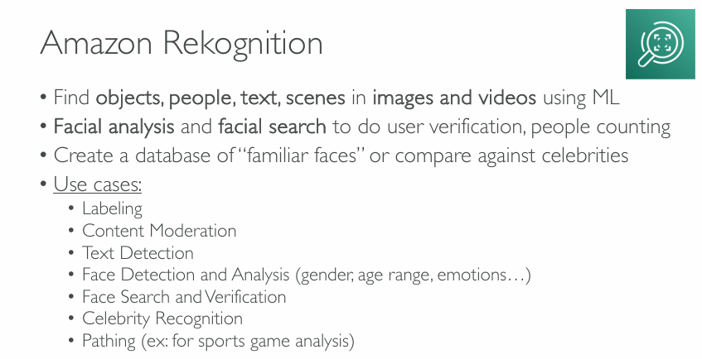

**What is Amazon Rekognition?**

Amazon Rekognition is an **AI-based image and video analysis service**. It helps you identify **objects, people, text, and scenes** using machine learning — without needing to build your own ML models.

**🧠 Key Features**

**1. Object & Scene Detection**

* Recognizes things like cars, animals, furniture, or indoor/outdoor scenes in images/videos.

**2. People & Facial Detection**

* Detects human faces and can analyze them to determine:
  + **Gender**
  + **Age range**
  + **Emotions** (happy, sad, angry, etc.)

**3. Facial Search & Verification**

* You can **match a face** against a known database (like for verifying identity).
* Great for **user login, access control**, or even security systems.

**4. Text in Images (OCR)**

* Finds and extracts **text from images**, like reading license plates or signs in a photo.

**5. Celebrity Recognition**

* Can detect and identify celebrities in media content.

**6. Content Moderation**

* Automatically flags **inappropriate content** in images and videos (violence, nudity, etc.)

**7. Pathing / Motion Tracking**

* Tracks **movement of people/objects** in videos (useful for sports analysis or surveillance).

**📌 Use Case Examples**

* **Labeling**: Tagging items in a photo automatically.
* **Moderation**: Filtering explicit content on social platforms.
* **Text Detection**: Reading signs in traffic footage.
* **Face Analysis**: Knowing age/gender distribution in a crowd.
* **Celebrity Match**: Media companies identifying public figures.
* **Security**: Face verification in secure zones or for logins.

**🧩 Summary**

Amazon Rekognition is a ready-to-use, scalable ML tool for **image and video intelligence**. It's helpful in domains like **security, retail, media, social media, and sports analytics**.

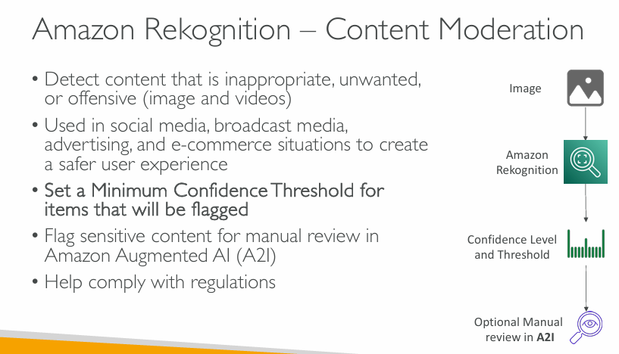

**What is Content Moderation in Rekognition?**

Content moderation helps detect **inappropriate or offensive content** — like violence, nudity, or suggestive imagery — in images or videos. This is important for platforms like **social media, e-commerce, advertising**, and more.

**🧠 How It Works (Step-by-Step)**

1. **Image or Video Input**
   * An image or video is submitted to Amazon Rekognition for analysis.
2. **Automated Analysis by Rekognition**
   * Rekognition scans the media and **detects inappropriate content**, such as:
     + Nudity
     + Violence
     + Drugs
     + Suggestive content
3. **Confidence Score**
   * Each finding comes with a **confidence level** (e.g., “I’m 92% sure this is nudity”).
   * You can **set a threshold**, say 80%, so only highly confident results get flagged.
4. **Optional Human Review (A2I)**
   * If the AI is unsure or if policy requires it, the result can be sent to **Amazon A2I (Augmented AI)** for a human to review.
   * This helps avoid mistakes and improves reliability.

**📌 Key Points**

* Helps **automatically moderate content** in large-scale platforms.
* Can be integrated into apps for **user safety and regulatory compliance**.
* Useful in:
  + **Social media**: Preventing harmful or explicit user posts.
  + **E-commerce**: Checking product images.
  + **Advertising**: Ensuring ad content is family-friendly.
  + **Broadcast media**: Moderating livestreams or uploads.

**✅ Benefits**

* Saves **manual effort** by automating first-level checks.
* Reduces exposure to moderators.
* **Scales easily** to handle thousands of media files.
* Supports **regulatory compliance** for sensitive markets (e.g., children’s apps).

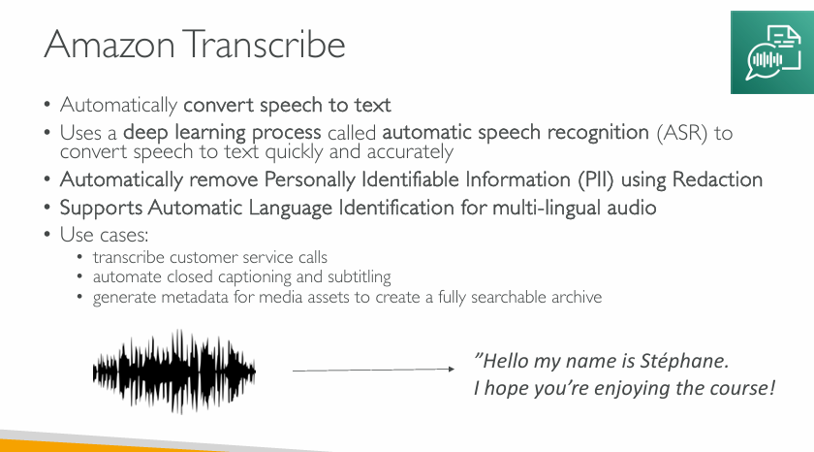

**What is Amazon Transcribe?**

Amazon Transcribe is a **speech-to-text** service powered by **deep learning**. It listens to spoken language in audio files and turns it into written text with high accuracy.

**⚙️ How It Works**

1. **Automatic Speech Recognition (ASR)**
   * Uses **deep learning models** to identify spoken words and convert them into text quickly and accurately.
2. **Redaction of PII (Personally Identifiable Information)**
   * Automatically **removes sensitive data** (e.g., names, phone numbers) to protect privacy — useful in regulated industries like healthcare or finance.
3. **Language Detection**
   * Can **automatically detect the language** being spoken in the audio, which is helpful when working with global content.

**💡 Use Cases**

* **Customer Service Transcription**  
  Automatically transcribe phone or support calls to analyze customer service quality and interactions.
* **Closed Captioning & Subtitling**  
  Generate subtitles for video content like online courses, YouTube videos, and live broadcasts.
* **Media Metadata Generation**  
  Turn audio content into searchable metadata so that large media archives can be indexed and easily searched.

**✨ Example**

In the image, the speech:

*"Hello, my name is Stéphane. I hope you’re enjoying the course!"*  
is transcribed from an audio waveform into text — which could be used for subtitles, archiving, or analytics.

**✅ Benefits**

* Reduces manual transcription time
* Enhances accessibility (via subtitles and captions)
* Helps with compliance (via PII redaction)
* Enables multilingual support and global scalability

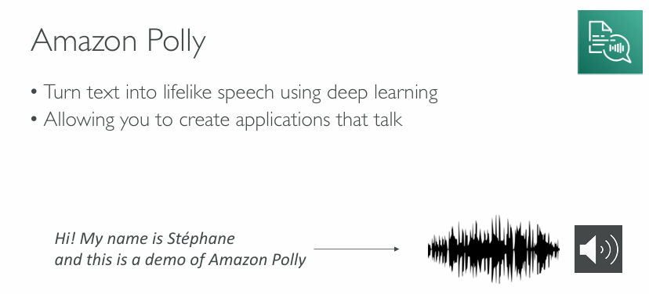

**What is Amazon Polly?**

Amazon Polly is a **text-to-speech service** that uses **deep learning** to generate **lifelike, natural-sounding speech** from text.

**🔧 Key Features**

* **Text to Speech (TTS)**  
  Converts plain text into audio in real-time.
* **Lifelike Voices**  
  Uses advanced deep learning (neural TTS) to produce speech that sounds natural and human-like.
* **Multi-language and Multi-voice Support**  
  Offers a wide range of languages and voice personas (male/female, regional accents).

**🎯 Use Cases**

* **Voice-enabled applications**  
  Apps that **"talk" to users** — like virtual assistants, e-learning platforms, and accessibility tools.
* **Audiobooks & Podcasts**  
  Automatically generate high-quality spoken content from written text.
* **Real-time announcements**  
  In public systems or customer service chatbots (e.g., airport or bank kiosks).

**📢 Example in the Slide**

The input text:

*"Hi! My name is Stéphane and this is a demo of Amazon Polly"*  
is converted into audio (shown as a waveform + speaker icon).

**✅ Benefits**

* Easy integration with other AWS services (e.g., Lambda, S3)
* Enables accessibility and enhances user experience
* Supports SSML (Speech Synthesis Markup Language) for pronunciation control

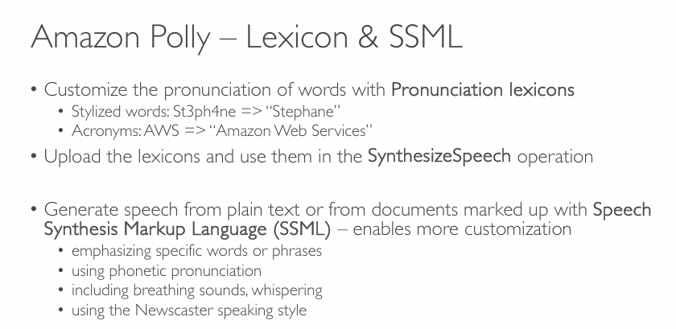

**Amazon Polly – Lexicon & SSML Overview**

**📖 Pronunciation Lexicons**

* Allow customization of how **specific words** are pronounced.
* Example use cases:
  + Stylized words: St3ph4ne → pronounced as **"Stephane"**
  + Acronyms: AWS → pronounced as **"Amazon Web Services"**

You can **upload lexicons** and reference them in the SynthesizeSpeech API call.

**🗣️ SSML – Speech Synthesis Markup Language**

SSML provides **fine control** over speech output with markup embedded in text. It enables:

* **Emphasis** on specific words/phrases  
  (e.g., “I *really* like it!”)
* **Phonetic pronunciation**  
  for tricky names/words
* **Breathing sounds**, **whispers**  
  for realism and emotion
* **Newscaster speaking style**  
  for formal or broadcast-quality speech delivery

**✅ Benefits of Using Lexicon & SSML**

* Natural and accurate pronunciation
* Enhanced listener experience
* Suitable for professional, accessible, and personalized applications

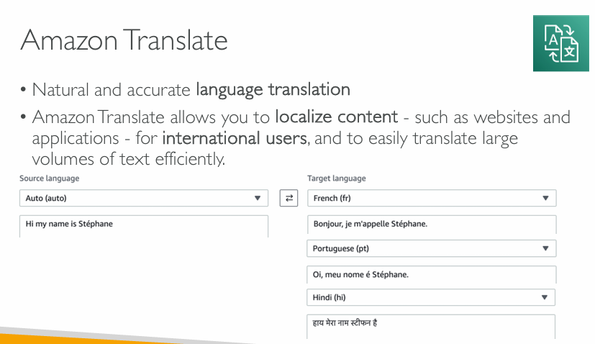

**Amazon Translate Overview**

**✅ Key Features:**

* Provides **natural and accurate language translation** using deep learning.
* Enables **localization** of:
  + Websites
  + Applications
  + Documentation
* Designed for **international users** and supports **large-scale text translation** efficiently.

**🔤 Example Usage:**

Input: "Hi my name is Stéphane"  
Source Language: **Auto-detected**

**Target Languages and Translations:**

* **French (fr):** *Bonjour, je m'appelle Stéphane.*
* **Portuguese (pt):** *Oi, meu nome é Stéphane.*
* **Hindi (hi):** *हाय मेरा नाम स्टेफ़न है*

**🌍 Use Cases:**

* Global customer support
* E-commerce product localization
* Real-time chat translation
* Multilingual content publishing

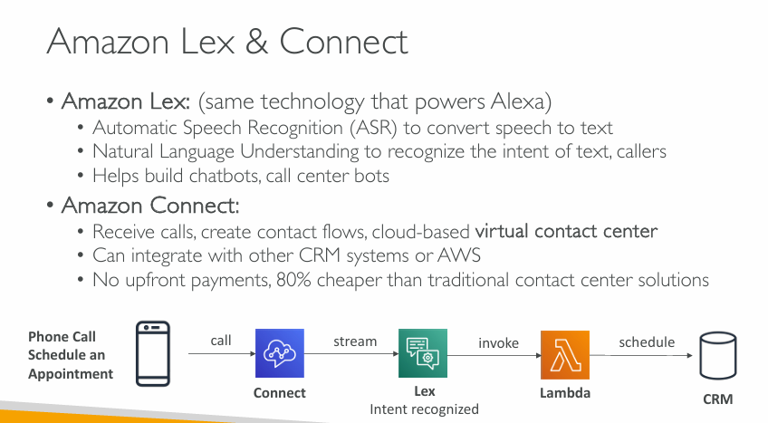

**Amazon Lex**

* **Technology base**: Same as **Alexa**
* **Features**:
  + **Automatic Speech Recognition (ASR)**: Converts speech to text
  + **Natural Language Understanding (NLU)**: Interprets user intent
  + Ideal for building **chatbots** and **call center bots**

**☁️ Amazon Connect**

* A **virtual contact center** service
* **Capabilities**:
  + Receives incoming **calls**
  + Enables **contact flows**
  + Integrates with **AWS Lambda**, **CRMs**, and other systems
* **Benefits**:
  + No upfront costs
  + **80% cheaper** than traditional contact centers

**📞 Example Workflow: *Schedule an Appointment via Phone***

1. **Customer calls** ➡️ **Amazon Connect**
2. Audio is **streamed** to **Amazon Lex**
3. Lex **recognizes intent**
4. Lex **invokes Lambda** function
5. Lambda interacts with **CRM** to schedule appointment

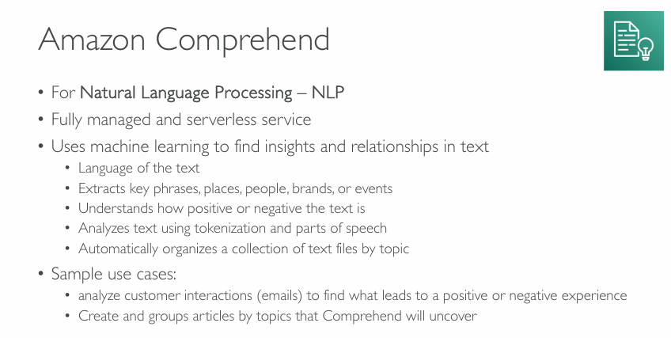

**Amazon Comprehend — Natural Language Processing (NLP)**

* **Fully managed** and **serverless**
* Uses **machine learning** to extract insights and detect relationships in text

**🔍 Capabilities**

* Detects **language** of the text
* Extracts **key phrases**, **people**, **places**, **brands**, or **events**
* Determines **sentiment** (positive, negative, neutral, or mixed)
* Performs **tokenization** and **parts of speech** analysis
* Can **automatically organize** text documents by **topics**

**💼 Use Cases**

* Analyze **customer interactions** (e.g., emails or chat logs) to detect sentiment and key concerns
* Group and organize **articles or documents** by **topics** using machine learning

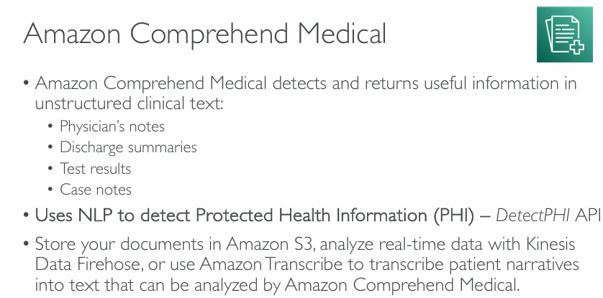

**What is Amazon Comprehend Medical?**

**Amazon Comprehend Medical** is a **machine learning service** provided by AWS that understands and analyzes **medical text** — especially text that is **unstructured**, like what doctors and nurses write in:

* 📝 **Physician’s notes** (notes a doctor types after seeing a patient)
* 📋 **Discharge summaries** (summary when a patient leaves the hospital)
* 🧪 **Test results** (like blood reports, X-rays)
* 🗂️ **Case notes** (general notes about the patient)

This information is usually hard for computers to understand, but **Amazon Comprehend Medical can read it just like a human**, and extract **useful medical facts** from it.

**🧬 What does it do?**

It uses **Natural Language Processing (NLP)** — a branch of AI that helps machines understand human language — to:

* Recognize and extract **important medical terms**
* Understand the **meaning** of what is written
* Identify **relationships** between terms (e.g., "patient has diabetes" or "prescribed aspirin")

**🔒 What is PHI (Protected Health Information) and how does it help?**

**PHI** means any information that can identify a patient, like:

* Name
* Date of birth
* Address
* Health conditions
* Medications

Amazon Comprehend Medical can detect PHI using a tool called the **DetectPHI API**. This is **very important for privacy** and **compliance**, especially in healthcare environments where **data protection laws** (like HIPAA in the US) are strict.

**🔄 How does it work in real scenarios?**

Let’s say you have **a folder full of doctor's notes** in a hospital system. Here’s what you can do:

1. 📂 **Store documents** in Amazon S3 (Amazon's cloud storage).
2. 🔁 Use **Amazon Comprehend Medical** to read and analyze those documents.
3. 🧠 It extracts details like:
   * Medical conditions (e.g., "diabetes")
   * Medications (e.g., "aspirin")
   * Procedures (e.g., "MRI scan")
   * Test results and more.
4. 🛡️ It can **automatically find and hide** sensitive PHI info.

You can also:

* Use **Amazon Transcribe** to convert voice notes (spoken by doctors) into text
* Then analyze them with **Comprehend Medical**
* Or use **Kinesis Data Firehose** to process real-time streaming data

**✅ Why use it?**

* Helps hospitals **digitize and analyze** records quickly
* Speeds up medical research
* Saves time for doctors and nurses
* Helps in building **AI-powered medical applications**
* Improves **data privacy** by detecting sensitive information

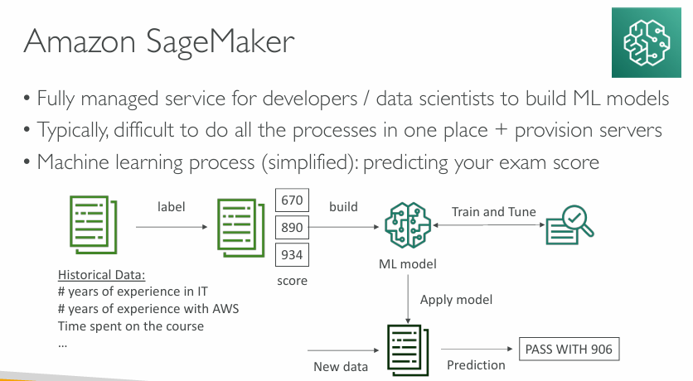

**What is Amazon SageMaker?**

**Amazon SageMaker** is a **cloud service from AWS** that helps **developers and data scientists** build, train, and deploy **machine learning (ML)** models easily — **without worrying about the servers** and infrastructure behind it.

**🧠 The Goal: Predict Your Exam Score**

We want to **predict your exam score** using machine learning, based on **your background and study habits**.

**📊 Step-by-Step Explanation of the Image**

**✅ 1. Historical Data Collection (left side)**

You start with **real-world data** that you already have. This is called **training data**.

📘 Example:

* Years of experience in IT
* Years of experience with AWS
* Time spent on a course
* … other factors

Each row also includes a **label**, which is the **actual exam score** a person got.

plaintext

CopyEdit

| Experience (IT) | AWS Experience | Course Time | Score |

|-----------------|----------------|-------------|-------|

| 3 years | 1 year | 20 hours | 670 |

| 5 years | 2 years | 30 hours | 890 |

| 6 years | 3 years | 35 hours | 934 |

**✅ 2. Build ML Model**

This historical data is used to **build a machine learning model** in SageMaker. It tries to **learn patterns** in the data — e.g., *“more study time often means higher scores.”*

**✅ 3. Train and Tune**

SageMaker then:

* **Trains** the model: teaches it using historical examples.
* **Tunes** it: adjusts it so predictions are more accurate (like tweaking a recipe).

Think of it as:

"Give the model lots of past examples so it can understand what factors affect scores."

**✅ 4. Apply Model to New Data**

Once training is complete, the model is ready to be used.

Now, you give it **new data** (a new student’s experience and study time), and it uses what it learned to **predict** the likely exam score.

📥 Input (New data):

* 4 years IT experience
* 2 years AWS experience
* 25 hours study

📤 Output (Prediction):

* **“PASS WITH 906”**

This is the **prediction made by the ML model**.

**🔁 This Whole Process is Serverless**

You don’t have to:

* Buy or manage servers
* Manually install ML software
* Handle infrastructure

SageMaker handles everything behind the scenes.

**🟩 Why SageMaker is Useful:**

* Simplifies the ML workflow (build, train, deploy)
* Scales automatically
* Integrated with other AWS services
* Cost-effective (pay for what you use)

**🎯 Summary:**

Amazon SageMaker helps you:

1. **Collect and label historical data**
2. **Build and train a model** on that data
3. **Use the model** to predict outcomes from new data (like your exam score)
4. **Do it all easily and serverlessly**

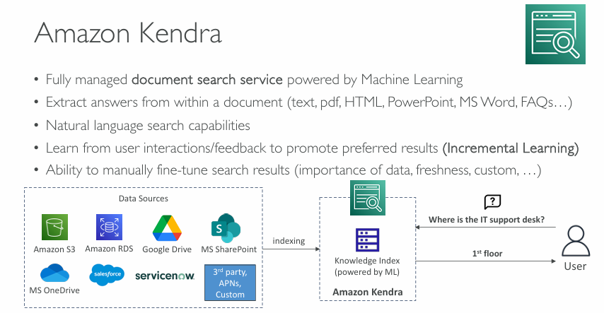

**What is Amazon Kendra?**

**Amazon Kendra** is an **intelligent search service** powered by **Machine Learning (ML)**.  
It helps users **quickly find answers** from large amounts of **documents and data**, even if those answers are **buried deep inside** files like PDFs, Word docs, PowerPoints, FAQs, etc.

**🧠 Key Features (Top Left Bullets)**

**✅ 1. Document Search Service**

* Kendra is fully managed by AWS.
* You don’t need to build or maintain your own search engine.

**✅ 2. Deep Document Understanding**

* Kendra doesn't just search file names or keywords.
* It goes **inside the documents** (e.g., PDFs, Word files) to extract **actual answers**.

**✅ 3. Natural Language Search**

* You can ask it **questions like a human**:  
  *"Where is the IT support desk?"*  
  Instead of typing exact keywords.

**✅ 4. Learns Over Time (Incremental Learning)**

* If users click one result more often, Kendra learns it’s more useful and **improves search results** over time.

**✅ 5. Manual Tuning**

* You can **adjust** how much importance Kendra gives to:
  + Recent documents (freshness)
  + Specific data types (e.g., FAQs vs PDFs)
  + Custom ranking rules

**🗃️ Data Flow (Bottom Diagram Explanation)**

**1️⃣ Data Sources (Left Box):**

Kendra pulls information from different storage systems:

* ✅ Amazon S3 (file storage)
* ✅ Amazon RDS (databases)
* ✅ Google Drive
* ✅ Microsoft SharePoint and OneDrive
* ✅ Salesforce
* ✅ ServiceNow
* ✅ 3rd-party/custom data sources (APNs = AWS Partner Network)

These are your **documents, notes, help docs, manuals, reports**, etc.

**2️⃣ Indexing into Kendra**

All this content is **indexed** (meaning: analyzed, organized, and understood) by **Amazon Kendra**.

Kendra uses Machine Learning to build a **"Knowledge Index"**, which is a special searchable collection of smartly processed content.

**3️⃣ User Search**

A user types a question, such as:

“Where is the IT support desk?”

Kendra searches the index and returns the **most relevant answer**.

In this case, it might find:

“1st floor”  
(from a building FAQ, employee handbook, or onboarding document)

**💡 Real-World Use Case**

Imagine a company with thousands of internal documents. Instead of manually searching or asking colleagues, employees can use Kendra to:

* Ask: *"How do I reset my password?"*
* Get: *"Use the IT portal and click ‘Forgot Password’"*

**🟩 Summary**

| **Feature** | **What it Means** |
| --- | --- |
| **ML-Powered** | Learns and improves results |
| **Natural Language** | Ask questions like a human |
| **Deep Document Search** | Searches **inside** files |
| **Multiple Data Sources** | Connects to cloud storage, databases, apps |
| **Smart Ranking** | Learns from clicks and lets admins tune search relevance |

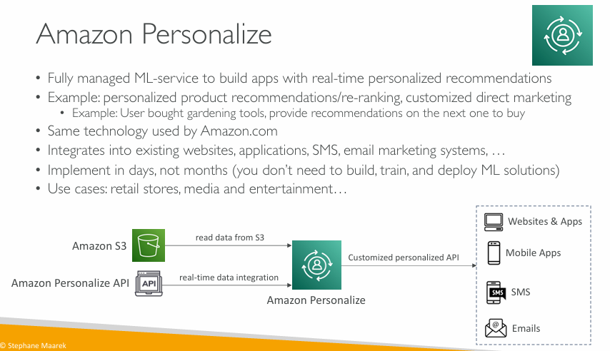

**What is Amazon Personalize?**

**Amazon Personalize** is a **fully managed machine learning service** from AWS that helps you:

* **Build apps** that can **recommend products, content, or actions** to individual users.
* Do this in **real-time** and with **personalization**, meaning each user gets tailored suggestions.

**📦 Real-Life Example**

Imagine you're running an e-commerce store:

* A user **buys gardening tools**.
* Next time they visit, your app can recommend:

"You might also like seeds, gloves, or plant pots."

This **personalized recommendation** is done by **Amazon Personalize** behind the scenes.

**🧠 Key Features Explained**

**✅ 1. No ML expertise needed**

* You don’t need to know machine learning algorithms.
* You just provide user and item data; AWS handles the rest.

**✅ 2. Same tech as Amazon.com**

* The **same technology** Amazon uses to recommend products is available to you.

**✅ 3. Fast to implement**

* You can set it up in **days**, not months.
* No need to build your own ML models.

**✅ 4. Works with existing systems**

* Easily integrates with:
  + Your **website or app**
  + **Email campaigns**
  + **SMS notifications**
  + **Mobile apps**

**✅ 5. Use cases**

* Online **retail**
* **Media** (music/video recommendations)
* **Marketing** (send custom emails or product links)

**🔄 How It Works (Bottom Diagram)**

**🟩 Step 1: Provide User Interaction Data**

* You store user activity data in **Amazon S3**.
* Example: “User A watched movie X,” “User B bought item Y”.

**🟦 Step 2: Real-Time Data via API**

* You can also send **live user behavior** using the **Amazon Personalize API**.
* Example: A user just clicked a product — update their preferences instantly.

**🧠 Step 3: Amazon Personalize Builds the Model**

* Based on your data, it builds a model that **understands user behavior**.
* It predicts what they are likely to want next.

**🧪 Step 4: Get Personalized Recommendations**

* Amazon Personalize gives back a **custom API**.
* You call this API from your:
  + Website or app
  + Mobile apps
  + SMS system
  + Email marketing tool

The API returns **recommendations tailored to each user**.

**💡 Summary Table**

| **Feature** | **What It Means** |
| --- | --- |
| Fully Managed | AWS handles ML training, infrastructure, and tuning |
| Personalized Recommendations | Suggestions specific to each user |
| Fast Setup | Can be implemented quickly, no ML expertise needed |
| Easy Integration | Works with S3, APIs, websites, apps, SMS, email |
| Real-Time Updates | Adjusts to user actions instantly |
| Based on Amazon's Own Tech | Uses the same ML engine Amazon.com uses for its customers |

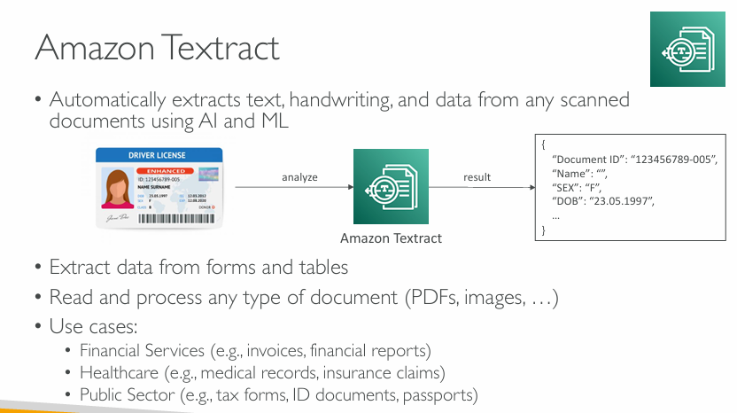

**What is Amazon Textract?**

**Amazon Textract** is a cloud-based **AI service** from AWS that:

* **Automatically reads and extracts** text, handwriting, and data from **documents** like scanned forms, PDFs, and images.
* Uses **Artificial Intelligence (AI)** and **Machine Learning (ML)** to do this **without manual effort**.

**🧠 What Does Textract Do?**

**✔️ Understands Different Types of Documents**

For example:

* A scanned **driver’s license**
* A printed **PDF invoice**
* A handwritten **insurance claim form**

It reads them like a human would and extracts key data.

**🔍 How It Works (Flow Diagram)**

1. **Input Document**:
   * You upload a document (e.g., scanned image of a driver’s license).
2. **Analyze**:
   * Textract processes the document using AI.
3. **Result**:
   * It returns structured data like:

json

CopyEdit

{

"Document ID": "123456789-005",

"Name": "Jane Sharma",

"SEX": "F",

"DOB": "23.05.1997"

}

So you get **clean, machine-readable data** from unstructured documents.

**📋 Key Features**

| **Feature** | **Explanation** |
| --- | --- |
| Extract Text | Gets all visible text from the document. |
| Handwriting Recognition | Reads human handwriting. |
| Form/Table Detection | Understands fields like “Name”, “Date of Birth”, or tables in reports. |
| Works with PDFs, Images, etc. | Supports various file types, even scans or pictures. |

**🧰 Use Cases**

**🏦 Financial Services**

* Extract data from:
  + Invoices
  + Financial reports
  + Bank statements

**🏥 Healthcare**

* Digitize:
  + Medical records
  + Insurance forms

**🏛️ Public Sector / Government**

* Automate processing of:
  + Tax forms
  + Passports
  + ID cards

**🧠 Why is Textract Useful?**

* Saves **time** and **manual work**.
* **Accurate** and **fast** even for complex documents.
* Helps build apps that can:
  + Automatically process incoming paperwork
  + Store structured info in databases
  + Trigger workflows (e.g., approve loans, open support tickets)

**✅ Summary**

| What It Does | Automatically reads and extracts data from scanned or digital documents |  
| Who It’s For | Businesses dealing with lots of paperwork (banks, hospitals, govt.) |  
| Why Use It | Fast, accurate, no manual data entry needed |  
| Inputs | PDFs, images, scanned documents |  
| Outputs | Structured text/data you can store or analyze |

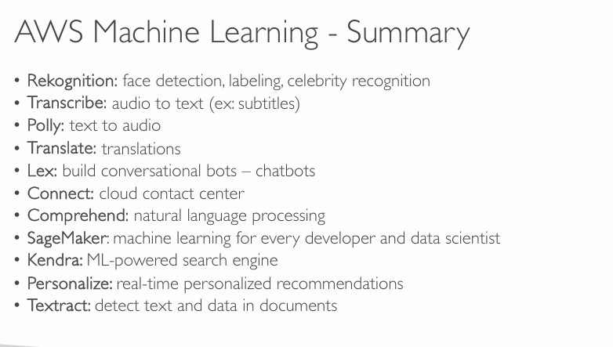

**1. Rekognition**

* **What it does**: Identifies objects, people, text, scenes, and activities in images and videos.
* **Examples**:
  + Face detection (e.g., in a photo)
  + Detect celebrities in a video
  + Content moderation (e.g., detect unsafe images)

**✅ 2. Transcribe**

* **What it does**: Converts **speech into text**.
* **Examples**:
  + Turn phone call recordings into transcripts
  + Add subtitles to videos

**✅ 3. Polly**

* **What it does**: Converts **text into natural-sounding speech**.
* **Examples**:
  + Read out news articles or documents
  + Voice for chatbots or virtual assistants

**✅ 4. Translate**

* **What it does**: Provides **language translation** in real-time.
* **Examples**:
  + Translate a website from English to French
  + Multi-language customer support

**✅ 5. Lex**

* **What it does**: Helps build **chatbots** and **voice assistants**.
* **Examples**:
  + Customer support bots
  + Alexa-style conversational interfaces

**✅ 6. Connect**

* **What it does**: Cloud-based **call center platform**.
* **Examples**:
  + Call routing, customer engagement, chatbot integration

**✅ 7. Comprehend**

* **What it does**: Understands the meaning of text using **Natural Language Processing (NLP)**.
* **Examples**:
  + Sentiment analysis (positive, negative, neutral)
  + Key phrase extraction (e.g., find names, locations)

**✅ 8. SageMaker**

* **What it does**: Full platform to **build, train, and deploy** machine learning models.
* **Examples**:
  + Predict sales
  + Forecast demand
  + Build ML apps

**✅ 9. Kendra**

* **What it does**: **Intelligent search service** for internal documents.
* **Examples**:
  + Search within PDFs, Word docs, or FAQs
  + Ask "Where is the HR policy?" → it finds the correct document/answer

**✅ 10. Personalize**

* **What it does**: Makes **product or content recommendations**.
* **Examples**:
  + Suggest movies like Netflix
  + Recommend products like Amazon

**✅ 11. Textract**

* **What it does**: Extracts text and data from **scanned documents**.
* **Examples**:
  + Pull data from ID cards, invoices, or application forms
  + Convert PDFs/images into structured data

**💡 Summary Table:**

| **Service** | **Main Purpose** | **Example Use Case** |
| --- | --- | --- |
| Rekognition | Face/object detection | Security systems, photo tagging |
| Transcribe | Speech to text | Subtitles, call transcripts |
| Polly | Text to speech | Voice assistants, audio books |
| Translate | Language translation | Global websites, multi-lingual apps |
| Lex | Chatbots and voice apps | Support bots, virtual assistants |
| Connect | Cloud call center | Customer service |
| Comprehend | NLP – understand text | Sentiment analysis, entity recognition |
| SageMaker | Build & deploy ML models | Sales prediction, fraud detection |
| Kendra | Smart search across documents | Internal knowledge search |
| Personalize | Recommendations | Product/movie suggestions |
| Textract | Extract data from documents | Process forms, ID scanning |

Section-27- Networking VPC

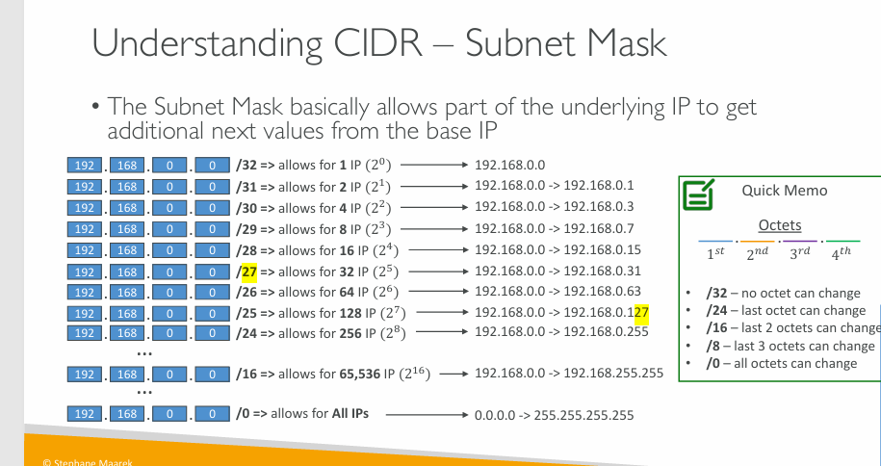

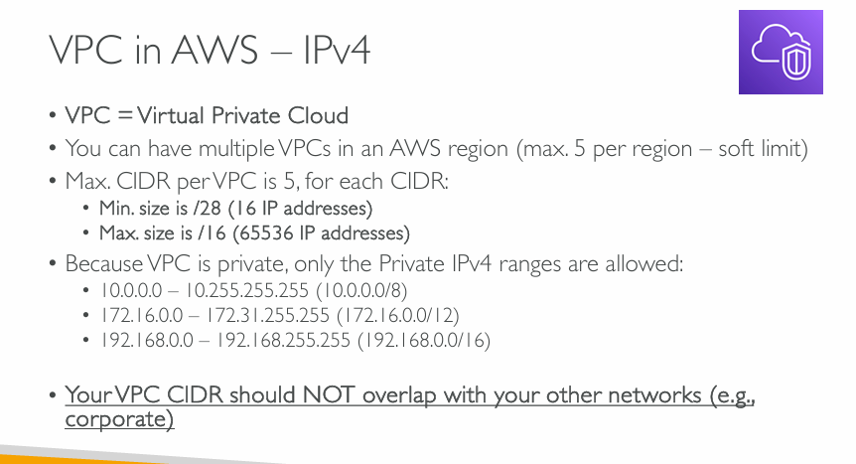

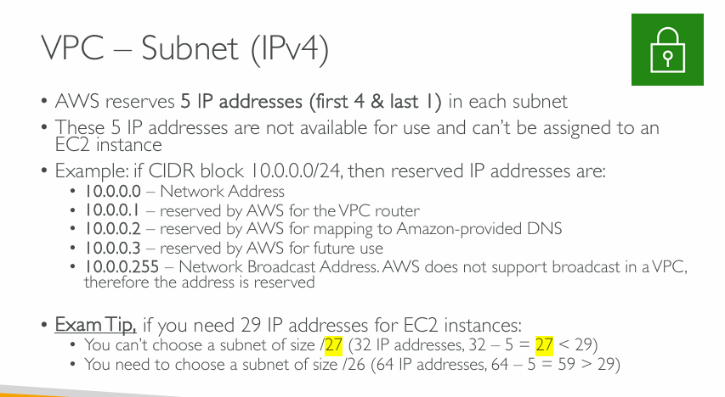  
Exam tip: In exam tip if they ask about 29 Ip addresses for vpc, /27 is not correct because  
remaining 5 bits=2^0+2^1+2^2+2^3+2^4 = 32 (in that 32, 5 will be reserved so 32-5=27) so its wrong option.

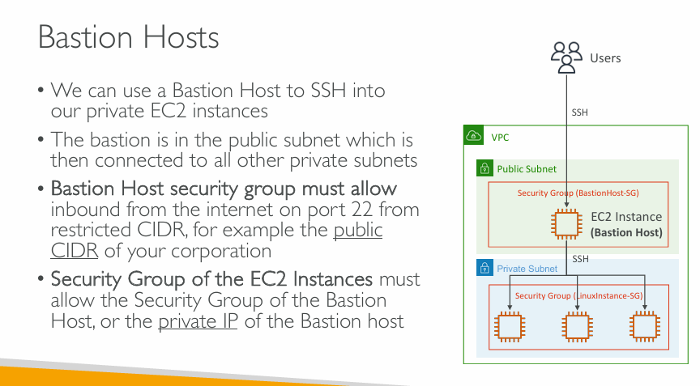  
In terms of security group which is something that can come in the exam, we need to understand what we can define. So for Bastion Hosts perspective the security group must allow access from the internet okay. But instead of allowing everywhere from the internet access, because that could be a security risk, we can only restrict, for example, access from the public CIDR of your corporation or your internet access and so on. So that we have to restrict the EC2 security groups of the bastion hosts as much as possible to guarantee that only a few selected IP’s can access it, because if somehow a random attacker has access to our EC2 instance as the bastion host, it could be a security risk for our infrastructure.

**Bastion Hosts** enable secure access to **private EC2 instances** in AWS. Here's a breakdown:

**🔐 What is a Bastion Host?**

A **Bastion Host** is a special-purpose EC2 instance that acts as a **secure entry point** (or “jump box”) to access **private resources** (like EC2 instances in private subnets) via **SSH**.

**🛠️ How it Works (Architecture Overview):**

**1. Placement**

* The Bastion Host is launched in a **public subnet** (with internet access).
* Private EC2 instances (targets) are in a **private subnet** (no direct internet access).

**2. Connection Flow**

* Users **SSH** into the Bastion Host.
* From there, they **SSH** into private EC2 instances using internal IPs.

**🔒 Security Group Requirements**

**✅ Bastion Host (Public Subnet)**

* Security group must **allow inbound SSH (port 22)** from a **restricted public CIDR range** (e.g., your office IP).
* This controls **who can access the Bastion Host**.

**✅ Private EC2 Instances**

* Security group must **allow SSH (port 22)** **from the Bastion Host**:
  + Either by referencing the **security group** of the Bastion Host
  + Or by allowing the **private IP** of the Bastion Host

**✅ Best Practices**

* Use IAM and SSH key-based auth for access control.
* Enable session logging or auditing (e.g., via AWS Systems Manager).
* Use a Network ACL or firewall to further restrict access.

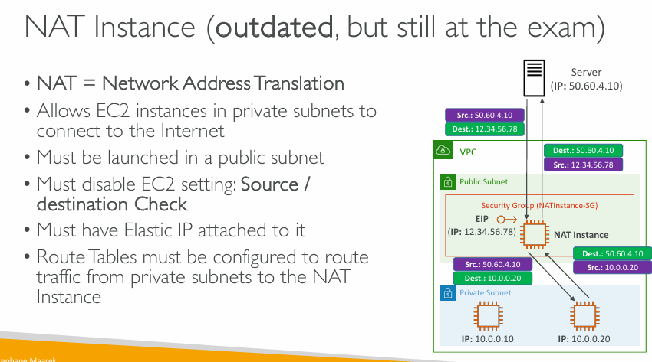

**What is a NAT Instance?**

A **NAT (Network Address Translation) Instance** lets **private EC2 instances** access the **internet** (e.g., for updates or external API calls) **without exposing them** directly to inbound traffic from the internet.

**⚙️ Key Characteristics**

1. **Placed in a Public Subnet**
   * NAT Instance itself is in a **public subnet** (with a route to an Internet Gateway).
2. **EC2 Setting: Source/Destination Check**
   * Must be **disabled** because a NAT instance routes traffic not originally destined for it.
   * Otherwise, the EC2 instance will drop traffic not explicitly addressed to it.
3. **Elastic IP (EIP) Required**
   * So the instance can be reached by the internet (for outbound traffic).
4. **Route Table Configuration**
   * Private subnet(s) must route **internet-bound traffic** (e.g., 0.0.0.0/0) **to the NAT Instance**.
   * This enables the flow:

vbnet

CopyEdit

Private EC2 ➝ NAT Instance ➝ Internet

**🔄 Traffic Flow Explained (Right-Side Diagram):**

* EC2 in private subnet (10.0.0.20) wants to reach the external server (50.60.4.10).
* Traffic is routed to NAT instance (12.34.56.78 via public subnet).
* NAT instance **replaces source IP** with its own Elastic IP and sends the request.
* Reply from the server goes to the NAT instance, which **translates** and forwards it to the private EC2.

**❗ Why It’s Outdated**

* Replaced by **NAT Gateways**, which are:
  + Managed by AWS
  + More scalable and reliable
  + Require less configuration (no EC2 management, source/destination check handling, etc.)

**✅ When to Know About NAT Instances**

* **Still tested on AWS exams** (especially Associate-level).
* May be used in legacy systems or low-budget environments.

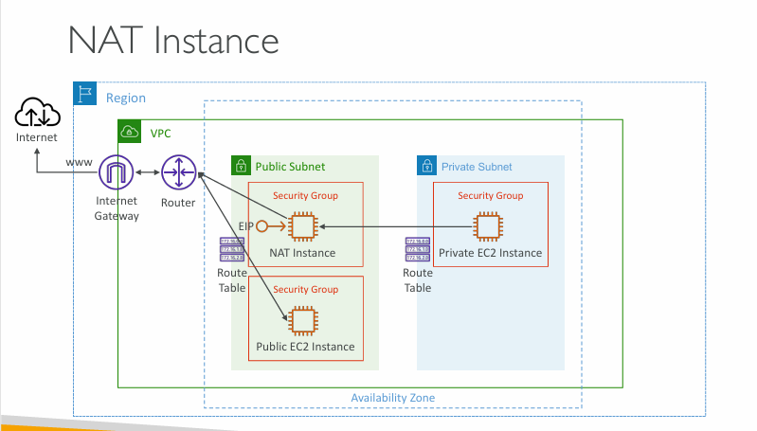

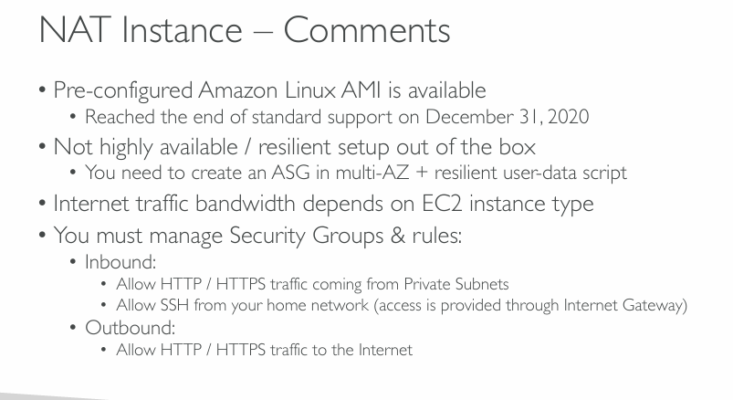  
In the exam they will ask you to choose between NAT instance and NAT Gateway

**Pre-configured Amazon Linux AMI is available**

* AWS provides a **pre-built NAT Instance AMI** you can use.
* However, this AMI **reached end of standard support on December 31, 2020**, meaning:
  + No more security updates or maintenance.
  + It's still usable but not recommended for new production setups.

**⚠️ Not highly available / resilient setup out of the box**

* NAT Instances do **not scale automatically** and are **not fault-tolerant** by default.
* To make them **resilient and HA**, you must:
  + Use an **Auto Scaling Group (ASG)** across **multiple AZs**.
  + Add a **user-data script** to configure the NAT functionality on boot.

**🌐 Internet traffic bandwidth depends on EC2 instance type**

* Throughput (bandwidth to/from the internet) is limited by:
  + The **EC2 instance size** (e.g., t2.micro vs. m5.large).
  + Unlike NAT Gateways, which **scale automatically**, NAT Instances do **not**.

**🔐 You must manage Security Groups & rules**

* **Inbound Rules**:
  + Allow **HTTP/HTTPS** from **private subnets** (for NAT translation).
  + Allow **SSH** from your **home network** (for maintenance/troubleshooting).
* **Outbound Rules**:
  + Allow **HTTP/HTTPS** to the **internet**, so EC2s in private subnets can pull updates, packages, etc.

**✅ Summary: NAT Instances are flexible but manual**

* Still show up on certification exams even though **NAT Gateways are preferred**.
* Require manual:
  + Setup
  + Scaling
  + Security group management
  + High availability configuration

For modern designs, **NAT Gateways** are typically recommended due to ease of setup and scalability.

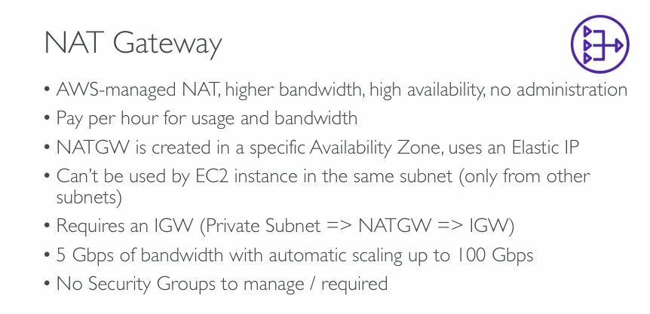  
**What is a NAT Gateway?**

NAT = **Network Address Translation**  
NAT Gateway = A **fully managed AWS service** that lets EC2 instances in **private subnets** connect **to the internet**, but **prevents the internet from initiating connections** back to those instances.

**🟪 Bullet-by-Bullet Breakdown**

**✅ “AWS-managed NAT, higher bandwidth, high availability, no administration”**

* Unlike NAT Instances (which are EC2 VMs you manage), NAT Gateways are:
  + **Managed by AWS** (you don’t patch or maintain them)
  + **Highly available by default** in the Availability Zone
  + **Faster and more reliable**
  + **Hands-off**: no setup scripts, no manual monitoring

**💵 “Pay per hour for usage and bandwidth”**

* Pricing is based on:
  + **How long** the NAT Gateway is running (per hour)
  + **How much data** goes through it (per GB)

So, costs depend on **uptime + traffic**.

**📍 “NATGW is created in a specific Availability Zone, uses an Elastic IP”**

* When you create a NAT Gateway:
  + You **select one AZ** (it's tied to that AZ)
  + You **assign an Elastic IP** (a public static IP)

This public IP is used for the outgoing internet traffic from your private EC2s.

**🚫 “Can’t be used by EC2 instance in the same subnet (only from other subnets)”**

* The NAT Gateway must be in a **public subnet**.
* Private EC2 instances **must be in a different subnet**.
  + Otherwise, they **won’t be able to route traffic** through the NAT Gateway.

**🌐 “Requires an IGW (Private Subnet => NATGW => IGW)”**

* The path for traffic is:
  + EC2 in **Private Subnet** → NAT Gateway in **Public Subnet** → Internet via **Internet Gateway (IGW)**
* So:
  + NAT Gateway needs to be in a **public subnet with a route to the IGW**

**🚀 “5 Gbps of bandwidth with automatic scaling up to 100 Gbps”**

* Starts with 5 Gbps (very fast).
* Automatically **scales up** as traffic increases, up to **100 Gbps**.
* No need to upgrade manually — AWS handles the scaling.

**🔐 “No Security Groups to manage / required”**

* Unlike NAT Instances (which need inbound/outbound rules via security groups):
  + NAT Gateways **don’t need security groups**
  + This makes setup **simpler and less error-prone**

**✅ Summary (Simple Words):**

* NAT Gateway is the **modern way** to let private EC2s **access the internet** securely.
* It’s **fast**, **scalable**, **automated**, and **easy to set up**.
* You pay for **what you use**, and there’s **no manual maintenance**.
* It must live in a **public subnet**, and your EC2s must live in **private subnets** to use it.

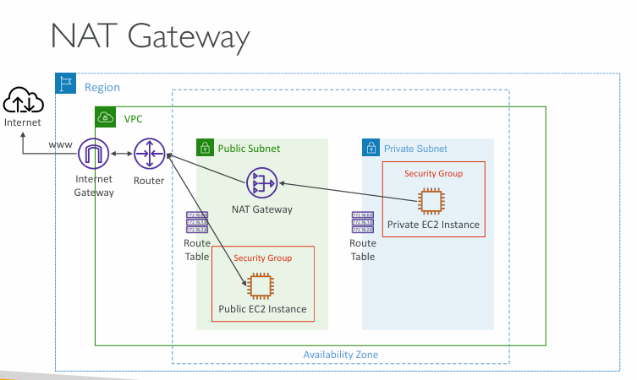  
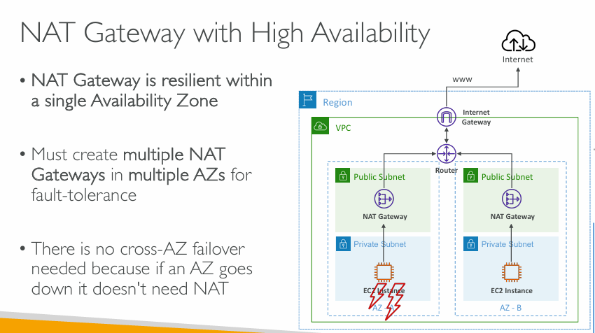  
**“NAT Gateway is resilient within a single Availability Zone”**

* Inside one AZ, the NAT Gateway is:
  + **Reliable** (AWS manages its redundancy within the AZ)
  + **Automatically scalable and robust**
* But: If the **entire AZ fails**, the NAT Gateway **in that AZ** also goes down.

**✅ “Must create multiple NAT Gateways in multiple AZs for fault-tolerance”**

* To protect against AZ failures, you need to:
  + **Create one NAT Gateway per AZ**
  + Place each in a **public subnet** of that AZ
* This way, if **AZ-A fails**, instances in **AZ-B** can still use the NAT Gateway in **AZ-B**

**✅ “There is no cross-AZ failover needed because if an AZ goes down it doesn’t need NAT”**

* You don’t need to re-route traffic from one AZ to another NAT Gateway in another AZ.
  + Why? Because **all EC2 instances in that AZ are down anyway**.
* So instead of complex failover routing, the solution is:
  + Keep NAT Gateways **local to each AZ**
  + **Private subnet in AZ-A → NAT Gateway in AZ-A**
  + **Private subnet in AZ-B → NAT Gateway in AZ-B**

**📊 Diagram Explanation (Right Side)**

* The **VPC spans two AZs**: AZ-A and AZ-B
* Each AZ has:
  + A **public subnet** with a NAT Gateway
  + A **private subnet** with an EC2 instance
* Both NAT Gateways are connected to the **Internet Gateway** (IGW)
* The **router** in the VPC directs traffic from private subnets to their local NAT Gateway
* The red lightning bolt shows **AZ-A is down**, so:
  + The EC2 in AZ-A and its NAT Gateway are unavailable
  + But **AZ-B is unaffected**, and can still access the internet via its NAT Gateway

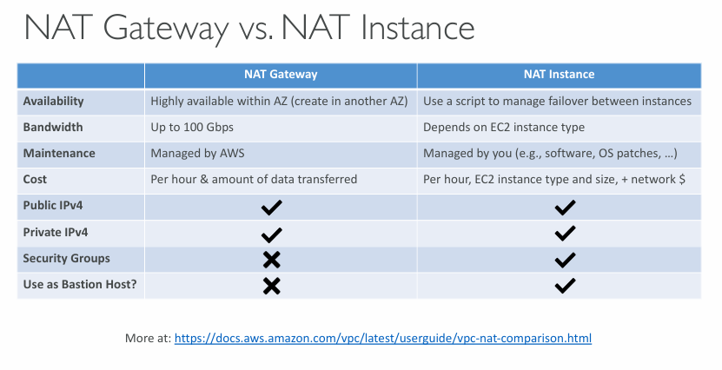  
  
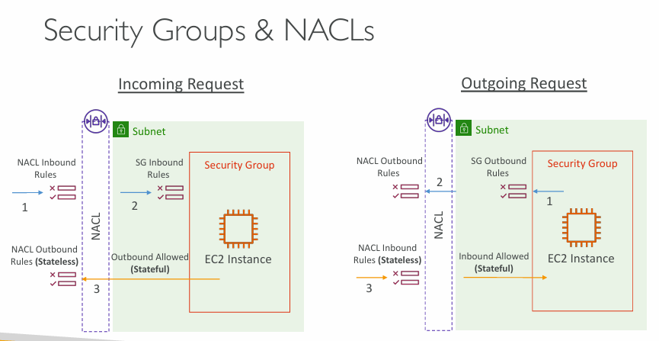  
NACL are stateless, Security Groups are statefull

**Left Side: Incoming Request**

This is when an external source is trying to **send traffic into your EC2 instance** (e.g., a user accessing your web server).

**🧭 Step-by-Step:**

1. **NACL Inbound Rules (Stateless)**
   * The NACL is the **first layer** of defense.
   * It checks if the **inbound rule** allows this traffic (e.g., allow port 80).
   * NACLs are **stateless** → If you allow inbound, you must separately allow outbound for return traffic.
2. **Security Group (SG) Inbound Rules (Stateful)**
   * If NACL allows the traffic, now the **SG checks its own inbound rules**.
   * Security Groups are **stateful**, meaning once inbound traffic is allowed, the response is **automatically allowed** outbound.
3. **Return Traffic Automatically Allowed**
   * Since SGs are stateful, **returning responses** to this request will be allowed without needing explicit outbound rules.

✅ If both NACL and SG allow the request → it reaches the EC2 instance.

**🚀 Right Side: Outgoing Request**

This is when the **EC2 instance initiates a request** to go out (e.g., access the internet).

**🧭 Step-by-Step:**

1. **Security Group (SG) Outbound Rules (Stateful)**
   * The EC2 instance sends a request.
   * First, the SG checks its **outbound rules**.
   * If allowed (e.g., port 443 for HTTPS), the traffic proceeds.
2. **NACL Outbound Rules (Stateless)**
   * Next, the **NACL outbound rules** are evaluated.
   * Since NACL is stateless, it checks this separately from inbound.
3. **NACL Inbound Rules Must Also Allow Response**
   * When the **response** comes back (from the internet, say), it has to go through **NACL inbound rules**.
   * If NACL does not allow inbound traffic back in → **response is blocked**, even though SG already allowed it.

**🔁 Key Differences Between SG and NACL:**

| **Feature** | **Security Group** | **NACL** |
| --- | --- | --- |
| **Stateful?** | ✅ Yes | ❌ No |
| **Applied To** | Instance level | Subnet level |
| **Direction** | Separate rules for inbound & outbound | Both directions must be explicitly allowed |
| **Rule Type** | Only “Allow” rules | Both “Allow” and “Deny” rules |
| **Traffic Return Handling** | Automatically allowed | Must manually allow both ways |

**🧠 Simple Analogy:**

* **Security Group** = Like a personal security guard for each EC2. If someone is let in, they’re also let out.
* **NACL** = Like a border patrol at the subnet level. Every time someone comes or goes, it checks both directions **individually**.

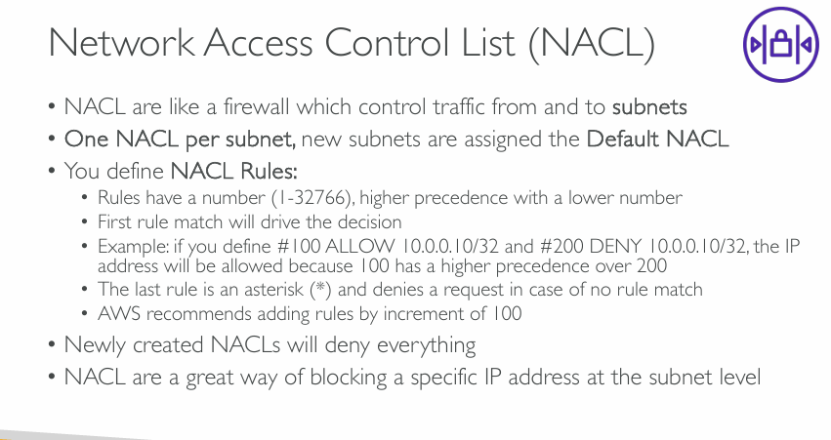  
**What is a NACL?**

* Think of a **NACL** as a **firewall at the subnet level**.
* It controls **incoming and outgoing traffic** for the entire subnet (not just individual instances).

**✅ Key Concepts Explained**

**1. One NACL per subnet**

* Each **subnet** in a VPC can have **only one** NACL.
* If you don’t assign a custom one, it uses the **default NACL** (which allows all traffic by default).

**2. NACL Rules**

You create rules to **allow** or **deny** specific traffic, based on IP, port, protocol, etc.

**🔢 Rule Numbers (1–32766)**

* Lower numbers have **higher priority**.
* AWS suggests using gaps of 100 (e.g., rule 100, 200, 300) so it’s easier to add new rules later.

**⛔ First Match Wins**

* NACL processes rules **in order**, starting from the lowest number.
* As soon as one rule matches, it **stops checking** further rules.

**🧠 Example:**

plaintext

CopyEdit

Rule #100: ALLOW 10.0.0.10/32

Rule #200: DENY 10.0.0.10/32

* Even though both rules mention the same IP, rule 100 will allow it because it's first (lower number = higher priority).

**❌ Default Rule: \***

* If no rule matches, traffic is blocked by default (* = deny all).

**3. New NACLs deny everything**

* If you create a fresh NACL, it **denies all inbound and outbound traffic** by default.
* You must add explicit **ALLOW** rules.

**4. Stateless Behavior**

* NACLs are **stateless**. This means:
  + If you ALLOW inbound traffic, you must also ALLOW outbound traffic **explicitly** for return responses to work.
  + This is unlike Security Groups, which are **stateful**.

**🔍 Use Case**

* NACLs are **great for blocking**:
  + Malicious IPs
  + Specific CIDR ranges
* Since they operate at the subnet level, they protect **all EC2 instances inside** that subnet.

**🧠 Summary Table**

| **Feature** | **NACL** |
| --- | --- |
| Applies to | Subnets |
| Stateful or Stateless? | ❌ Stateless |
| Allow & Deny Rules? | ✅ Both allowed |
| Default Behavior | Deny all (new NACL) |
| Rule Processing | By rule number (lowest wins) |
| Directional? | Yes (Inbound and Outbound) |

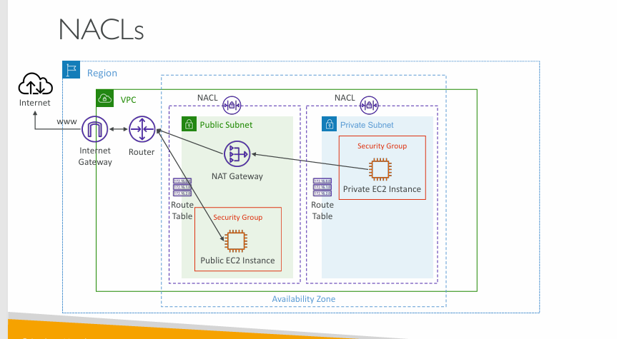

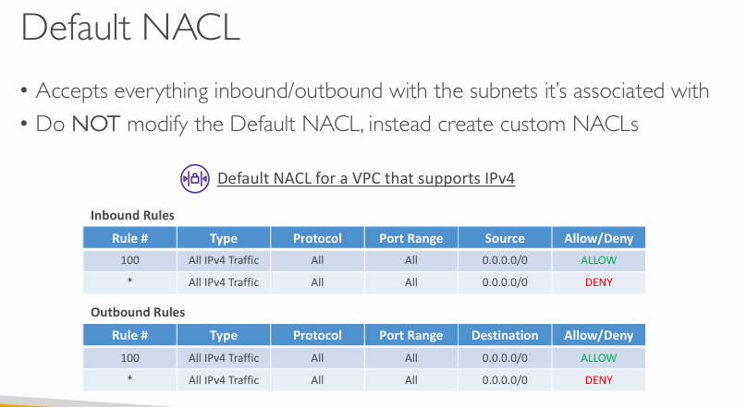

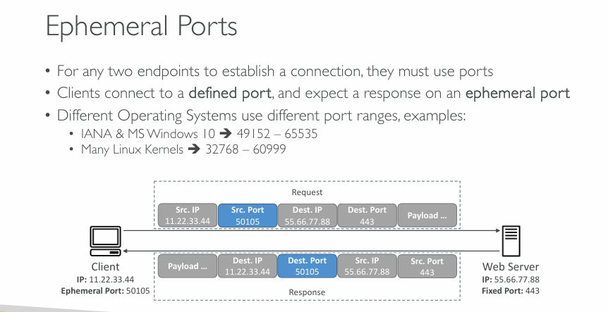  
**What Are Ephemeral Ports?**

When a **client (like your laptop)** connects to a **server (like a website)**:

* The **client chooses a random high-numbered port**, called an **ephemeral port**.
* The **server uses a fixed port**, like port 443 for HTTPS or 80 for HTTP.

**💡 Key Points**

**✅ 1. Communication Requires Ports**

* Every network connection uses **two IP addresses and two ports** (source & destination).
* Ports are like **doors** through which data enters and leaves a computer.

**✅ 2. Client Uses Ephemeral Port**

* The **client doesn't use port 443** — it picks an available **ephemeral port** (random high number like 50105).
* The server always **responds back to that same ephemeral port**.

**✅ 3. Server Uses a Fixed Port**

* Servers listen on **well-known ports**, like:
  + 443 for HTTPS
  + 80 for HTTP
* These are the **destination ports** from the client’s perspective.

**📦 Example in Diagram**

**➤ The Request (Client → Server)**

* Client IP: 11.22.33.44
* Ephemeral port: 50105
* Destination (Server) IP: 55.66.77.88
* Destination Port: 443 (HTTPS)

So, the **request is sent** to:  
55.66.77.88:443 **from** 11.22.33.44:50105

**➤ The Response (Server → Client)**

* Server sends data **back** to: 11.22.33.44:50105

**🔢 Port Ranges for Ephemeral Ports**

Different systems use different ranges for ephemeral ports:

| **System/Standard** | **Ephemeral Port Range** |
| --- | --- |
| Windows 10 / IANA | 49152 – 65535 |
| Linux Kernels | 32768 – 60999 |

These are **dynamically assigned** for each new outgoing connection.

**🧠 Summary**

| **Role** | **Port Used** | **Example Value** |
| --- | --- | --- |
| Server | Fixed port | 443 (HTTPS) |
| Client | Ephemeral port | 50105 |

* Clients always start with an ephemeral port.
* The response from the server goes back to that ephemeral port.
* This way, multiple client connections can be handled at the same time without confusion.

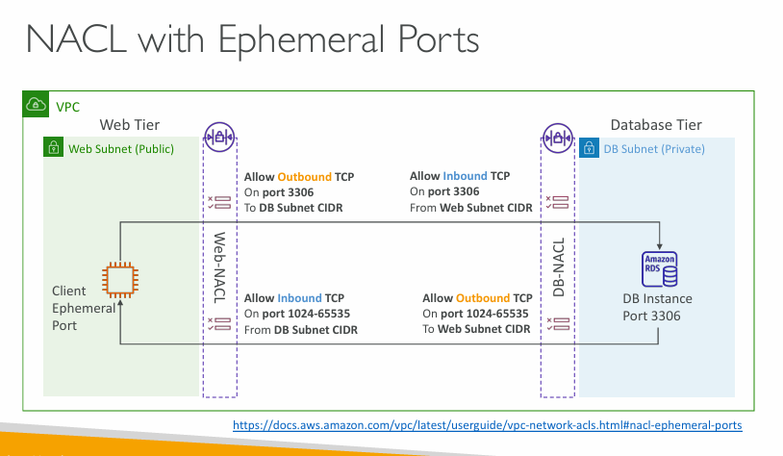  
**What is Happening in This Diagram?**

This shows **a web server in a public subnet** (Web Tier) connecting to a **database server (like Amazon RDS)** in a **private subnet** (Database Tier).  
They are in **different subnets**, and **NACLs (Network ACLs)** control the traffic.

**🧠 Key Concept: Ephemeral Ports**

When the web server connects to the database on **port 3306 (MySQL)**:

* The **web server uses a random high-numbered ephemeral port** (like 50123).
* The **database receives the request on fixed port 3306**.
* The **database replies back to the ephemeral port** used by the web server.

**🔐 What NACL Rules Are Needed?**

Because **NACLs are stateless** (unlike Security Groups), you must allow **both directions** of traffic manually.

**🔸 Web-NACL Rules (on Public Subnet):**

* ✅ **Outbound TCP on port 3306** to the DB subnet → allows sending the request.
* ✅ **Inbound TCP on ephemeral port range (1024–65535)** from the DB subnet → allows receiving the reply.

**🔸 DB-NACL Rules (on Private Subnet):**

* ✅ **Inbound TCP on port 3306** from the Web subnet → allows receiving the request.
* ✅ **Outbound TCP on ephemeral port range (1024–65535)** to the Web subnet → allows sending the reply.

**🔁 Direction Summary**

| **Direction** | **Source** | **Destination** | **Port** | **Rule Location** |
| --- | --- | --- | --- | --- |
| Web → DB | Web Tier | DB Port 3306 | 3306 | Web-NACL (Outbound) & DB-NACL (Inbound) |
| DB → Web (reply) | DB Tier | Web Ephemeral Port | 1024-65535 | DB-NACL (Outbound) & Web-NACL (Inbound) |

**⚠️ Why Is This Important?**

If you **forget the ephemeral port range** in your NACL rules:

* The **response from the DB won’t reach the web server**.
* You’ll get **connection timeouts** or **failed database calls**.

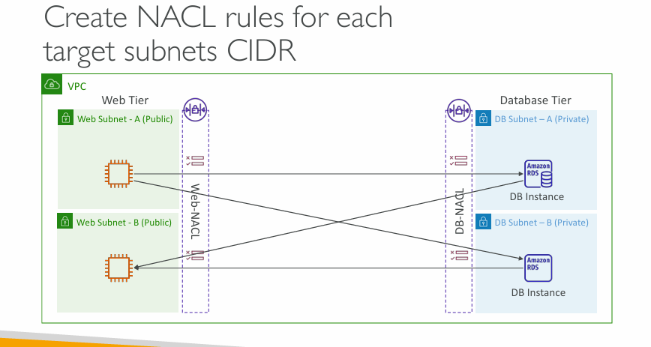  
**What's the Main Message?**

You must create **NACL rules for each target subnet CIDR** — **not just one rule per tier**.  
Every **subnet-to-subnet communication path** must be explicitly allowed.

**🔍 What’s in the Diagram?**

* There are **two public subnets** in the **Web Tier**:
  + Web Subnet – A (Public)
  + Web Subnet – B (Public)
* There are **two private subnets** in the **Database Tier**:
  + DB Subnet – A (Private)
  + DB Subnet – B (Private)
* Both **Web Subnets** need to access both **DB Subnets**, so:
  + Each **NACL** (Web and DB) must allow traffic to/from **all possible CIDRs** involved.

**🛡️ What NACL Rules Are Required?**

**🔸 Web-NACL (applied to Web Tier Subnets A & B):**

You must allow:

* ✅ **Outbound**:
  + TCP on **port 3306** (MySQL) to:
    - DB Subnet A CIDR
    - DB Subnet B CIDR
* ✅ **Inbound**:
  + TCP on **ephemeral port range (1024–65535)** from:
    - DB Subnet A CIDR
    - DB Subnet B CIDR

**🔸 DB-NACL (applied to DB Tier Subnets A & B):**

You must allow:

* ✅ **Inbound**:
  + TCP on **port 3306** from:
    - Web Subnet A CIDR
    - Web Subnet B CIDR
* ✅ **Outbound**:
  + TCP on **ephemeral port range (1024–65535)** to:
    - Web Subnet A CIDR
    - Web Subnet B CIDR

**❗Why Is This Important?**

If you **forget to allow a specific subnet’s CIDR**:

* That **subnet won't be able to communicate** with the DB.
* Your application might **partially fail** — e.g., only one web server can access the database.

**✅ Key Takeaway**

Always **add separate NACL rules for each individual subnet CIDR** that will be involved in communication — **even if they’re in the same tier** (web/database).

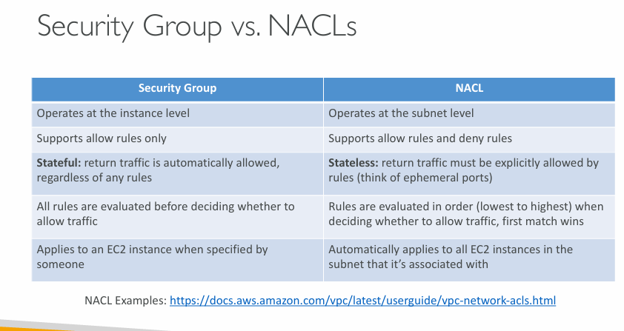

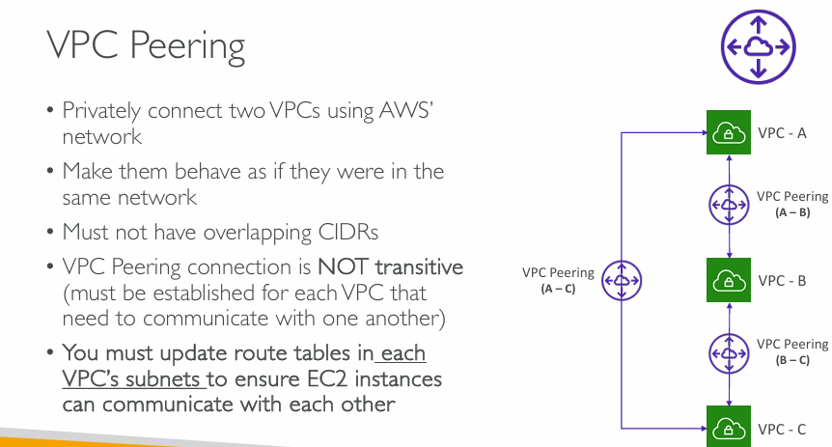  
**Main Concept: VPC Peering**

**VPC Peering** lets you **privately connect two VPCs** using AWS's internal network. This makes the VPCs behave **as if they are on the same network**, allowing resources like EC2 instances to communicate directly.

**📌 Key Points Explained**

**🔹 "Privately connect two VPCs"**

* No traffic goes over the public internet.
* Lower latency and better security.

**🔹 "Behave as if they were in the same network"**

* You can **use private IPs** to reach resources across VPCs.
* Works across **same or different AWS accounts and regions**.

**🔹 "Must not have overlapping CIDRs"**

* CIDR blocks (IP address ranges) in the peered VPCs must be **unique** to avoid routing conflicts.

**🔹 "VPC Peering connection is NOT transitive"**

* Example:
  + If A ↔ B and B ↔ C are peered, **A cannot talk to C** unless **A ↔ C** is also explicitly peered.
* You must create a **direct peering connection** between every VPC that needs to talk.

**🔹 "Update route tables in each VPC’s subnets"**

* After peering, **you still need to update routing**:
  + Add a route in each VPC's route table pointing to the **CIDR of the peer VPC**, using the **peering connection ID** as the target.

**📊 Diagram (Right Side) Breakdown**

* Shows **three VPCs**: A, B, and C.
* Peering connections exist between:
  + VPC-A ↔ VPC-B
  + VPC-B ↔ VPC-C
  + VPC-A ↔ VPC-C
* This is necessary because of **non-transitivity**. Without the A–C connection, VPC-A and VPC-C couldn’t communicate.

**✅ Key Takeaways**

* VPC Peering is **point-to-point and non-transitive**.
* Always check:
  1. No CIDR overlap.
  2. Routes are configured correctly in **each subnet's route table**.
* Use **multiple peering connections** if you have many VPCs that need to talk.

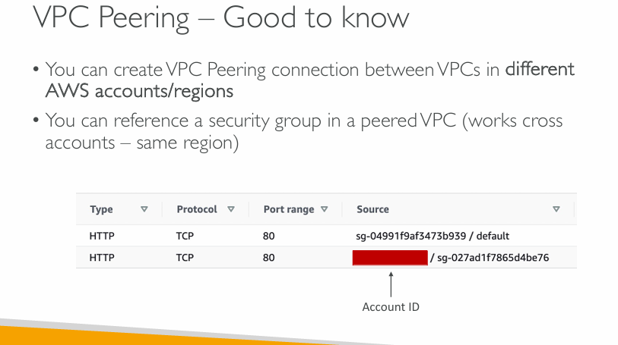

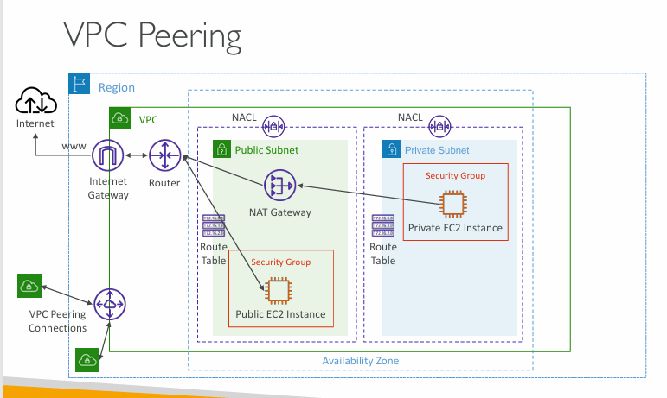

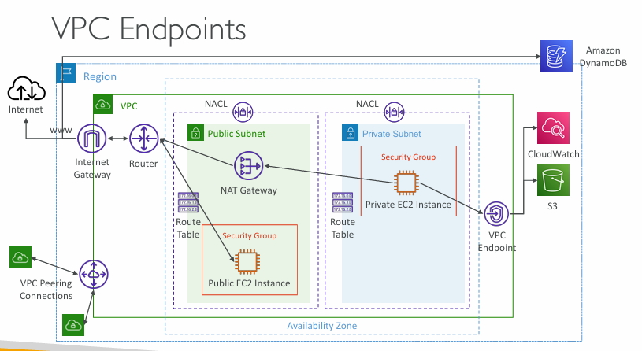

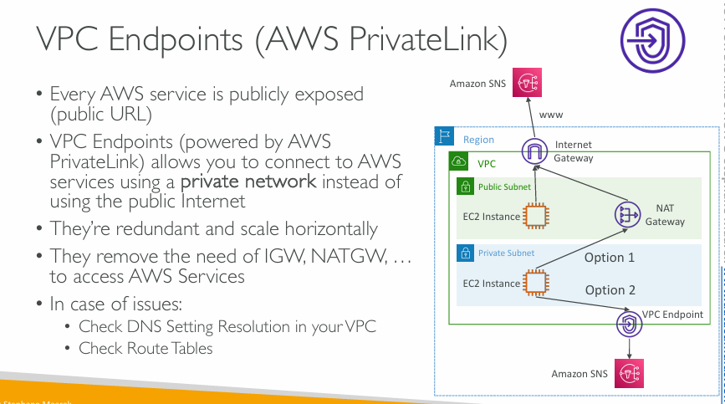  
**What Are VPC Endpoints?**

By default, AWS services like SNS, S3, or DynamoDB are exposed over the **public internet** via **public URLs** (e.g., https://sns.us-east-1.amazonaws.com).

**VPC Endpoints**, powered by **AWS PrivateLink**, let your VPC **privately access these services** over AWS’s internal network.

**🧠 Key Benefits**

**✅ Private Network Access**

* No need for an **Internet Gateway (IGW)** or **NAT Gateway (NATGW)**.
* Traffic never leaves the AWS network → **more secure and lower latency**.

**✅ Highly Available**

* VPC Endpoints are **redundant and horizontally scalable**.
* You don’t need to manage availability – AWS handles it.

**✅ Simplified Architecture**

* Reduces complexity and cost (you can skip NAT Gateway for private subnets).

**📊 Diagram Explained**

The diagram shows two options for an EC2 instance in a **private subnet** to access **Amazon SNS**:

**🔸 Option 1: Public Path**

* EC2 → NAT Gateway → Internet Gateway → SNS (over public internet)
* Requires:
  + NAT Gateway (adds cost)
  + Public route
  + Public exposure

**🔸 Option 2: PrivateLink (VPC Endpoint)**

* EC2 → VPC Endpoint → SNS (over private AWS network)
* Much **more secure and efficient**

The EC2 instance in the **public subnet** also uses the internet (via IGW) to access SNS unless you configure it to use the VPC Endpoint.

**⚠️ Troubleshooting Tips**

If the VPC Endpoint isn’t working:

1. **Check DNS Resolution**
   * Make sure the VPC is configured to resolve AWS service DNS to PrivateLink endpoints.
   * Enable “DNS hostnames” and “DNS resolution” in your VPC settings.
2. **Check Route Tables**
   * Ensure your route tables allow traffic from your subnet to the VPC endpoint.

**🔐 Security Bonus**

With VPC Endpoints, you can also **restrict service access using endpoint policies**, allowing only certain principals or actions.

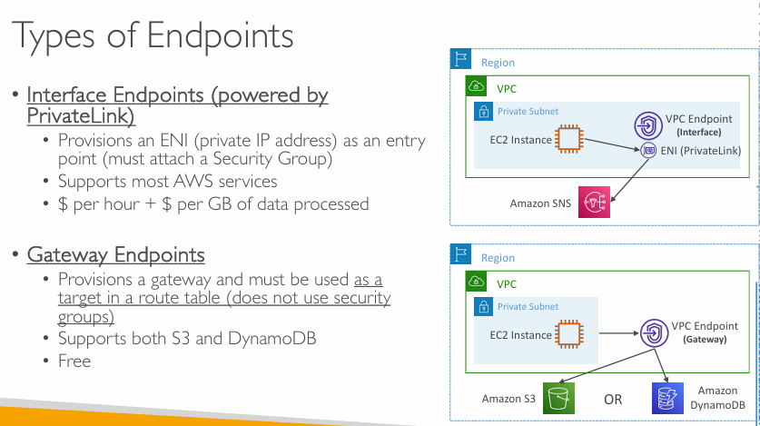  
**Types of VPC Endpoints**

**1. Interface Endpoints (🔌 via PrivateLink)**

* Uses a **private IP** (Elastic Network Interface).
* **Must attach a Security Group**.
* Supports **most AWS services** (e.g., SNS, SSM, Secrets Manager).
* 💰 **Not free**: Charged **per hour** + **per GB** of traffic.
* 🛡️ Provides private connectivity **inside your VPC**.

**Example:** Accessing Amazon SNS privately from an EC2 instance.

**2. Gateway Endpoints (🚪 via Route Table)**

* Uses a **route table entry** to reach AWS services.
* Does **not use security groups**.
* Only supports **Amazon S3 and DynamoDB**.
* 💸 **Free to use**.
* Good for **large-volume, cost-sensitive** data access (e.g., S3 backups).

**Example:** EC2 accessing S3 or DynamoDB via a VPC route.

**🧠 Summary Table:**

| **Feature** | **Interface Endpoint** | **Gateway Endpoint** |
| --- | --- | --- |
| Protocol | ENI (PrivateLink) | Route Table |
| Security Group Needed | ✅ Yes | ❌ No |
| Supported Services | Most AWS Services | S3, DynamoDB Only |
| Cost | 💰 Charged | 🆓 Free |

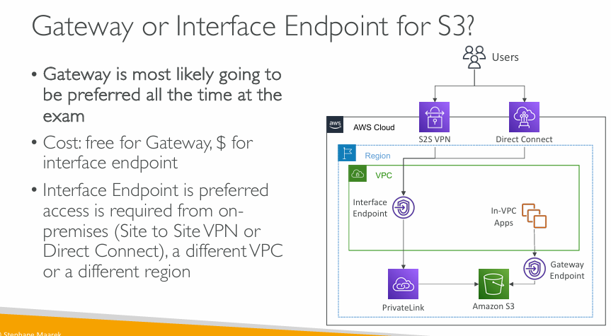  
**Gateway or Interface Endpoint for S3?**

**✅ Gateway Endpoint (🟢 Preferred in Most Cases)**

* **Best choice for exam questions** (almost always preferred).
* **Free of cost** – there’s no hourly or data processing charge.
* Works **within the same VPC**.
* Uses a **route table** to route traffic to S3.
* **Supports S3 and DynamoDB only**.
* Doesn’t support access from on-premises, other VPCs, or regions.

🔧 **Use Case Example**:

* Your application is inside an EC2 instance in a VPC and needs to access S3 – the Gateway Endpoint is the cheapest and simplest way.

**🔌 Interface Endpoint (via PrivateLink)**

* **Costs money** – charged **per hour** and **per GB of data processed**.
* Uses a **private IP address** inside your VPC (called an ENI).
* Supports access from:
  + **On-premises networks** via Site-to-Site VPN or Direct Connect.
  + **Different VPCs** (shared services).
  + **Different regions**.

🔧 **Use Case Example**:

* You have a data center connected to AWS with a VPN or Direct Connect and want secure, private access to S3 – Interface Endpoint is needed.

**📊 Comparison Table:**

| **Feature** | **Gateway Endpoint** | **Interface Endpoint** |
| --- | --- | --- |
| Cost | 🆓 Free | 💰 Charged hourly + per GB |
| Access from On-premises | ❌ Not supported | ✅ Yes |
| Cross-VPC or Cross-Region | ❌ No | ✅ Yes |
| Security Group | ❌ Not applicable | ✅ Required |
| Protocol | Route Table | ENI (Private IP) |
| Services Supported | S3, DynamoDB only | Most AWS services |

**📌 Summary:**

* Use **Gateway Endpoint** for S3 if everything is inside the **same VPC** — it’s free and simple.
* Use **Interface Endpoint** if you need **cross-VPC**, **on-premises**, or **cross-region access** to S3 — it provides flexibility but comes with a cost.

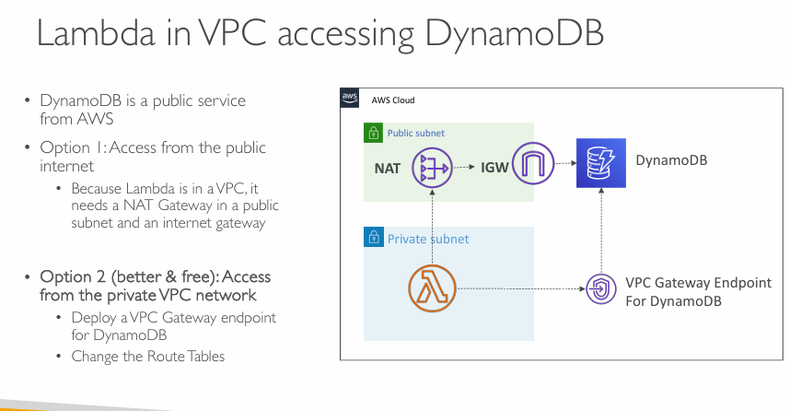  
**Allow a Lambda function in a VPC to access Amazon DynamoDB**

**🗒️ Background:**

* **DynamoDB** is a **public AWS service**, not inside your VPC.
* When **Lambda is inside a VPC**, it **can’t directly access the internet or public AWS services** like DynamoDB.
  + This is a **network limitation** of VPCs.

**🔁 Two Ways to Solve This:**

**✅ Option 1: Access via Public Internet (Not ideal)**

* **How?**
  + Lambda is placed in a **private subnet**.
  + You must use:
    - A **NAT Gateway** in a **public subnet**, and
    - An **Internet Gateway** attached to your VPC.
* **Drawbacks:**
  + ❌ **Costly** – NAT Gateways incur charges.
  + ❌ Less secure – traffic flows through the public internet.
  + ❌ More complex networking setup.

**✅✅ Option 2: Access via Private Network (Best Practice)**

* **How?**
  + Deploy a **VPC Gateway Endpoint for DynamoDB**.
  + Update the **route table** of the Lambda’s subnet to use this endpoint.
* **Benefits:**
  + 🆓 **Free** – Gateway Endpoints are free.
  + ✅ **More secure** – data never leaves the AWS private network.
  + ✅ **Simpler** setup – no need for NAT or IGW.
  + ✅ **Better performance** and **less latency**.

**📊 Summary Table:**

| **Feature** | **Option 1: NAT Gateway** | **Option 2: VPC Gateway Endpoint** |
| --- | --- | --- |
| Cost | 💰 Expensive (NAT costs) | 🆓 Free |
| Internet dependency | 🌐 Yes (uses public internet) | 🚫 No (stays within AWS) |
| Security | ⚠️ Public path | ✅ Private, secure |
| Complexity | 🔧 Needs NAT + IGW | ✅ Just update route tables |
| Best Practice | ❌ Not ideal | ✅ Recommended |

**📌 Final Recommendation:**

* **Always use VPC Gateway Endpoints** for DynamoDB (and S3) **when Lambda is inside a VPC**.
* It’s **cheaper, more secure, and better for exam answers**.

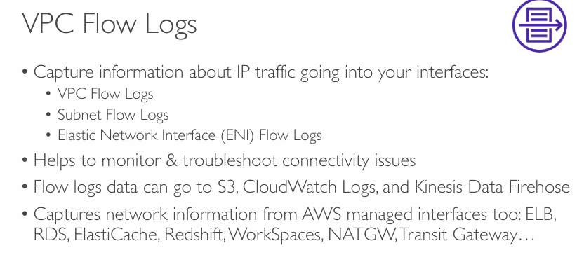  
**What are VPC Flow Logs?**

**VPC Flow Logs** are a way to **capture information about the IP traffic** going to and from network interfaces in your VPC.

Think of them as **network "surveillance cameras"** for your AWS infrastructure – they watch and log traffic behavior.

**📌 What Can You Log?**

You can create flow logs at different levels:

1. **VPC level** – captures traffic for the entire VPC.
2. **Subnet level** – captures traffic for a specific subnet.
3. **ENI (Elastic Network Interface) level** – captures traffic for a specific network interface (like for an EC2 instance, RDS, etc.).

**🔍 Why Use Flow Logs?**

* ✅ **Monitor** network traffic
* ✅ **Troubleshoot** connectivity issues (e.g., why an EC2 instance can't connect)
* ✅ **Audit** and analyze patterns (like who is talking to whom)
* ✅ Helps with **security investigations**

**📤 Where Can the Logs Be Sent?**

Flow logs can be sent to:

* **Amazon S3** – for storage and later analysis
* **CloudWatch Logs** – for real-time monitoring and alarms
* **Kinesis Data Firehose** – for streaming to analytics tools or external systems

**💡 It Also Works With...**

You can collect flow logs **not just from EC2**, but also from **AWS managed services** like:

* ELB (Elastic Load Balancer)
* RDS (Relational Database Service)
* ElastiCache
* Redshift
* WorkSpaces
* NAT Gateway
* Transit Gateway  
  ... and more.

**🧠 Key Exam Tips:**

* VPC Flow Logs **do not capture packet contents**, only metadata (like source IP, destination IP, ports, protocol, etc.).
* They **don’t log traffic to Amazon DNS**, **Windows license servers**, and **some other AWS infrastructure IPs**.

**📝 Simple Summary:**

| **Feature** | **Description** |
| --- | --- |
| What it captures | IP traffic metadata for VPC interfaces |
| Levels | VPC, Subnet, ENI |
| Where logs go | S3, CloudWatch Logs, Kinesis Firehose |
| Use cases | Troubleshooting, monitoring, auditing |
| Works with | Both user-created and AWS-managed interfaces (e.g., RDS, ELB) |

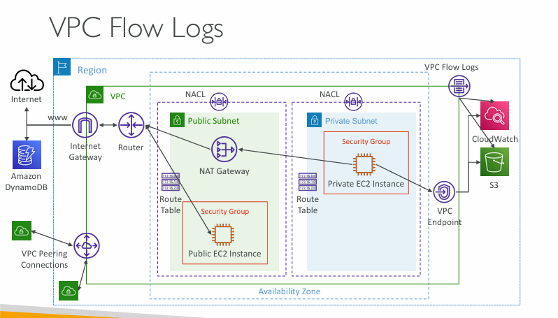

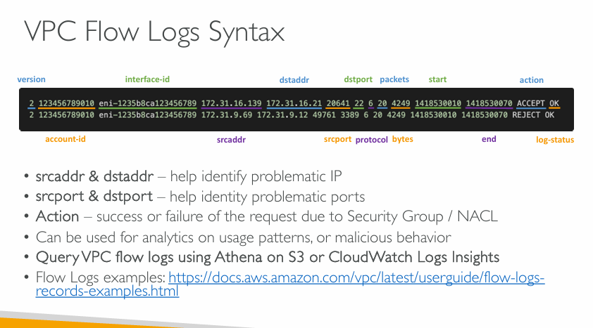  
**What is VPC Flow Log Syntax?**

Each flow log entry is a **line of data** with specific fields. These fields capture network traffic details like source/destination IPs, ports, actions taken, etc.

**📊 Example Flow Log Entry (broken into parts):**

2 123456789010 eni-1235b8ca123456789 172.31.16.139 172.31.16.21 20641 22 6 20 4249 1418530010 1418530070 ACCEPT OK

**🧩 Field-by-Field Breakdown**

| **Field** | **Meaning** |
| --- | --- |
| **version** | Format version of the flow log (currently 2) |
| **account-id** | AWS Account ID |
| **interface-id** | Elastic Network Interface (ENI) on which traffic was observed |
| **srcaddr** | Source IP address (where the traffic originated from) |
| **dstaddr** | Destination IP address (where the traffic is going) |
| **srcport** | Source port |
| **dstport** | Destination port |
| **protocol** | Protocol number (e.g., 6 = TCP, 17 = UDP) |
| **packets** | Number of packets transferred in the flow |
| **bytes** | Amount of data (in bytes) transferred |
| **start** | Start time of the flow (epoch format) |
| **end** | End time of the flow (epoch format) |
| **action** | Whether traffic was **ACCEPTED** or **REJECTED** |
| **log-status** | Shows log result: OK, NODATA, or SKIPDATA |

**🎯 Important Notes:**

* ✅ srcaddr & dstaddr: Use these to trace which IPs might be causing issues.
* ✅ srcport & dstport: Useful for identifying which ports are being used or blocked.
* ✅ action: Shows if traffic was allowed (ACCEPT) or blocked (REJECT) by security groups or network ACLs.
* ✅ log-status:
  + OK = logged successfully
  + NODATA = no data for this interval
  + SKIPDATA = data was skipped due to resource limits

**🔍 How to Analyze?**

* You can analyze flow logs using:
  + **Amazon Athena** (if logs are stored in S3)
  + **CloudWatch Logs Insights** (if logs are in CloudWatch)

**📘 Use Cases:**

* 🚨 **Troubleshoot connectivity issues**
* 🔐 **Check if security rules are blocking traffic**
* 🕵️ **Detect suspicious traffic behavior**
* 📈 **Audit traffic patterns and costs**

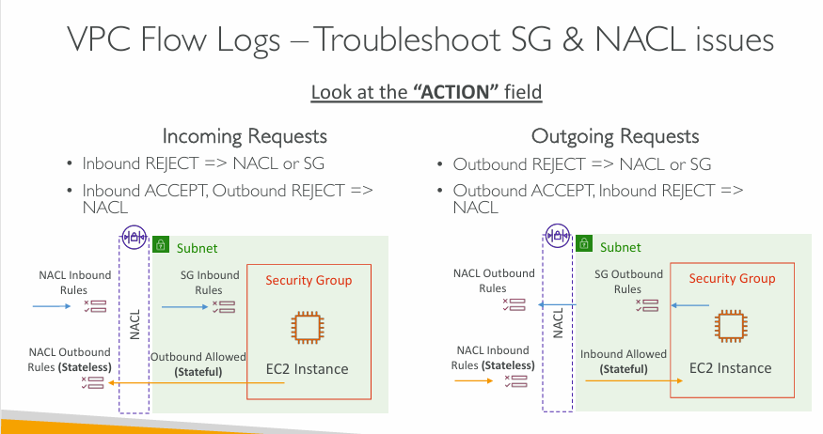  
**Key Concept: Look at the "ACTION" field in VPC Flow Logs**

| **ACTION Result** | **Possible Cause** |
| --- | --- |
| REJECT | Blocked by **NACL** or **Security Group** |
| ACCEPT | Traffic was **allowed** |

**🛠️ Troubleshooting Based on Traffic Direction:**

**🔁 Incoming Requests**

* 🔴 Inbound REJECT → Issue with **NACL** or **Security Group**
* ⚠️ Inbound ACCEPT, but Outbound REJECT → Likely **NACL** is blocking the return response

📊 Example:

* NACL is **stateless**, so both directions (inbound & outbound) must be explicitly allowed.
* Security Groups are **stateful**, meaning if inbound is allowed, the return outbound is automatically allowed.

**🔁 Outgoing Requests**

* 🔴 Outbound REJECT → Blocked by **NACL** or **Security Group**
* ⚠️ Outbound ACCEPT, but Inbound REJECT → **NACL** likely blocks the return traffic

**🧠 Summary Table**

| **Scenario** | **Likely Blocker** |
| --- | --- |
| Inbound REJECT | SG or NACL |
| Inbound ACCEPT, Outbound REJECT | NACL |
| Outbound REJECT | SG or NACL |
| Outbound ACCEPT, Inbound REJECT | NACL |

**📘 Notes on the Diagram:**

* Left side shows **Inbound** request:
  + If SG allows it, but NACL denies outbound → request never completes.
* Right side shows **Outbound** request:
  + If SG allows outbound, but NACL blocks inbound response → connection fails.

This is very useful when debugging **EC2 connectivity issues**, and helps you determine **where** the block is happening: at the **SG level** or **NACL level**.

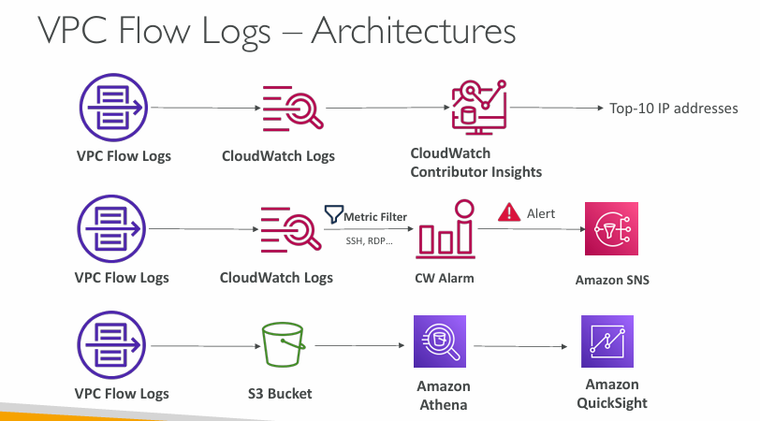

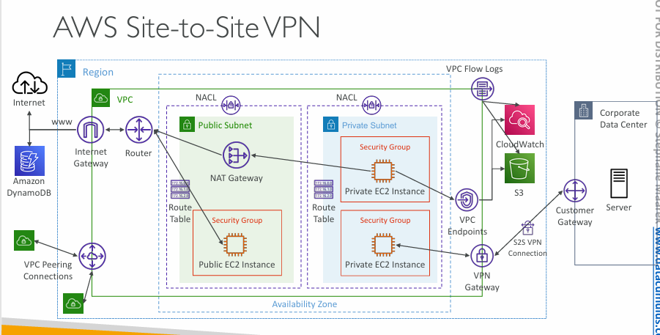

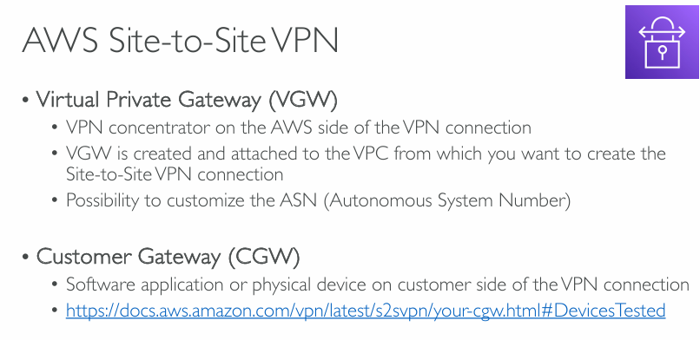  
**AWS Site-to-Site VPN Overview**

**🔒 1. Virtual Private Gateway (VGW)**

* Acts as the **VPN concentrator** on the **AWS side** of the connection.
* You:
  + Create it in AWS.
  + Attach it to your **VPC**.
* Can customize the **ASN (Autonomous System Number)**, useful for **BGP routing**.

✅ Think of VGW as the AWS endpoint for your VPN.

**🏠 2. Customer Gateway (CGW)**

* Represents the **on-premises side** of the VPN connection.
* Can be:
  + A **hardware appliance** (e.g., Cisco, Juniper).
  + A **software VPN** solution.
* Must provide:
  + CGW IP address.
  + ASN (if using BGP).

🔗 Link provided: [Customer Gateway Devices Tested](https://docs.aws.amazon.com/vpn/latest/s2svpn/your-cgw.html#DevicesTested)

**🧠 Summary:**

| **Component** | **Role** | **Location** |
| --- | --- | --- |
| **VGW** | AWS VPN endpoint | AWS Cloud |
| **CGW** | Customer VPN endpoint | On-premises |

Together, VGW and CGW establish a **secure IPsec tunnel** between AWS and your data center.

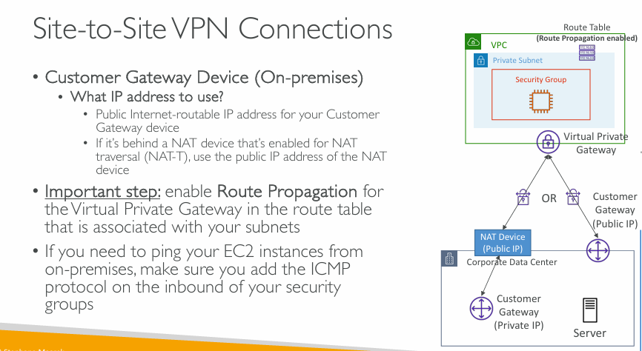  
(Important slide for exam)

**Components Involved**

**1. Customer Gateway Device (CGW)**

* This is the **VPN device at your end (on-premises)**—in your corporate data center.
* Its job is to **establish a secure VPN tunnel to AWS**.

**❓What IP address should you use?**

* You need a **public, internet-routable IP address** for this device so AWS can reach it.
* Two cases:
  1. ✅ **Device has a public IP**: Use it directly.
  2. 🔀 **Device is behind a NAT** (Network Address Translation):
     + Use the **public IP of the NAT device**, not the private IP of the CGW.
     + This is called **NAT Traversal (NAT-T)**.

**2. Virtual Private Gateway (VGW)**

* This is the **AWS side** of the VPN connection.
* It is attached to your **AWS VPC** and connects to the CGW over the internet.

**🛣️ Important: Enable Route Propagation**

Once the VPN tunnel is up, AWS needs to know **how to route traffic** from your VPC to your on-premises network.

* In your **VPC route table**, you **must enable “Route Propagation”**.
* This allows AWS to **automatically add routes** to your route table when the VPN is connected, based on the VPN configuration.

Without this step, **your EC2 instances won’t know how to send traffic back to your on-premises network**, even though the tunnel is up.

**🛑 Ping Troubleshooting (ICMP)**

If you want to **test the connection using ping**:

* Ping uses the **ICMP protocol**.
* Make sure your **Security Group in AWS allows ICMP** **inbound**.
  + By default, ICMP is often blocked.

**🔍 Diagram Explanation (Right side of slide)**

1. The top part shows your **AWS VPC**, with:
   * A **Private Subnet**.
   * A **Security Group** around your EC2 instance.
   * A **Route Table** with Route Propagation enabled.
   * A **Virtual Private Gateway**.
2. The bottom part shows your **On-Premises Corporate Data Center**, which has:
   * A **Customer Gateway** (VPN device).
   * Possibly a **NAT Device** (if the CGW is using a private IP).
   * A **Server** (maybe your local application or internal system).
3. The VPN connection is established **between VGW (AWS) and CGW (on-prem)**.

**✅ Summary: What You Must Do**

| **Task** | **Why it Matters** |
| --- | --- |
| Provide a **public IP** for CGW | So AWS can reach your device |
| **Enable Route Propagation** in VPC route table | So traffic to on-prem routes correctly |
| **Allow ICMP in SG** | So ping requests work |
| Configure NAT-T if CGW is behind NAT | Ensures tunnel still works properly |

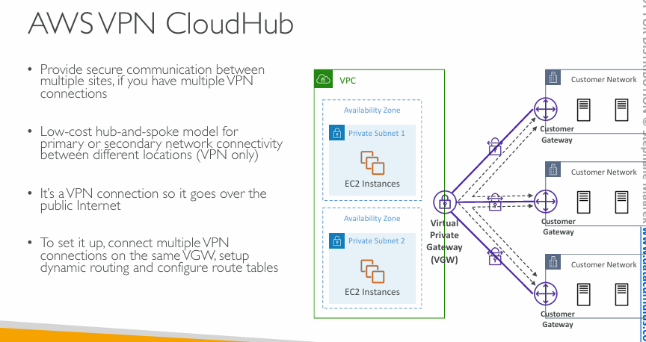  
**What is AWS VPN CloudHub?**

**Definition:**

AWS VPN CloudHub is a **hub-and-spoke VPN architecture** using AWS as the **hub** to connect **multiple customer sites (spokes)** securely over the internet.

**🔧 When and Why to Use It?**

| **Feature** | **Description** |
| --- | --- |
| 🔒 **Secure communication** | Between **multiple sites** via AWS |
| 💸 **Low cost** | Cheaper than direct private connections (like MPLS or Direct Connect) |
| 🔁 **Hub-and-spoke model** | Central VGW (AWS VPC) connects to **multiple CGWs** |
| 🌍 **Internet-based VPN** | Uses **public internet**, but the data is **encrypted** via VPN tunnels |

This is ideal for:

* A company with **multiple branch offices** needing to **talk to each other** and AWS.
* Providing a **backup** connection path if a primary connection fails.

**🏗️ How It Works (Diagram Explained)**

* **VPC (in AWS)** contains:
  + **Private Subnet 1** and **Subnet 2**
  + **EC2 instances** (your AWS resources)
  + **Virtual Private Gateway (VGW)**
* **Customer Networks** (like your company’s offices in New York, London, and Tokyo):
  + Each has a **Customer Gateway (CGW)** device.
  + Each CGW has a **VPN connection to the VGW**.
* The VGW acts as a **central router (hub)**:
  + Routes traffic between:
    - AWS and each CGW.
    - CGWs to each other (office-to-office communication).
  + This setup allows **branch offices to talk to each other securely** through AWS.

**🛠️ How to Set It Up (Simple Steps)**

1. **Create VPN Connections**:
   * Each site gets a **VPN tunnel to the same VGW**.
2. **Enable Dynamic Routing**:
   * Use **BGP (Border Gateway Protocol)** to advertise each site's IP ranges.
   * BGP helps VGW know where to send traffic for each office.
3. **Update Route Tables**:
   * Update VPC and CGW route tables to allow traffic between each customer site and AWS.
4. **Ensure Security Groups and NACLs**:
   * Configure them to allow traffic between sites if needed.

**✅ Summary Table**

| **Aspect** | **Explanation** |
| --- | --- |
| 🔌 Connectivity | Multiple CGWs to one VGW |
| 🧭 Routing | BGP used to dynamically route between sites |
| 🌍 Internet Use | VPN runs over public internet |
| 🔐 Security | IPsec VPN encryption |
| 💡 Use Case | Multi-site companies needing low-cost interconnectivity |

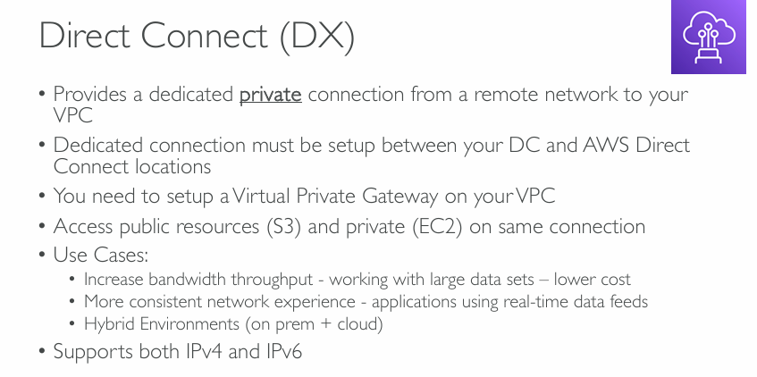  
**What is Direct Connect (DX)?**

**👉 It's a private, physical connection (not over the public internet) that links your data center (DC) to AWS.**

* Unlike VPN, which travels over the **public internet**, DX gives you a **dedicated line** for **faster, more secure, and more consistent** network traffic.

**🔧 How Does It Work?**

1. **Establish a connection** between your **data center (DC)** and an **AWS Direct Connect location** (this is usually done at a co-location facility).
2. Set up a **Virtual Private Gateway (VGW)** on your AWS VPC to receive the Direct Connect link.
3. Once set up, you can access:
   * **Private resources** (e.g., EC2, RDS inside your VPC)
   * **Public AWS services** (e.g., S3, DynamoDB) over the **same physical connection**

**✅ Key Benefits and Use Cases**

| **Use Case** | **Description** |
| --- | --- |
| 🚀 **High Bandwidth Needs** | Ideal for large datasets or data transfer operations that need high throughput (e.g., video rendering, backups) |
| 📶 **Consistent Performance** | Great for real-time applications (e.g., live analytics or trading apps) because you avoid the variability of internet latency |
| 🔗 **Hybrid Environments** | Perfect for environments where on-prem systems and AWS cloud systems need to talk over a reliable, low-latency network |

**🧰 Requirements to Use DX**

* Must have a **physical setup** at a **Direct Connect location**
* Requires a **VGW** attached to the AWS VPC
* You'll either lease a connection from AWS or via a partner
* DX can be **combined with VPN** as a backup

**🌐 Protocol Support**

* Works with both **IPv4 and IPv6**, meaning it’s future-proof and compatible with modern networks.

**🆚 DX vs. VPN (Comparison Summary)**

| **Feature** | **Direct Connect (DX)** | **Site-to-Site VPN** |
| --- | --- | --- |
| **Type** | Dedicated private line | Encrypted tunnel over public internet |
| **Performance** | High, consistent | Variable (depends on internet) |
| **Security** | Physically isolated | Encrypted but over public lines |
| **Setup Complexity** | More complex | Simpler |
| **Use Cases** | Big data, hybrid cloud | Small-medium hybrid setups or backups |

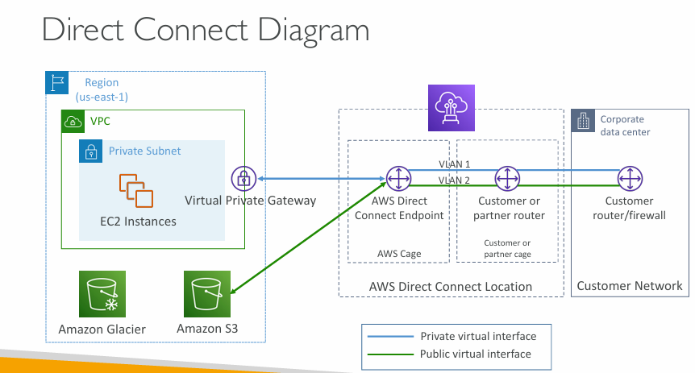  
**What is AWS Direct Connect?**

**AWS Direct Connect** is a **dedicated network connection** between your on-premises **corporate data center** and **AWS**.  
It gives you **lower latency**, **higher bandwidth**, and **more consistent network performance** than public internet.

**📘 Main Components in the Diagram**

**🔷 1. Region (us-east-1)**

* This is your AWS Region where your resources live.
* Inside it, there's a **VPC** (Virtual Private Cloud) with a **Private Subnet** hosting **EC2 instances**.

**🟩 2. Amazon Services (S3, Glacier)**

* These are AWS services you might want to access from your on-prem network.

**🔐 3. Virtual Private Gateway**

* Think of this as a “door” between your AWS VPC and the Direct Connect service.
* It lets you privately route traffic from AWS resources to your on-prem data center.

**🧩 Middle Section: AWS Direct Connect Location**

This is where your **AWS infrastructure meets your corporate infrastructure**. It typically lives in a third-party **data center**.

* 🟪 **AWS Direct Connect Endpoint**: The AWS side of the Direct Connect setup.
* 🔁 **Customer or Partner Router**: The network hardware that connects to your on-premises network.
* Both sides use **VLANs** to separate traffic.

**🧑‍💼 Right Side: Customer Network**

* Your **corporate data center**, including your **firewall/router** that connects to the outside world.
* This network is where your employees or services live.

**🧵 Two Types of Virtual Interfaces (Important!)**

**🔹 Private Virtual Interface (Blue Line)**

* **Purpose**: To connect **privately** to AWS services inside your VPC (like EC2, RDS, etc.)
* **Flow**:  
  Customer Network → Customer Router → AWS Direct Connect Endpoint → Virtual Private Gateway → EC2

**🟢 Public Virtual Interface (Green Line)**

* **Purpose**: To access **public AWS services** (like **S3**, **Glacier**, etc.) but **without using the public internet**.
* **Flow**:  
  Customer Network → Customer Router → AWS Direct Connect Endpoint → Amazon S3/Glacier

**✅ Benefits of Using Direct Connect**

* **High performance**: Bypasses public internet.
* **Predictable**: Better latency and bandwidth.
* **Secure**: Traffic stays private.
* **Cost-saving**: Especially for large data transfers.

**📌 Summary of the Flow**

| **Source** | **Destination** | **Interface Type** | **Example Use** |
| --- | --- | --- | --- |
| On-prem data center | EC2 in AWS VPC | Private VIF (blue) | Internal apps using AWS backend |
| On-prem data center | S3 or Glacier | Public VIF (green) | Backups, data storage |

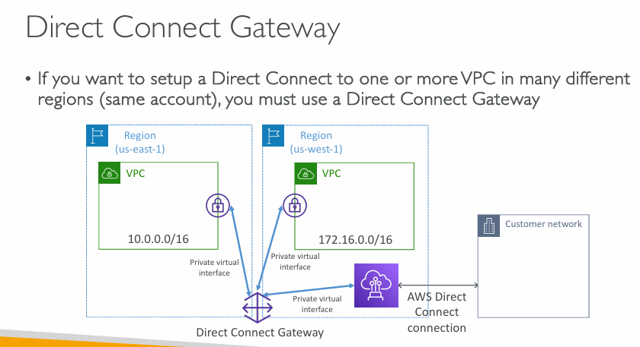  
**What is a Direct Connect Gateway?**

A **Direct Connect Gateway (DX Gateway)** is an **AWS networking resource** that lets you:

* Use **one Direct Connect (DX) connection** to connect to **multiple VPCs**.
* Those VPCs can even be in **different AWS Regions**.
* This makes it more **efficient**, **cost-effective**, and **scalable** than setting up separate connections for each VPC.

**🎯 Why Use It?**

If your company has:

* A **centralized on-prem data center**, and
* **Multiple VPCs in different regions** (e.g., us-east-1, us-west-1),  
  then instead of building **separate Direct Connect connections** for each VPC, you use **one Direct Connect** with a **Direct Connect Gateway**.

**📘 Diagram Breakdown**

**👤 Right Side: Customer Network**

* Your **on-premises network**.
* Connects via **AWS Direct Connect**.

**🟪 AWS Direct Connect Gateway**

* This is the core component.
* Think of it like a **hub** that links your Direct Connect to many **spoke VPCs**, even in different regions.

**🔌 AWS Direct Connect Connection**

* This is the **physical dedicated connection** between your data center and AWS (often through a partner colocation facility).
* Only **one physical connection is needed**, even if you have multiple VPCs.

**🔷 Regions**

* **us-east-1** has a VPC with CIDR 10.0.0.0/16
* **us-west-1** has a VPC with CIDR 172.16.0.0/16
* Both VPCs are in **different AWS Regions** but are reachable from the same customer network using the Direct Connect Gateway.

**🔐 Private Virtual Interfaces**

* These are used to connect **privately to AWS VPCs** (no internet).
* All the VPCs connect back to the **Direct Connect Gateway** using private virtual interfaces.

**🧭 Traffic Flow Summary**

Customer Network

↓

AWS Direct Connect connection

↓

Direct Connect Gateway

↙ ↘

us-east-1 VPC us-west-1 VPC

(10.0.0.0/16) (172.16.0.0/16)

**Key Benefits**

| **Feature** | **Benefit** |
| --- | --- |
| **Multi-region** | Connect to VPCs across different AWS Regions. |
| **Single connection** | Only one Direct Connect connection needed. |
| **Simplifies setup** | No need to peer VPCs or duplicate links. |
| **Secure and private** | No traffic goes over the public internet. |

**🛠️ Notes & Best Practices**

* The **VPC CIDR blocks must not overlap**.
* You must **associate VPCs with the Direct Connect Gateway** manually.
* Configure **route tables** in each VPC so traffic flows through the virtual gateway correctly.

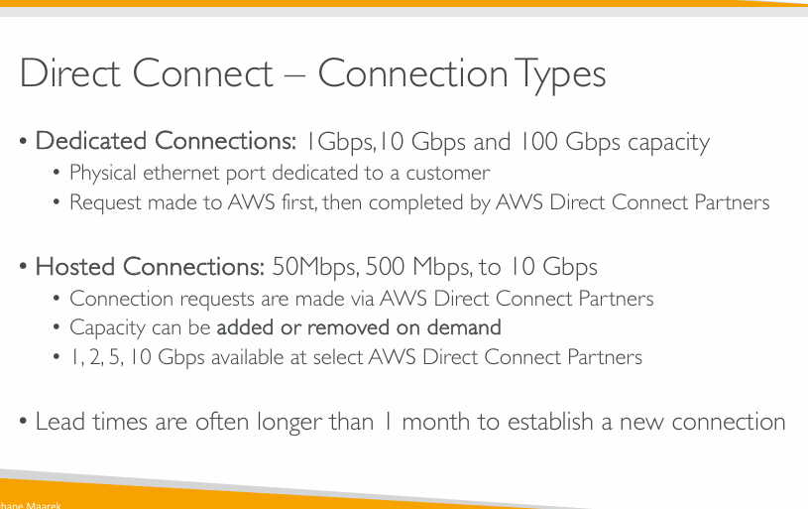  
In exam they will ask questions around, we want to transfer some data within a week and we want it to be fast, so the answer cannot be Direct Connect because Direct Connect takes often more than one month to establish. So we need to look into question whether or not there is already a Direct Connect established, and whether or not the time to transmit the data is less or greater than one month.

**What is AWS Direct Connect?**

**AWS Direct Connect** lets you establish a **dedicated network connection** between your on-premises network (e.g., data center) and AWS.

It's a **faster, more reliable, and secure alternative** to accessing AWS over the public Internet.

**🔷 1. Dedicated Connections**

**📌 Key Points:**

* **Speeds available**: 1 Gbps, 10 Gbps, and 100 Gbps.
* A **physical ethernet port** in an AWS data center is assigned **exclusively to you**.
* **You initiate** the connection request **through AWS**.
* Once AWS approves, an **AWS Direct Connect Partner** (a network provider) helps complete the setup.

**✅ Use Case:**

Large enterprises needing consistent, high-throughput, secure traffic between their data centers and AWS.

**🟦 2. Hosted Connections**

**📌 Key Points:**

* **Speeds available**: 50 Mbps, 500 Mbps, up to 10 Gbps.
* You **don’t get your own dedicated port**—instead, an **AWS Partner shares their port** with multiple customers.
* You must **request it through an AWS Partner** (not directly via AWS).
* Bandwidth can be **scaled up or down on demand** (flexible).

**✅ Use Case:**

* Small to medium businesses or variable workloads.
* Great for **burstable needs** or testing AWS Direct Connect without full commitment.

**📅 Important Note: Lead Time**

“Lead times are often longer than 1 month to establish a new connection.”

* Direct Connect setup (especially **Dedicated**) is a **long process** involving physical infrastructure.
* Plan accordingly—**you won’t get instant access like with a VPN**.

**✅ Summary Comparison Table**

| **Feature** | **Dedicated Connection** | **Hosted Connection** |
| --- | --- | --- |
| **Speed** | 1, 10, 100 Gbps | 50 Mbps to 10 Gbps |
| **Port Ownership** | Exclusive | Shared |
| **Request Through** | AWS → Partner | Partner directly |
| **Scalability** | Static | Scalable (on demand) |
| **Use Case** | Large, stable workloads | Small/medium or dynamic needs |

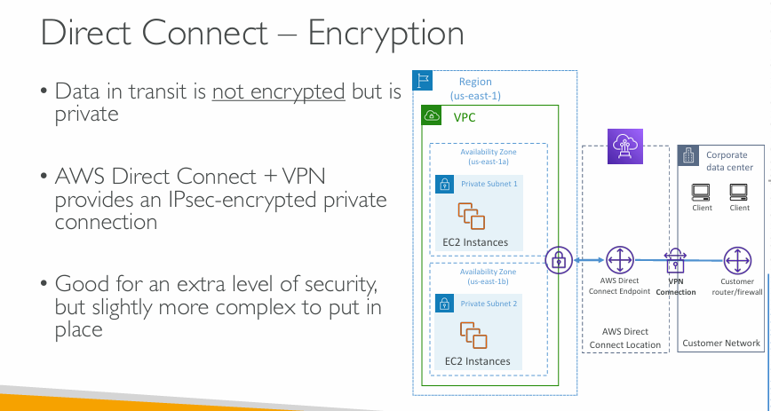  
**Is AWS Direct Connect Encrypted?**

**❗ Important: Data in transit is not encrypted**

* AWS Direct Connect uses a **private** network connection between your on-premises network and AWS.
* However, that **doesn’t mean the data is encrypted**. It’s private (not exposed to the public Internet), but **unencrypted** by default.

**🔒 How to Add Encryption**

**✅ Combine Direct Connect + VPN**

* You can run a **VPN tunnel** over your Direct Connect line.
* This creates an **IPSec-encrypted** channel, meaning:
  + Data is **encrypted** in transit.
  + You get the best of both worlds: **low latency, private line + encryption**.

**💡 Why Add VPN to Direct Connect?**

| **Without VPN** | **With VPN** |
| --- | --- |
| Private connection, but **unencrypted** | Private connection **and encrypted** |
| Easier to set up | Slightly **more complex** (extra configuration) |
| Lower latency, lower complexity | **Extra security** for sensitive data |

**📊 Diagram Walkthrough (Right Side)**

Here’s what the architecture is showing:

1. **Corporate data center**:
   * Hosts client systems.
   * Connects to AWS over **Direct Connect** (purple line).
2. **Customer router/firewall**:
   * Handles routing from on-premises to AWS.
   * Now includes a **VPN device or software** (shown as “VPN Connection”).
3. **AWS Direct Connect Endpoint**:
   * At the AWS location where the Direct Connect circuit terminates.
   * Connects to your VPC through a **Virtual Private Gateway**.
4. **VPC in AWS (Region: us-east-1)**:
   * Contains EC2 instances in two availability zones.
   * Traffic from your data center securely reaches EC2 over **Direct Connect + VPN**.

**🧠 Summary**

* 🔸 **Direct Connect is private, but not encrypted**.
* 🔸 To protect sensitive data (e.g., financial, healthcare), **use VPN over Direct Connect**.
* 🔸 Adds complexity but increases **security assurance**.

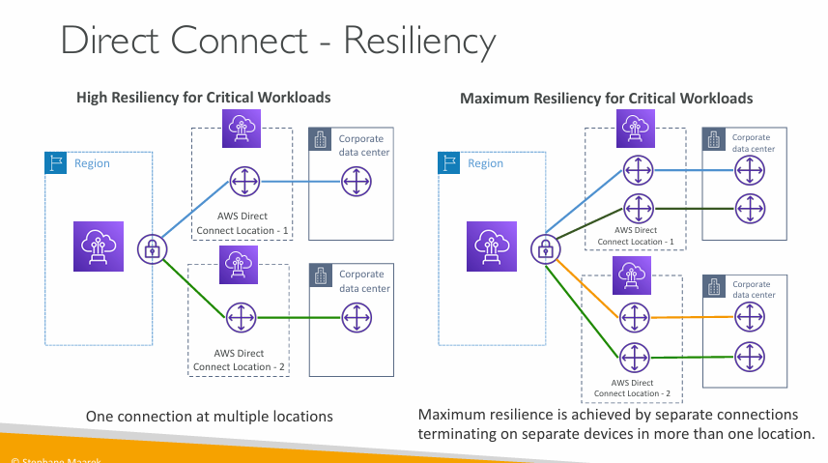  
Resiliency topic also comes in the exam

**What is Resiliency in AWS Direct Connect?**

Resiliency refers to the system’s **ability to continue operating even if one part fails**. For AWS Direct Connect, this means **maintaining connectivity** even if a location or device fails.

**🔹 Left Side: High Resiliency for Critical Workloads**

**Setup:**

* One AWS Region.
* Two **AWS Direct Connect Locations** (Location 1 and Location 2).
* Each location has **one connection** to **a separate corporate data center**.

**Benefits:**

* **Redundancy** at the **location level**.
* If one location goes down, traffic can be rerouted through the other.
* Good for many **business-critical apps**.

**Summary:**

✅ **High availability**  
✅ Covers location failure  
❌ Doesn't cover **device-level** failures within the location

**🔸 Right Side: Maximum Resiliency for Critical Workloads**

**Setup:**

* Same Region.
* Two AWS Direct Connect Locations.
* **Each location has two connections** going to **two different routers/devices** at separate corporate data centers.
* Total of **4 connections**.

**Benefits:**

* Resilience at both **location level** *and* **device level**.
* **Each connection terminates on a separate router**, so even if one **device, location, or fiber link** fails, the others remain.

**Summary:**

✅ **Highest level of fault tolerance**  
✅ Handles device, router, and location failures  
✅ Recommended for **mission-critical systems** like healthcare, finance, etc.

**📌 Key Takeaways**

| **Feature** | **High Resiliency** | **Maximum Resiliency** |
| --- | --- | --- |
| # of Direct Connect locations | 2 | 2 |
| # of connections | 2 (1 per location) | 4 (2 per location) |
| Redundancy type | Location-level | Location + Device-level |
| Use Case | Business-critical workloads | Mission-critical workloads |

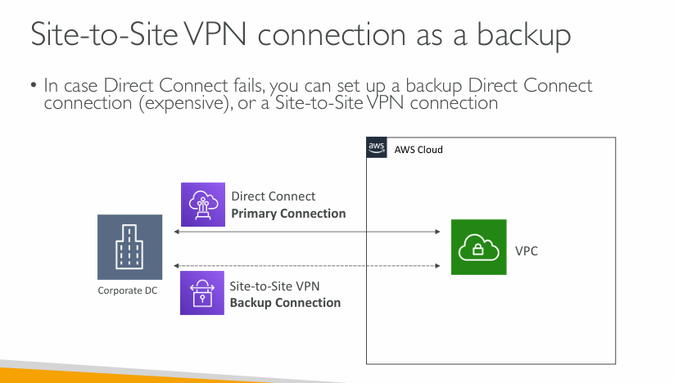  
**Site-to-Site VPN as a Backup for Direct Connect**

**🔹 Primary Connection:**

* **AWS Direct Connect**
* Provides **high bandwidth** and **low latency** connectivity between your on-premises **corporate data center** and your **AWS VPC**.
* **Does not encrypt** traffic by default (unless used with VPN).
* More **expensive** and **dedicated**.

**🔸 Backup Connection:**

* **Site-to-Site VPN**
* Encrypted using **IPSec**.
* Traverses the **public internet**, so it might be **slower** or **less reliable**.
* Much **cheaper** than having a secondary Direct Connect link.
* Can **automatically take over** when Direct Connect fails using BGP (Border Gateway Protocol) failover configuration.

**✅ Why Use This Approach?**

* **Cost-effective failover**: You avoid the cost of a second dedicated connection.
* **Business continuity**: Your apps remain reachable even if the primary Direct Connect goes down.
* **Simple to set up**: VPN is managed service on AWS and easier to provision than Direct Connect.

**🧠 How AWS Handles Failover?**

AWS supports **dynamic routing with BGP**, allowing:

* **Automatic failover** from Direct Connect to VPN if the Direct Connect path becomes unavailable.
* AWS **prioritizes Direct Connect** over VPN when both paths are available.

**Summary Table**

| **Feature** | **Direct Connect** | **Site-to-Site VPN** |
| --- | --- | --- |
| Path Type | Dedicated link | Over public internet |
| Encryption | ❌ Not encrypted by default | ✅ Encrypted (IPSec) |
| Cost | 💸 High | 💰 Lower |
| Reliability | ✅ High | ⚠️ Depends on internet |
| Use as Primary/Backup | ✅ Primary | ✅ Ideal for backup |

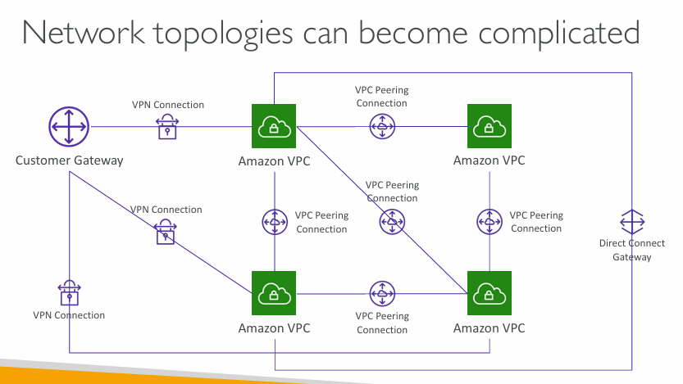  
**What’s in This Diagram?**

**🔶 Customer Gateway:**

* Represents your **on-premises network**.
* Connects to AWS using **VPN Connections** (IPSec-encrypted).

**🟩 Amazon VPCs:**

* Multiple **Virtual Private Clouds** in AWS.
* Each green box represents a separate **VPC**.

**🔗 VPC Peering Connections:**

* Direct **private IP connectivity** between VPCs.
* Multiple peerings are shown — forming a **mesh network**.

**📡 Direct Connect Gateway:**

* Used to **centralize** Direct Connect access across multiple VPCs.
* Connects VPCs across different AWS Regions or accounts.

**❗ Why Can This Get Complicated?**

1. **Multiple VPN connections** to multiple VPCs:
   * Requires careful routing and IP management.
   * Each VPN must be configured and monitored separately.
2. **Peering Mesh**:
   * To allow full connectivity, you need **N×(N-1)/2** peering connections.
     + For 5 VPCs: 10 peering connections
   * **Doesn't scale well** — hard to manage, troubleshoot, and secure.
3. **Transitive Routing is Not Supported** in VPC Peering:
   * A VPC cannot forward traffic from one peer to another (no hop-through).
   * Forces you to explicitly peer every VPC that needs access.

**✅ Solutions to Simplify This**

* **Transit Gateway (TGW)**:
  + Centralized hub for connecting VPCs and VPNs.
  + Supports transitive routing (unlike VPC peering).
  + Reduces the need for a full mesh topology.
* **Use Direct Connect Gateway with TGW**:
  + Combines high-speed private connectivity with centralized management.

**Summary**

| **Challenge** | **Solution** |
| --- | --- |
| Too many peerings | Use **Transit Gateway** |
| Transitive routing limitation | Transit Gateway supports it |
| Complex VPN setup | Centralize via TGW or DX GW |
| Difficult scalability | Transit Gateway scales better |

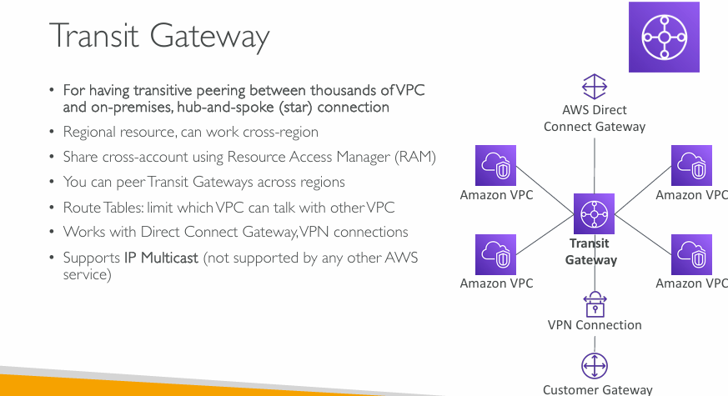   
**What is a Transit Gateway?**

* **Transit Gateway (TGW)** is a **hub-and-spoke** networking service.
* It allows **thousands of VPCs and on-premises networks** to connect via a central hub.
* It **enables transitive routing**, which is not possible with regular VPC peering.

**💡 Key Features (from the slide):**

1. **Transitive Peering**:
   * A VPC can talk to another VPC or VPN-connected network **through the TGW**.
   * No need for direct peering between each VPC.
2. **Regional Resource**:
   * TGW is created per AWS region but can connect VPCs **across regions** via peering.
3. **Cross-Account Sharing**:
   * Share TGWs with other AWS accounts using **AWS Resource Access Manager (RAM)**.
4. **Transit Gateway Peering**:
   * Connect TGWs in different regions to expand your global network.
5. **Custom Route Tables**:
   * Use routing rules to control **who can talk to whom**.
   * Enforce segmentation, security, and policies.
6. **Integration with Direct Connect and VPN**:
   * TGW supports connections from **VPNs and Direct Connect Gateway**.
   * Simplifies hybrid architecture.
7. **IP Multicast Support**:
   * Unique among AWS services.
   * Useful for use cases like financial trading systems, video streaming, etc.

**🖼️ Diagram Explanation (Right Side of Slide):**

* **Transit Gateway** in the center.
* Spoke connections to:
  + **Amazon VPCs**
  + **Customer Gateway** (on-premises via VPN)
  + **Direct Connect Gateway** (for high-bandwidth hybrid connectivity)

This **hub-and-spoke model** greatly simplifies the routing logic compared to a **full mesh** of VPC peerings or VPNs.

**🆚 Transit Gateway vs VPC Peering**

| **Feature** | **Transit Gateway** | **VPC Peering** |
| --- | --- | --- |
| Transitive routing | ✅ Supported | ❌ Not supported |
| Scalability | Up to 5000 attachments | Manual mesh; not scalable |
| Centralized management | ✅ Yes | ❌ Peer-by-peer |
| Cross-region connectivity | ✅ With peering | ✅ But manual |
| Use cases | Large, multi-VPC networks | Small, simple connections |

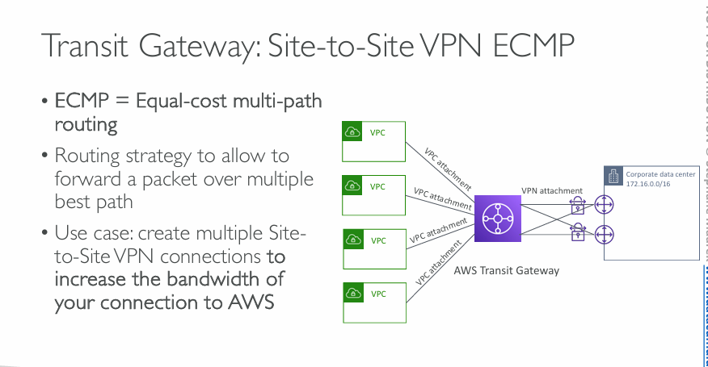  
**What is ECMP?**

* **ECMP (Equal-Cost Multi-Path Routing)** is a networking technique.
* It **allows multiple paths** to be used simultaneously **if they have the same cost (latency, metrics, etc.)**.
* In AWS, it is supported by Transit Gateway when you set up **multiple VPN tunnels** to the same destination.

**📌 Why use ECMP with Transit Gateway?**

* **Traditional VPNs are limited in bandwidth** per tunnel (1.25 Gbps per tunnel).
* **ECMP allows you to scale bandwidth** horizontally:
  + By creating **multiple VPN tunnels**, packets can be distributed across them.
  + This creates a **parallel VPN connection** setup to increase throughput.

**💼 Use Case (as described in the slide):**

“Create multiple Site-to-Site VPN connections to **increase the bandwidth** of your connection to AWS.”

✅ **More connections → more bandwidth**  
✅ **Automatic load distribution by Transit Gateway**

**🖼️ Diagram Breakdown (Right Side):**

* **Corporate data center (172.16.0.0/16)** on the right.
* Connected via **multiple Site-to-Site VPN tunnels** to **AWS Transit Gateway**.
* **Transit Gateway** is also connected to **multiple Amazon VPCs** via VPC attachments.
* All VPCs can now **share this aggregated VPN bandwidth** through Transit Gateway.

**⚙️ Technical Notes:**

* You must **manually configure** multiple VPN tunnels with equal cost.
* Transit Gateway automatically performs **hash-based load balancing** of flows.
* Works best when your workloads have **many flows/connections** (e.g., thousands of users or microservices).
* Not all protocols benefit equally—TCP/UDP heavy workloads typically do.

**🧩 When to Use This**

| **Scenario** | **Transit Gateway ECMP** |
| --- | --- |
| You need > 1.25 Gbps to/from AWS | ✅ Yes |
| You already use Site-to-Site VPNs | ✅ Easy extension |
| You don’t want to use Direct Connect | ✅ Good alternative |

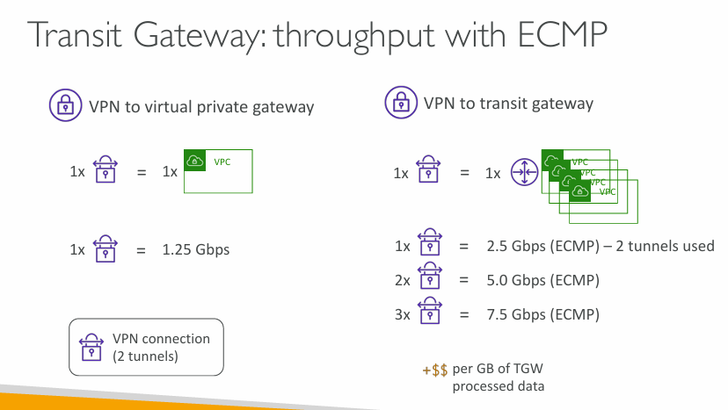  
we can except a question on ECMP in exam

**Two options to connect your on-prem data center to AWS:**

**1. VPN to Virtual Private Gateway (VGW)**

* 1 VPN connection = 1.25 Gbps max throughput
* Each VPN connection includes **2 tunnels** (but still limited to 1.25 Gbps overall)
* No way to increase bandwidth easily — you’re stuck at 1.25 Gbps

**2. VPN to Transit Gateway (TGW) with ECMP**

* TGW supports **ECMP**, meaning it can **use multiple VPN tunnels at once**
* Each VPN connection (2 tunnels) can provide **2.5 Gbps**
* Add more VPNs → get more speed!

| **Number of VPNs** | **Throughput** |
| --- | --- |
| 1 VPN (2 tunnels) | 2.5 Gbps |
| 2 VPNs (4 tunnels) | 5.0 Gbps |
| 3 VPNs (6 tunnels) | 7.5 Gbps |

💡 **ECMP spreads traffic over all available tunnels equally**, increasing total bandwidth.

**📌 Final Notes:**

* 🟢 **Transit Gateway + ECMP = scalable VPN bandwidth**
* ⚠️ You pay **per GB of data processed** by Transit Gateway (shown as +$$)
* Ideal for **high-bandwidth hybrid workloads**

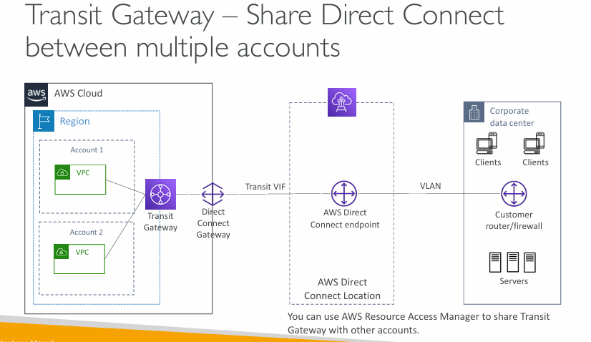  
**What's the use case?**

You have:

* A **corporate data center** with on-prem servers and users
* Multiple AWS accounts (Account 1, Account 2) with their own **VPCs**
* You want a **high-speed, private connection (Direct Connect)** to AWS, **shared** across all these accounts

**🧩 How it works (step by step):**

**✅ Inside the AWS Cloud:**

1. **Transit Gateway (TGW)** connects to VPCs in **Account 1 and Account 2**
2. This TGW is linked to a **Direct Connect Gateway**
3. That DX Gateway connects to the **AWS Direct Connect endpoint** via a **Transit VIF (Virtual Interface)**

**✅ Outside AWS – At your corporate data center:**

1. The **Direct Connect link** reaches your on-prem network using a **VLAN**
2. A **customer router/firewall** splits and routes traffic to internal **clients and servers**

**📌 Key features:**

* **Transit Gateway** allows you to **share one Direct Connect** with **many VPCs** across **multiple AWS accounts**
* You use **AWS Resource Access Manager (RAM)** to **share the TGW** with other accounts
* No need to create separate Direct Connects for each account → **saves money and simplifies networking**

**🧠 Real-world analogy:**

Imagine Direct Connect as a **super fast, private highway** to AWS. Transit Gateway acts like a **traffic controller** at the highway entrance, deciding which AWS account/VPC the cars (data) should go to.

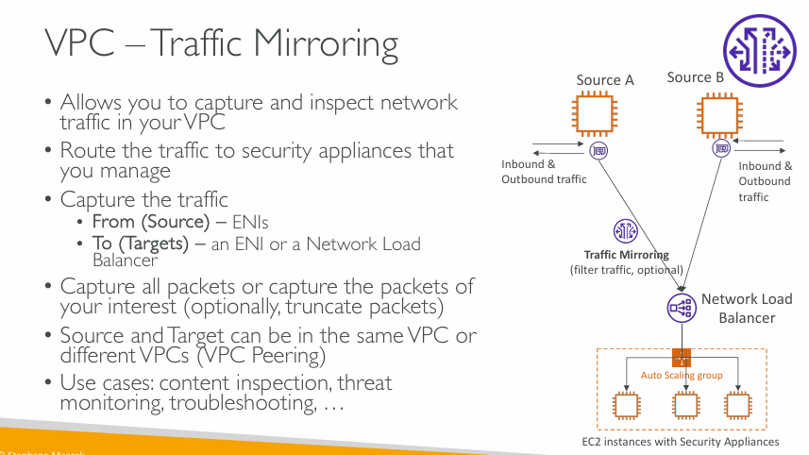  
**What is VPC Traffic Mirroring?**

It lets you **copy (mirror) network traffic** from one or more EC2 instances and **send that copy to a monitoring or security tool**—like a firewall, intrusion detection system (IDS), or even packet analyzer.

**🧩 How it works:**

1. **Source:**
   * The EC2 instances whose traffic you want to monitor (e.g., Source A and B).
   * AWS copies both **inbound and outbound** traffic from these instances.
2. **Mirror Target:**
   * You send the copied traffic to a **Network Load Balancer (NLB)**, which then routes it to **EC2 instances running security appliances** (like threat detection tools).
   * These EC2s are usually in an **Auto Scaling Group**, so they can scale as needed.
3. **Filtering (optional):**
   * You can filter what kind of traffic is mirrored (e.g., only traffic to a specific port or IP).
   * You can also truncate (cut off) packets to reduce data volume.

**📦 Source and Target flexibility:**

* **Source and Target ENIs** (Elastic Network Interfaces) can be in:
  + The **same VPC**, or
  + **Different VPCs** via **VPC Peering**

**🔐 Use Cases:**

* Deep packet inspection
* Threat detection / monitoring
* Performance troubleshooting
* Compliance analysis

**🛠 Real-world analogy:**

Imagine you're in a bank and you install **hidden cameras (traffic mirroring)** at teller counters (source instances). The camera feed goes to a **monitoring room (security appliance)** where experts analyze it for fraud or suspicious behavior.

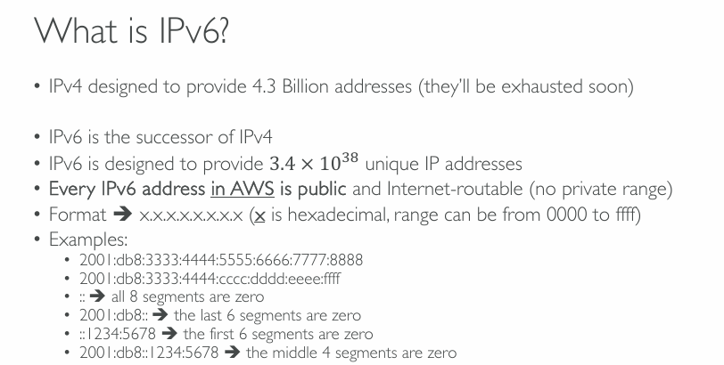  
**What is IPv6?**

* **IPv4** (the current widely-used version) has about **4.3 billion IP addresses**, and we’re **running out of them** due to the explosion of devices connected to the internet.
* **IPv6** is the **newer version** that solves this problem.

**🧮 How many addresses in IPv6?**

* IPv6 can provide **3.4 × 10³⁸** (340 undecillion) IP addresses — that’s a **mind-blowing number** of addresses, more than enough for all devices on Earth many times over.

**🔒 Important for AWS users:**

* In **AWS**, **every IPv6 address is public and internet-routable**.
  + ❌ There are **no private IPv6 addresses** in AWS (unlike IPv4).
  + This means you must **secure them properly** using **security groups** and **NACLs**.

**🔢 IPv6 Format:**

* IPv6 addresses look like this:  
  x:x:x:x:x:x:x:x — each x is a group of 4 hexadecimal digits (0–9 and a–f).

**✅ Examples and shorthand:**

* Full address:  
  2001:db8:3333:4444:5555:6666:7777:8888
* You can shorten it by replacing **consecutive zero blocks** with :::
  + :: = all segments are zero  
    :: = 0000:0000:0000:0000:0000:0000:0000:0000
  + 2001:db8:: = last 6 segments are zero
  + ::1234:5678 = first 6 segments are zero
  + 2001:db8::1234:5678 = middle 4 segments are zero

Note: You can only use :: **once per address** to avoid confusion.

**🔐 Final Note:**

IPv6 in AWS is powerful but also requires **careful security planning** because there's no NAT and everything is publicly reachable unless restricted.

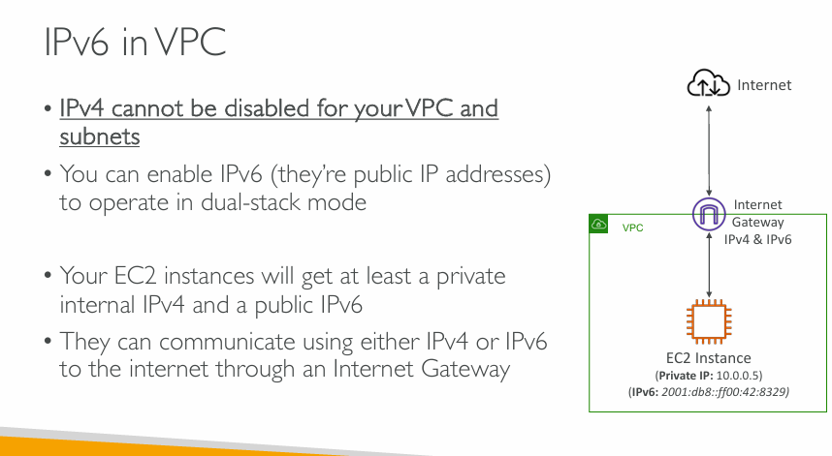  
**Key Points about IPv6 in VPC:**

**🔹 IPv4 cannot be turned off**

* Even if you use IPv6, **IPv4 is still always active** in your VPC and subnets.
* AWS doesn't let you **disable IPv4**.

**🔹 Dual-stack mode**

* You can **enable IPv6** alongside IPv4 — this is called **dual-stack mode**.
* EC2 instances can use **both IPv4 and IPv6** to communicate.

**🔹 IP Address Allocation**

* When you launch an EC2 instance:
  + It gets a **private IPv4 address** (like 10.0.0.5)
  + And it gets a **public IPv6 address** (like 2001:db8::8329)
* The IPv6 address is **public and directly reachable from the internet** (unless blocked by security rules).

**🔹 Internet Connectivity**

* Your instance can reach the internet using either **IPv4 or IPv6** via the **Internet Gateway**.

**📦 Diagram Explanation:**

* The VPC contains an EC2 instance.
* That instance has:
  + Private IPv4: 10.0.0.5
  + Public IPv6: 2001:db8::ff00:42:8329
* It connects to the internet using an Internet Gateway that supports **both IPv4 and IPv6**.

**💡 Use Case Tip:**

You should **secure IPv6 access** using security groups, because it's **publicly accessible** by default in AWS.

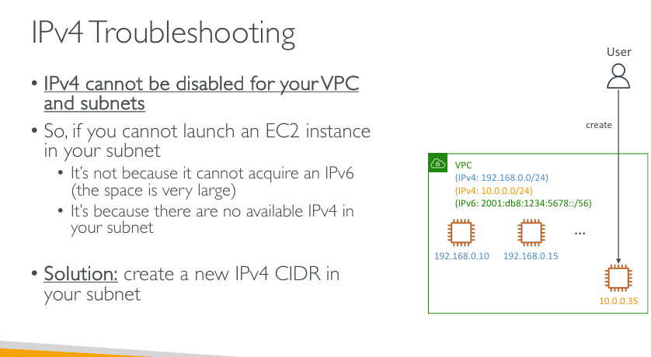  
Exam scenario, so around IPv6 troubleshooting. So as you know, IPv4 cannot be disabled for your VPC and subnets.

**Why This Happens**

* **IPv4 cannot be disabled** in AWS VPCs or subnets — it's always required, even if you're using IPv6.
* **Problem:** When you try to launch a new EC2 instance and it fails, **it's not due to IPv6 exhaustion** (there’s plenty of IPv6 space).
* The **real issue** is usually:  
  👉 **Your subnet ran out of available IPv4 addresses**.

**🧠 Explanation with the Diagram**

* The user tries to launch an EC2 instance.
* The VPC has:
  + **IPv4 ranges**: 192.168.0.0/24 and 10.0.0.0/24
  + **IPv6 range**: 2001:db8:1234:5678::/56
* Several EC2 instances already occupy IPv4 addresses.
* When trying to create a new instance, there's **no free IPv4 left**, even though IPv6 is available.

**✅ Solution**

* You need to **add a new IPv4 CIDR block** to your VPC/subnet to make more IPv4 addresses available.
  + For example, you can expand with 10.0.1.0/24 or another range that doesn’t overlap.

**⚠️ Tip**

Even with IPv6 enabled, AWS still **requires** IPv4 for EC2 networking. Every EC2 instance **must** have an IPv4 address, even if it's only internal.

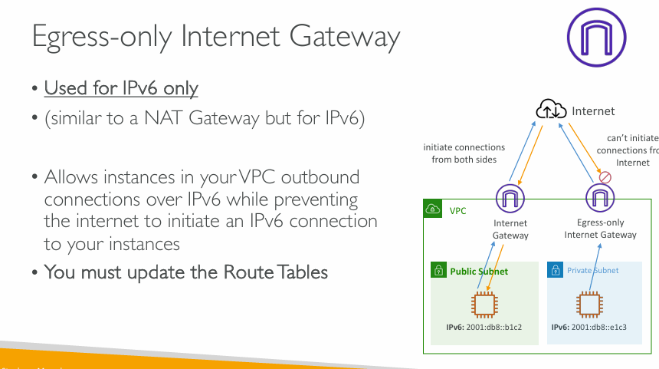  
**What is an Egress-only Internet Gateway?**

* **Used only for IPv6 traffic**.
* It's **similar to a NAT Gateway**, but:
  + NAT is for **IPv4**
  + EIGW is for **IPv6**

**✅ What it Does**

* Allows EC2 instances in a **private subnet** to:
  + **Initiate outbound** connections to the internet over IPv6.
  + **Prevent inbound** IPv6 connections **from the internet** back into the instances.
* Ensures **security** by blocking unsolicited inbound traffic while still allowing outbound access.

**🧠 Visual Breakdown**

* In the diagram:
  + **Public Subnet** (left):
    - Uses a regular **Internet Gateway**.
    - Can **initiate and receive** IPv6 connections.
  + **Private Subnet** (right):
    - Uses an **Egress-only Internet Gateway**.
    - Can only **initiate outbound** IPv6 connections.
    - **Inbound IPv6 connections are blocked**.

**⚠️ Important Reminder**

* You **must update your subnet's route tables** to point IPv6 traffic (::/0) to the **Egress-only Internet Gateway**.

**✅ Use Case**

* When you want **IPv6 internet access for private subnets**, but **do not** want to expose them to **incoming IPv6 traffic**.

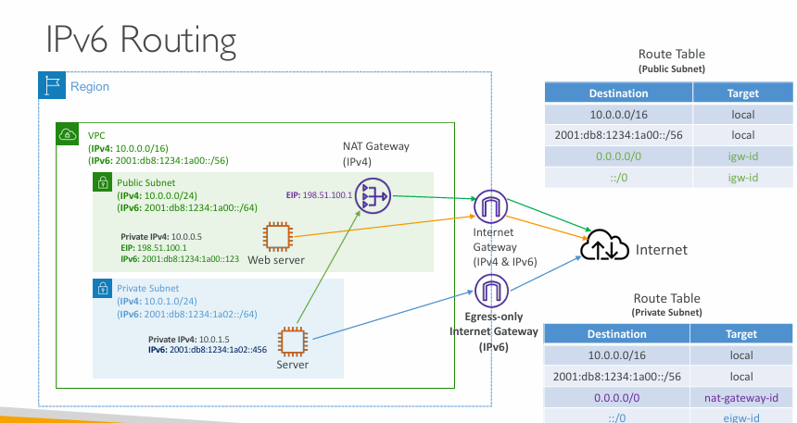  
**High-Level Concept**

Your VPC and its subnets can use **dual-stack mode**:

* **IPv4** for compatibility.
* **IPv6** for scalability and future-proofing.

This diagram shows a VPC with:

* A **Public Subnet** and a **Private Subnet**.
* A **NAT Gateway** (for outbound IPv4 from private subnets).
* An **Internet Gateway** (for full IPv4/IPv6 access).
* An **Egress-only Internet Gateway** (for outbound IPv6 from private subnets).

**📦 Resources**

* **Web Server** in Public Subnet:
  + IPv4: 10.0.0.5 | EIP: 198.51.100.1
  + IPv6: 2001:db8:1234:1a00::123
* **Server** in Private Subnet:
  + IPv4: 10.0.1.5
  + IPv6: 2001:db8:1234:1a02::456

**🧭 Route Tables**

**🔹 Public Subnet**

* 10.0.0.0/16 → local (intra-VPC IPv4)
* 2001:db8:1234:1a00::/56 → local (intra-VPC IPv6)
* 0.0.0.0/0 → igw-id (outbound IPv4 to internet)
* ::/0 → igw-id (outbound IPv6 to internet)

➡️ The public subnet can **send/receive** IPv4 and IPv6 traffic to/from the internet.

**🔹 Private Subnet**

* 10.0.0.0/16 → local
* 2001:db8:1234:1a00::/56 → local
* 0.0.0.0/0 → nat-gateway-id (for IPv4 outbound only)
* ::/0 → eigw-id (for **IPv6 outbound only**)

➡️ The private subnet:

* Uses the **NAT Gateway** for **IPv4 outbound**
* Uses the **Egress-only IGW** for **IPv6 outbound**
* **Cannot receive inbound traffic** from the internet (IPv4 or IPv6)

**🌐 Summary of Gateway Use**

| **Subnet** | **IPv4 Outbound** | **IPv4 Inbound** | **IPv6 Outbound** | **IPv6 Inbound** |
| --- | --- | --- | --- | --- |
| Public Subnet | IGW | IGW | IGW | IGW |
| Private Subnet | NAT Gateway | ❌ | EIGW | ❌ |

**✅ Key Takeaways**

* IPv6 is fully **public and routable**, so private subnets **must use** an **Egress-only IGW** to block inbound.
* Route tables determine how traffic flows per protocol and subnet.
* **You must update route tables** when setting up EIGWs and IGWs.

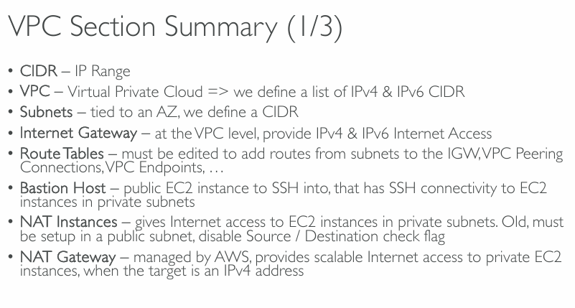  
**Key Concepts Summarized**

* **CIDR (Classless Inter-Domain Routing)**  
  ➤ Represents the IP range (e.g., 10.0.0.0/16) used to allocate IP addresses within your VPC or subnet.
* **VPC (Virtual Private Cloud)**  
  ➤ A logically isolated virtual network.  
  ➤ You define IPv4 and optionally IPv6 CIDR blocks when creating a VPC.
* **Subnets**  
  ➤ Sub-divisions within a VPC tied to a specific **Availability Zone**.  
  ➤ Each subnet must have a CIDR range (subset of the VPC CIDR).
* **Internet Gateway (IGW)**  
  ➤ Attached at the **VPC level** to provide outbound/inbound internet access for IPv4 and IPv6.  
  ➤ Required for any public internet communication.
* **Route Tables**  
  ➤ Determine traffic flow.  
  ➤ Must be updated to enable communication via:
  + **IGW** (for internet)
  + **VPC Peering** (cross-VPC traffic)
  + **VPC Endpoints** (to reach AWS services privately)
* **Bastion Host**  
  ➤ A public EC2 instance used to **SSH into private instances** (which don't have public IPs).  
  ➤ It has access to the internet and private subnets.
* **NAT Instances**  
  ➤ Older method to provide internet access to EC2s in private subnets.  
  ➤ Manual setup: needs to be in a **public subnet** and must **disable source/destination check**.
* **NAT Gateway**  
  ➤ Modern, **AWS-managed alternative** to NAT instances.  
  ➤ Provides **scalable IPv4 internet access** to EC2 instances in private subnets.  
  ➤ Cannot be used for IPv6 (use **Egress-only IGW** for that).

**🧠 Want-to-Know**

* **NAT Gateway ≠ Internet Gateway**  
  NAT GW = for **private** IPv4 → internet  
  IGW = for **public** IPv4 & IPv6 internet connectivity
* **Egress-only Internet Gateway** is the **IPv6 counterpart** of NAT Gateway.

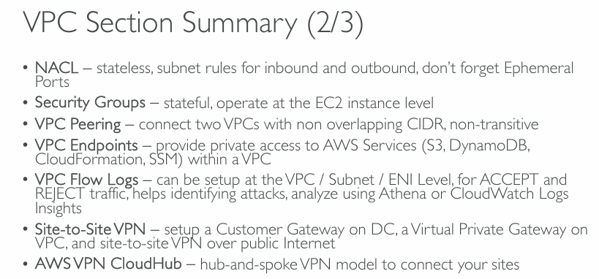  
**Network Security & Monitoring**

* **NACL (Network Access Control List)**  
  ➤ **Stateless**: rules must be defined **for both inbound and outbound**.  
  ➤ Applied at the **subnet level**.  
  ➤ Don’t forget **ephemeral ports** (high-numbered ports needed for responses).  
  ➤ Good for **coarse-grained control** (e.g., block IP ranges).
* **Security Groups**  
  ➤ **Stateful**: return traffic is automatically allowed.  
  ➤ Applied at the **EC2 instance level** (actually on the network interface).  
  ➤ Used for **fine-grained control** of access (e.g., allow SSH from your IP only).

**🔗 Connectivity Between Networks**

* **VPC Peering**  
  ➤ Directly connect two VPCs.  
  ➤ Must have **non-overlapping CIDRs**.  
  ➤ **Non-transitive**: VPC A ↔ B and B ↔ C does **not** mean A ↔ C.  
  ➤ Low latency and cost-effective.
* **VPC Endpoints**  
  ➤ Connect **privately to AWS services** without using the public internet.  
  ➤ Two types:
  + **Interface endpoints** (ENI-based, e.g., for SSM, CloudFormation)
  + **Gateway endpoints** (for S3 and DynamoDB only)

**🕵️‍♂️ Monitoring & Logging**

* **VPC Flow Logs**  
  ➤ Capture traffic metadata (ACCEPT/REJECT) at VPC, subnet, or ENI level.  
  ➤ Helps troubleshoot network issues or detect suspicious activity.  
  ➤ Analyzable with Athena or CloudWatch Logs Insights.

**🌐 Hybrid Network Options (On-Premises ↔ AWS)**

* **Site-to-Site VPN**  
  ➤ Connect your **on-premises network to AWS** via encrypted VPN over the public internet.  
  ➤ Requires:
  + A **Customer Gateway** (on-prem device or software)
  + A **Virtual Private Gateway** (attached to VPC)
* **AWS VPN CloudHub**  
  ➤ A **hub-and-spoke model** to connect multiple sites (on-prem or branch offices) through AWS over VPN.

**✅ Quick Tip:**

* Use **NACLs** for broad subnet-level filtering.
* Use **Security Groups** for detailed instance-level rules.
* Use **Flow Logs** to monitor and troubleshoot both.

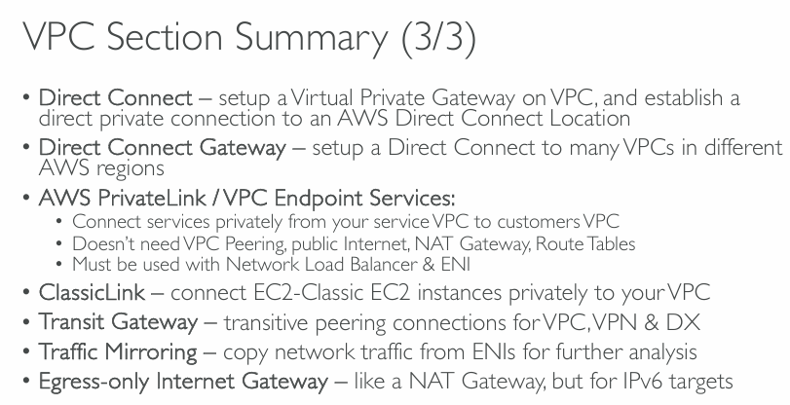  
**Connectivity Services in AWS VPC**

**1. Direct Connect**

* Establishes a **private, high-speed, low-latency connection** from your data center to AWS.
* Requires setting up a **Virtual Private Gateway** on the VPC.

**2. Direct Connect Gateway**

* Extends **Direct Connect** to **multiple VPCs across different regions**.
* Centralized gateway for inter-region VPC connectivity.

**🔒 Private Connectivity Services**

**3. AWS PrivateLink / VPC Endpoint Services**

* Enables **private connectivity** between VPCs without:
  + VPC Peering
  + Public Internet
  + NAT Gateway
  + Custom Route Tables
* **Must use**: Network Load Balancer (NLB) + Elastic Network Interface (ENI).
* Best for offering **private SaaS services** across VPCs.

**🧩 Other Features**

**4. ClassicLink *(Legacy)***

* Connects **EC2-Classic instances** to VPCs **privately**.
* Deprecated and replaced by modern VPC-native features.

**5. Transit Gateway**

* Allows **transitive routing** between multiple:
  + VPCs
  + VPNs
  + Direct Connect links
* Acts as a **hub-and-spoke model** for routing.

**6. Traffic Mirroring**

* Captures traffic from **ENIs (Elastic Network Interfaces)**.
* Useful for **deep packet inspection and analysis**.

**7. Egress-Only Internet Gateway**

* **IPv6-only** NAT-like gateway.
* Allows outbound internet access for **IPv6 instances** while blocking inbound traffic.

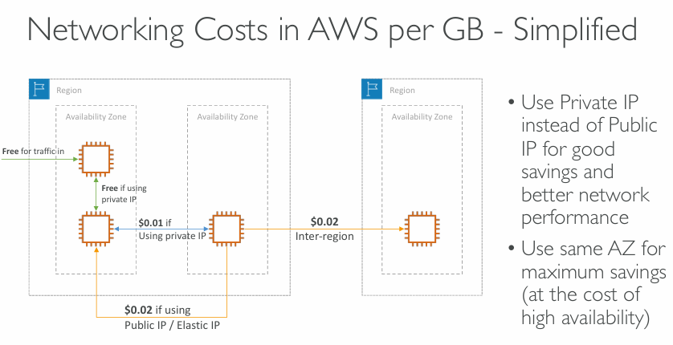  
**AWS Networking Cost Summary (Per GB)**

**🔹 Within the Same Availability Zone (AZ)**

* **Free**: If traffic stays within the **same instance** or uses **private IPs** within the **same AZ**.
* **$0.01**: If using **private IPs across AZs** within the same region.
* **$0.02**: If using **Public IP or Elastic IP**, even within the **same AZ**.

**🔹 Across Regions**

* **$0.02** per GB for **inter-region traffic** (e.g., between us-east-1 and eu-west-1).

**✅ Best Practices for Cost Optimization**

* Use **Private IPs** instead of **Public/Elastic IPs** for lower cost and better performance.
* **Stay within the same AZ** for free data transfer—but be aware this may **compromise high availability**.
* Avoid **inter-region data transfer** unless necessary, as it costs more.

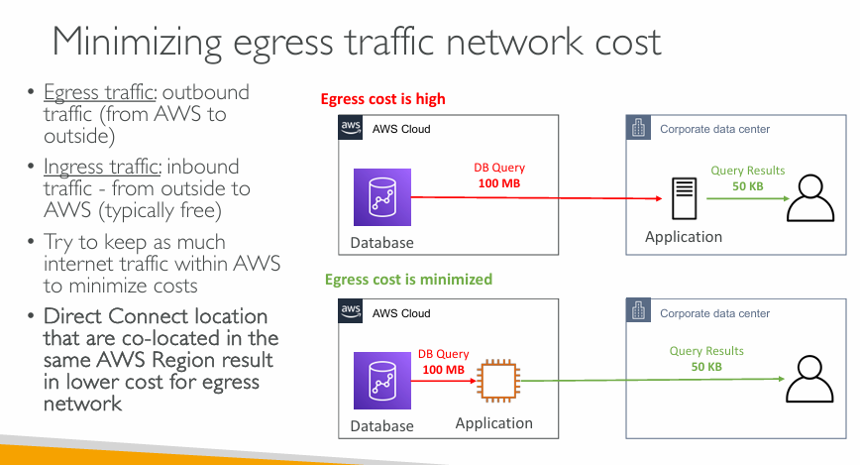  
**Basic Definitions**

**✅ Egress Traffic**

* **Means:** Data going **out from AWS** to **the internet** or **your data center**.
* **Cost:** Usually **costs money**.

**✅ Ingress Traffic**

* **Means:** Data coming **into AWS** from **outside** (e.g., from your users or your on-premise systems).
* **Cost:** Often **free** or **very low cost**.

**🧠 Key Idea: Keep traffic within AWS to save money.**

**💸 Two Scenarios Explained**

**❌ Scenario 1 – High Egress Cost**

* A **database** is in AWS.
* An **application** is in your **corporate data center** (outside AWS).
* The application sends a **DB query** (100 MB) to the AWS database.
* The **response** is small (50 KB) and goes back to the data center.

**Cost Impact:**

* **100 MB** of egress traffic (outbound from AWS) = **high cost**.
* This happens because all query data (100 MB) is going **from AWS to outside**.

**✅ Scenario 2 – Minimized Egress Cost**

* Both the **database** and **application** are inside **AWS** (same region).
* The app makes the same **DB query** (100 MB) internally.
* Only the **final result** (50 KB) goes to the **corporate data center**.

**Cost Impact:**

* **100 MB** of internal traffic (within AWS) = **low or free**.
* Only **50 KB** is sent out of AWS = **very low egress cost**.
* Since the app and DB are in the same AWS region, **no extra charge** for the large internal traffic.

**🧠 Pro Tip from AWS**

**Use Direct Connect** (private network) that is **co-located** in the same region as your AWS resources.  
This further **reduces the cost** of sending data out of AWS.

**📌 Summary (in simple words)**

| **Tip** | **Why It Helps** |
| --- | --- |
| Keep your apps and databases **inside AWS** | So large traffic stays internal and is cheaper |
| Use **Private IPs** and same **Availability Zone** | Reduces data transfer costs |
| Use **Direct Connect** | Cheaper than public internet for egress traffic |
| Only send **final results** outside AWS | Avoid paying for sending large data out |

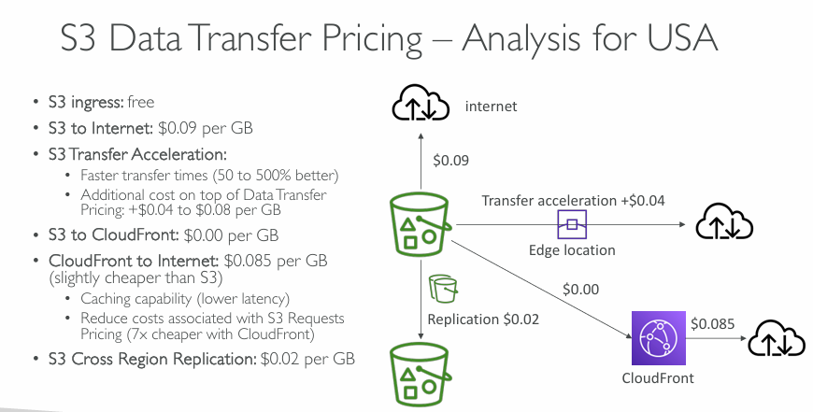  
**Key Terms**

* **S3 (Simple Storage Service)**: AWS storage service for objects like files, backups, etc.
* **CloudFront**: AWS content delivery network (CDN) that caches content closer to users.
* **Edge Location**: AWS’s global servers used by CloudFront.
* **Transfer Acceleration**: A way to make data move faster by using AWS edge locations.
* **Replication**: Copying data to another AWS region for backup or access.

**💰 Data Transfer Pricing Summary (USA)**

| **Type of Transfer** | **Cost (per GB)** | **Details** |
| --- | --- | --- |
| **S3 Ingress (upload to S3)** | **Free** | Uploading data to S3 is free |
| **S3 to Internet (direct download)** | **$0.09** | Standard outbound transfer |
| **S3 Transfer Acceleration** | **+$0.04–$0.08 extra** | Makes transfer 50% to 500% faster using edge locations |
| **S3 to CloudFront** | **$0.00** | Free to send S3 data to CloudFront (CDN) |
| **CloudFront to Internet** | **$0.085** | Slightly cheaper than direct S3-to-Internet ($0.09) |
| **S3 Cross-Region Replication** | **$0.02** | Sending data between S3 buckets in different regions |

**📊 Visual Summary Breakdown**

**📤 S3 to Internet:**

* Costs **$0.09/GB**
* Standard direct download from S3 to any user/device.

**⚡ S3 Transfer Acceleration:**

* Costs **$0.09 + $0.04** = **$0.13/GB** (minimum)
* Faster downloads using **AWS Edge locations**
* Useful for **global users** needing faster access

**🌍 S3 to CloudFront:**

* **Free ($0.00)** to send S3 data to CloudFront.
* CloudFront caches content globally.

**🌐 CloudFront to Internet:**

* **$0.085/GB** – **cheaper than S3 direct**
* Also gives **lower latency** (faster for users)
* Helps reduce costs of **S3 requests** (7x cheaper)

**🔁 Cross Region Replication:**

* **$0.02/GB**
* Used for **disaster recovery**, **backup**, or **geo-availability**

**✅ Cost Optimization Tips**

1. **Use CloudFront instead of direct S3 → Internet**
   * Saves you money ($0.085 vs $0.09/GB)
   * Provides **faster delivery** to users
2. **Use Transfer Acceleration only when speed is critical**
   * Great for global uploads/downloads
   * Comes with extra cost ($0.04–$0.08/GB)
3. **Replication is optional**
   * Only needed if you want your data in **multiple AWS regions**

**🧠 In Simple Words:**

* Uploading is **free**
* Downloading **costs money**, especially to the internet
* **CloudFront** saves cost and speeds up delivery
* **Transfer Acceleration** is faster but more expensive
* **Replication** is useful for backup but not free

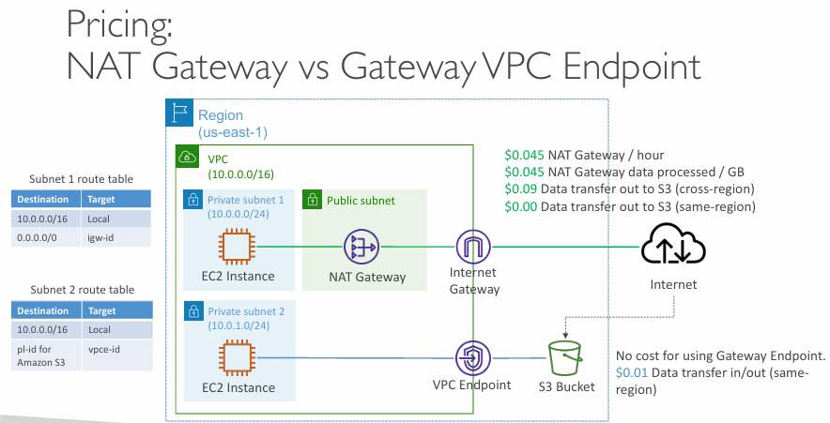  
**Scenario Overview**

There are **two EC2 instances** in different **private subnets**:

* **Subnet 1** uses a **NAT Gateway** to access S3 via the **Internet Gateway**
* **Subnet 2** uses a **Gateway VPC Endpoint** to directly access S3

Both are in **us-east-1 region**, and the destination is an **S3 bucket**.

**🧾 Cost Breakdown**

**🔁 NAT Gateway Path (via Internet Gateway)**

* **$0.045/hour** — cost to run the NAT Gateway
* **$0.045/GB** — cost per GB processed through the NAT Gateway
* **$0.09/GB** — data transfer to S3 in **another region**
* **$0.00/GB** — data transfer to S3 in **same region**

📌 Example:  
If EC2 → NAT Gateway → S3 (same region):

* Pay for **NAT Gateway usage** + **data processed**
* No charge for S3 data transfer (in-region)

If EC2 → NAT Gateway → S3 (cross-region):

* Pay for **NAT Gateway** + **data processed** + **$0.09/GB transfer**

**🟢 VPC Endpoint Path (direct to S3)**

* **$0.00** — no hourly charge for using Gateway VPC Endpoint
* **$0.01/GB** — data transfer cost (in-region)

📌 Example:  
If EC2 → Gateway VPC Endpoint → S3 (same region):

* Only **$0.01/GB**
* Much **cheaper** and **faster** than NAT Gateway

**📋 Route Tables Comparison**

| **Subnet** | **Route to S3** | **Used Resource** |
| --- | --- | --- |
| Subnet 1 | 0.0.0.0/0 → Internet Gateway (igw-id) | NAT Gateway |
| Subnet 2 | S3 prefix list → VPC Endpoint (vpce-id) | Gateway Endpoint |

**✅ Summary: Which One Should You Use?**

| **Feature** | **NAT Gateway** | **VPC Endpoint (Gateway)** |
| --- | --- | --- |
| **Hourly Cost** | $0.045/hour | $0 |
| **Per GB Cost** | $0.045/GB | $0.01/GB (in-region) |
| **Cross-Region Charges** | $0.09/GB | Not applicable (same-region only) |
| **Use Case** | Internet access, general API calls | S3 and DynamoDB access only |
| **Best For** | General internet/SaaS usage | Efficient S3 access in same region |

**💡 Tips**

* Use **VPC Gateway Endpoints** whenever possible for **S3 or DynamoDB** — saves money and reduces network hops.
* Use **NAT Gateway** only when the EC2 instance needs to access **other internet services**, not just S3.

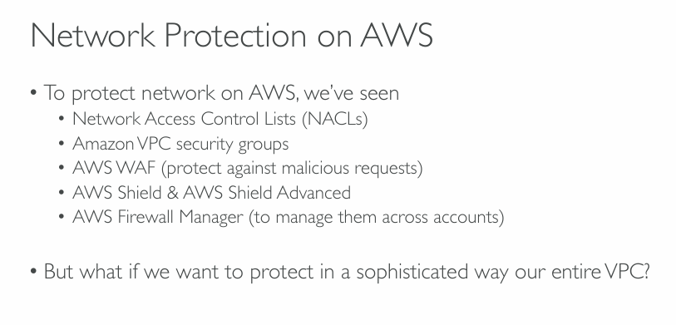  
**Basic AWS Network Protection Tools**

1. **Network Access Control Lists (NACLs)**
   * Work at the **subnet level**.
   * Control **inbound and outbound traffic** using rules based on IP, port, and protocol.
   * Like a **firewall for subnets**.
   * Rules are **stateless** (you must define both inbound and outbound separately).
2. **VPC Security Groups**
   * Work at the **instance level** (e.g., EC2).
   * Only control **allowed traffic** (no deny rules).
   * Rules are **stateful** (return traffic is automatically allowed).
   * Acts like a **virtual firewall for individual resources**.
3. **AWS WAF (Web Application Firewall)**
   * Protects web applications against **malicious HTTP/HTTPS requests**.
   * Blocks things like **SQL injection**, **cross-site scripting (XSS)**, etc.
   * Integrated with services like CloudFront, API Gateway, and ALB.
4. **AWS Shield & AWS Shield Advanced**
   * Protects against **DDoS (Distributed Denial of Service) attacks**.
   * **Shield Basic** is free and automatically active for all AWS customers.
   * **Shield Advanced** provides more protection and DDoS response support.
5. **AWS Firewall Manager**
   * A **centralized tool** to manage all the above protections across **multiple AWS accounts and resources**.
   * Helps enforce **organization-wide security policies**.

**🧠 But what if we want to protect the *entire* VPC in a more sophisticated way?**

The slide hints that there's **another level of protection** — something that goes **beyond individual components** and helps secure the **entire Virtual Private Cloud (VPC)** more effectively.

➡️ **Answer** (not shown on the slide but implied):  
Use **AWS Network Firewall** or **Third-party Firewall Appliances**.

**🌐 Sophisticated VPC-wide Protection (Answer to the Question)**

| **Tool** | **Purpose** |
| --- | --- |
| **AWS Network Firewall** | Fully managed, scalable firewall to inspect and filter traffic at the VPC level. |
| **Gateway Load Balancer** | Helps deploy **third-party firewalls** across multiple VPCs. |
| **Traffic Mirroring** | Allows capturing network traffic for **deep inspection** (IDS/IPS, forensics). |

These tools give **fine-grained control** and **visibility** over the entire VPC traffic — **ideal for regulated or sensitive workloads**.

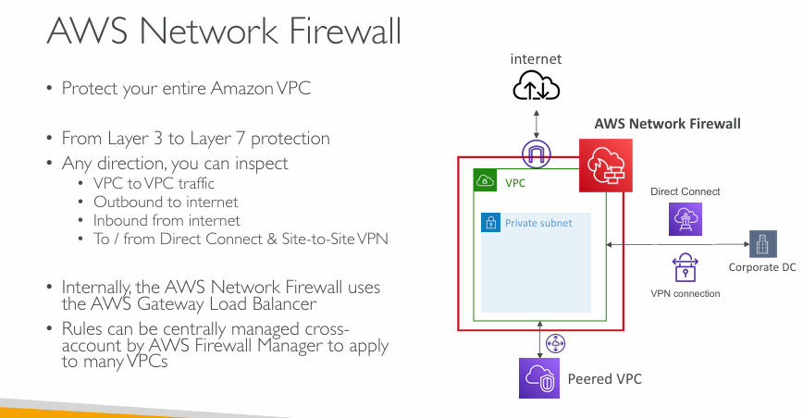  
**What is AWS Network Firewall?**

AWS Network Firewall is a **security system** that monitors and filters **network traffic** in and out of your VPC — just like a traditional network firewall, but made for AWS cloud environments.

**✅ Key Features Explained**

**🔒 Protect Your Entire VPC**

* Instead of protecting just EC2 instances or subnets, this firewall can **secure the whole VPC**, covering **all network traffic** inside and outside.

**🔍 Layer 3 to Layer 7 Protection**

* This means it can **analyze traffic deeply**:
  + **Layer 3 (Network layer)**: IP addresses, ports, protocols
  + **Layer 7 (Application layer)**: HTTP/HTTPS, DNS, etc.

**🔁 Inspects Traffic in Any Direction:**

1. **VPC to VPC traffic** – even traffic across peered VPCs.
2. **Outbound to internet** – prevents sending data to malicious sites.
3. **Inbound from internet** – blocks threats before they hit your applications.
4. **To/from Direct Connect or VPN** – inspects data going to/from on-premises environments.

**⚙️ Internally Uses Gateway Load Balancer**

* AWS Network Firewall is built on **AWS Gateway Load Balancer**, which allows it to scale and route traffic to **inspection points** seamlessly.

**🧠 Centrally Manage Rules with Firewall Manager**

* If your organization has **many VPCs across accounts**, you can:
  + Define rules once using **AWS Firewall Manager**
  + Apply those rules to **multiple VPCs at once**

**🖼️ Diagram Breakdown**

In the image:

* The **red outline** represents the **firewall boundary** around the VPC.
* All traffic (inbound/outbound/peered/VPN) **flows through** this firewall.
* It's connected to:
  + **Internet**
  + **Direct Connect**
  + **VPN to Corporate DC**
  + **Peered VPC**

So, the firewall **monitors every entry and exit point**.

**🔐 Summary**

| **Feature** | **What It Means** |
| --- | --- |
| **VPC-wide security** | Covers entire traffic in and out of the VPC |
| **Layer 3–7 protection** | Deep packet inspection, even app-level traffic |
| **Bi-directional filtering** | Monitors both inbound and outbound traffic |
| **Integrates with GWLB** | For scalable and reliable traffic inspection |
| **Central rule management** | Manage from a single place via Firewall Manager |

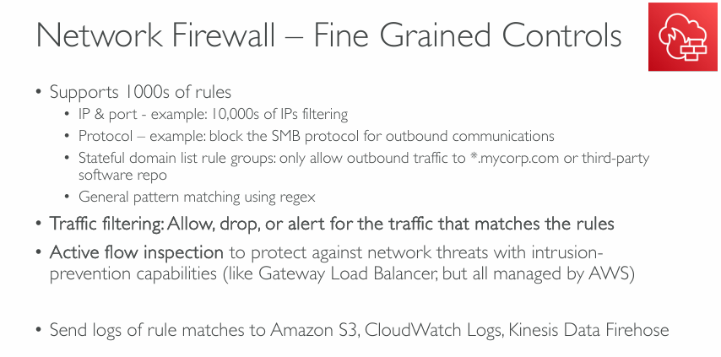  
**What Are Fine-Grained Controls in AWS Network Firewall?**

**✅ Rule-Based Filtering (Thousands of Rules Supported)**

You can define **thousands of custom rules** to precisely control what traffic is allowed or blocked.

Examples:

* **IP & Port filtering**
  + Block or allow access to specific IPs and ports (e.g., block 10,000+ IPs).
* **Protocol-based control**
  + Block specific protocols like **SMB** (used for Windows file sharing).
* **Domain-based rules**
  + Restrict traffic to trusted domains (e.g., only *.mycorp.com).
* **Pattern matching with regex**
  + Advanced matching for complex threats or naming patterns.

**🚦 Traffic Filtering Options**

You can set rules to:

* **Allow** – permit traffic.
* **Drop** – silently block traffic.
* **Alert** – log the activity without allowing it.

This enables **flexible response** based on the type of traffic.

**🕵️ Active Flow Inspection**

* Performs **deep inspection** of ongoing traffic flows.
* Protects against:
  + Malware
  + Intrusions
  + Unauthorized communication attempts
* Similar to **Intrusion Prevention Systems (IPS)**, but fully managed by AWS.

Uses **AWS Gateway Load Balancer under the hood** to scale and inspect traffic dynamically.

**📤 Logging & Monitoring**

You can **send logs** of all rule matches to:

* **Amazon S3** – for long-term storage.
* **CloudWatch Logs** – for real-time monitoring and alerts.
* **Kinesis Data Firehose** – for data streaming and analytics pipelines.

**📝 Summary Table**

| **Feature** | **Explanation** |
| --- | --- |
| IP/Port filtering | Block thousands of IPs or port ranges |
| Protocol rules | Block specific protocols like SMB |
| Domain restrictions | Only allow traffic to known domains |
| Regex pattern matching | Match advanced patterns in traffic |
| Action types | Allow, Drop, or Alert on traffic |
| Intrusion prevention | Active flow inspection to detect and block threats |
| Central logging | Store logs in S3 / CloudWatch / Firehose for analysis |